Integers, Place Value, Decimals, Rounding and Estimating

Total marks available = 32

Total marks achieved = ____
Questions
Q1.
(a) Write these numbers in order of size.
Start with the smallest number.
52 102 25 120 55
...........................................................
(1)
(b) Write these numbers in order of size.
Start with the smallest number.
6 −2 0 −5 3
...........................................................
(1)
(c) Write these numbers in order of size.
Start with the smallest number.
0.63 0.633 0.603 0.6 0.06
...........................................................
(1)
(Total for Question is 3 marks)

Q2.
Write 2148 correct to the nearest 100
...........................................................
(Total for question = 1 mark)

Q3.
(a) Write the number seven thousand and twenty five in figures.

..............................................................................................................................................
(1)
(b) Write the number 9450 in words.

..............................................................................................................................................
(1)
(c) Write the number 28.75 to the nearest whole number.

..............................................................................................................................................
(1)
(d) Write the number 7380 to the nearest thousand.

..............................................................................................................................................
(1)
(Total for Question is 4 marks)

Q4.
The table shows the heights of six mountains.
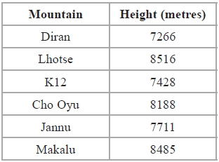
(a) Write down the name of the highest of these mountains.
...........................................................
(1)
(b) Write the number 8188 to the nearest hundred.
...........................................................
(1)
(c) Write the number 7428 in words.
.............................................................................................................................................
(1)
The mountain K3 is eight thousand and fifty one metres high.
(d) Write the number eight thousand and fifty one in figures.
...........................................................
(1)
(Total for Question is 4 marks)

Q5.
The table shows the temperature every four hours one day in December.
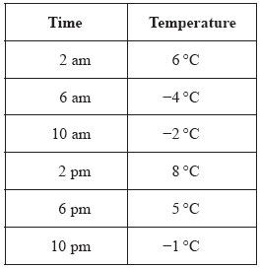

(a) Write down the time with the lowest temperature.

..............................................................................................................................................
(1)
(b) Work out the difference between the temperature at 2 pm and the temperature at 6 pm.

..............................................................................................................................................
(1)
Between 10 pm and midnight the temperature goes down 5°C.
(c) Work out the temperature at midnight.

..............................................................................................................................................
(2)
(Total for Question is 4 marks)

Q6.
Write 4.4354 correct to 2 decimal places.
...........................................................
(Total for question is 1 mark)

Q7.
(a) Write 5643 to the nearest hundred.

..............................................................................................................................................
(1)
(b) Write 197 768 to the nearest thousand.

..............................................................................................................................................
(1)
(Total for Question is 2 marks)

Q8.
28569 people watch a football match.
(a) Write 28569 to the nearest hundred.
...........................................................
(1)
(b) Write down the value of the 2 in the number 28569
...........................................................
(1)
5619 of the 28569 people are female.
(c) Work out the number of males.
...........................................................
(1)
(Total for Question is 3 marks)

Q9.
Work out the number that is halfway between 2.9 and 3.6
...........................................................
(Total for Question is 1 mark)

Q10.
Sally uses her van to deliver boxes to shops.
She can put a maximum weight of 450 kg in the van.
Sally has to deliver 50 boxes to a shop.
Each box has a weight of 30 kg.
Work out the least number of times Sally has to drive to the shop to deliver all 50 boxes.
You must show all your working.
...........................................................
(Total for Question is 3 marks)

Q11.
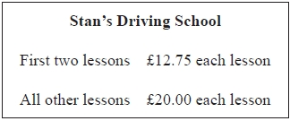
Alex has 5 lessons with Stan's Driving School.
(a) Work out the total cost.
£ ...........................................................
(2)
Leah has some lessons with Stan's Driving School.
The total cost of the lessons is £305.50
(b) Work out how many lessons Leah has.
...........................................................
(3)
(Total for Question is 5 marks)

Q12.
Jayne writes down the following

3.4 × 5.3 = 180.2

Without doing the exact calculation, explain why Jayne's answer cannot be correct.
.............................................................................................................................................
.............................................................................................................................................

(Total for question is 1 mark)

Examiner's Report
Q1.
This was an accessible question for most candidates. It allowed candidates a positive start to the paper. Part (a) and (b) were usually correctly answered. However in part (c), the most successful strategy seen was to write all the numbers out to 3 decimal places and then compare. A common incorrect answer was to place 0.63 before 0.603 or misplace 0.6.

Q2.
No Examiner's Report available for this question

Q3.
Most candidates gained at least 3 of the 4 available marks in this question. For part (b), although most answered correctly, a common incorrect answer was 'Nine thousand and fifty'. Although slight spelling errors are overlooked, candidates need to ensure that slips do not lead to ambiguity in meaning. In part (c), a common mistake was to write 28.75 to the nearest 10 (30) instead of the nearest whole number. In part (d), rounding up was not uncommon.

Q4.
This question allowed students to make a good start to the paper with most students getting parts (a), (c) and (d) correct. Although most students wrote that Lhotse was the highest mountain some candidates gave the height of 8516 instead which meant they could not score the mark. Most students could write 8188 to the nearest hundred with the common incorrect responses being 8100, 8000 and 200.

Q5.
All parts of this question were answered well. There were very few mistakes in part (a). In part (b), 10 was a common error, maybe through misreading am for pm. In part (c), errors tended to be either from calculating −1 + 5 or from a possible misread in using 10am instead of 10pm; however when an answer of −7 was seen, it had to be supported by explicit working before any credit was given. Calculating errors were common.

Q6.
No Examiner's Report available for this question

Q7.
Part (a) was again a well answered question with a large majority of answers being fully correct. Only a few candidates rounded inappropriately.
Part (b) was not as well done as part (a) however many candidates did succeed in rounding correctly. A popular incorrect answer was 200 000.

Q8.
This question was well understood but sometimes not very well answered as candidates tended to write 600 rather than 28 600 in part (a) thousand rather than 20 000 in part (b). The success rate for part (c) though was much higher with almost all candidates obtaining the right answer. A significant number of candidates included a decimal point in the answer as a delimiter and this was not accepted for the mark in part (c).

Q9.
Less than half of the candidates answered this question correctly with many giving the answer of 3.2 or 3.3 and a significant number wrote 3.2¹⁄₂ which also was not accepted.

Q10.
This question was well attempted with many students gaining full marks, though poor arithmetic did let students down and repeated addition was a common approach to division. Some students demonstrated the correct method but then incorrectly stated only three trips needed. The weakest students were often able to gain a mark for 50×30 or for writing 450÷30 even though they couldn't complete this calculation.

Q11.
Although most students appreciated that the first two lessons were cheaper, many missed that the information in the box showing that they cost £12.75 each and instead used £12.75 as the price of both.
For part (a), the omission of the final zero in an answer of £85.5 was often seen and condoned but students need to be aware that they should always use correct money notation.
For part (b) most students gained marks for their correct method to subtract the cost of 2 £12.75 lessons or the 5 lesson total calculated in part (a) and then divide the remainder by 20.
Use of just the single £12.75 cost for 2 initial lessons was condoned for the award of method marks here. Once the figure of 14 additional lessons had been reached, some students forgot to add on the initial 2 lessons and so gave 14 rather than 16 as their final answer. Although students were permitted calculators, a number showed lengthy working to add enough £20 lessons individually to the initial starter lesson figure rather than use a more efficient division calculation. This strategy sometimes led to errors counting up the number of £20 lessons and incorrect final answers.

Q12.
No Examiner's Report available for this question

Mark Scheme
Q1.
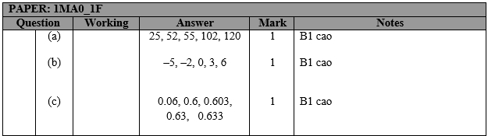

Q2.
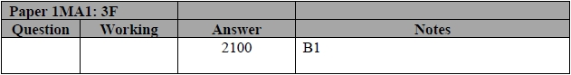

Q3.
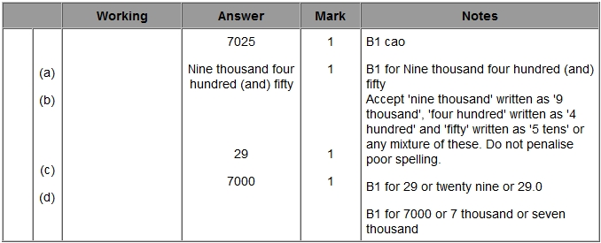

Q4.
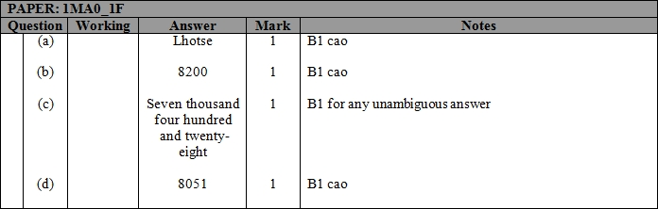

Q5.
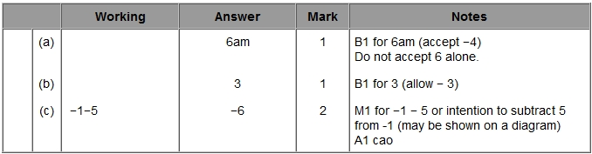

Q6.
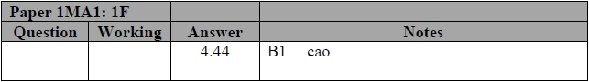

Q7.
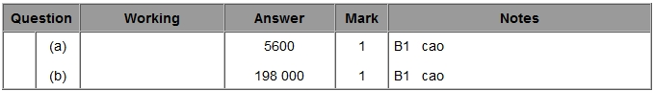

Q8.
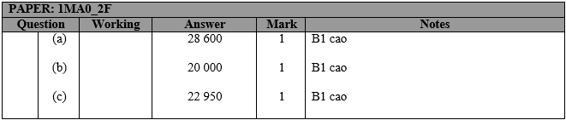

Q9.
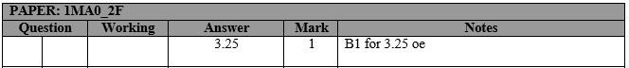

Q10.
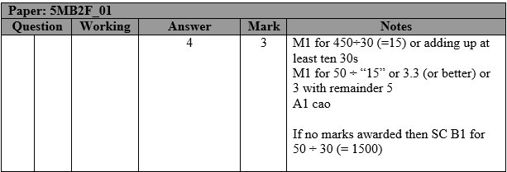

Q11.
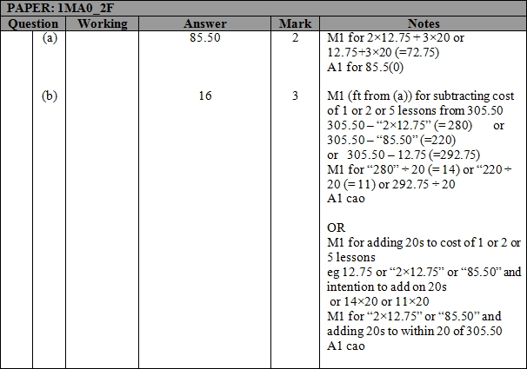

Q12.
