Expressions,
Simple Substitution,
Expanding and Factorising, Sequences and Inequalities, Simple proof

Total marks available = 66

Total marks achieved = ____

Questions
Q1.
(a) Factorise fully 6ab + 10ac
...........................................................
(2)
(b) Expand and simplify (x − 5)(x + 7)
...........................................................
(2)
(c) Simplify 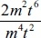
Give your answer in its simplest form.
...........................................................
(2)
(d) Factorise y² − 16
...........................................................
(1)
(e) Simplify (h²)⁻³
...........................................................
(1)
(Total for Question is 8 marks)
Q2.
5 female giraffes have a mean weight of x kg.
7 male giraffes have a mean weight of y kg.
Write down an expression, in terms of x and y, for the mean weight of all 12 giraffes.

..............................................................................................................................................
(Total for Question is 2 marks)

Q3.
(a) Expand and simplify (p + 9)(p – 4)

..............................................................................................................................................
(2)
(b) Solve 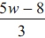 = 4w + 2

w = . . . . . . . . . . . . . . . . . . . . . .
(3)
(c) Factorise x² – 49

..............................................................................................................................................
(1)
(d) Simplify (9x⁸y³)^{½}

..............................................................................................................................................
(2)
(Total for Question is 8 marks)

Q4.
(a) Expand 3(x + 2)
..............................................................................................................................................
(2)
(b) Factorise completely 12 x³y – 18 xy²

..............................................................................................................................................
(2)
(c) Expand and simplify (2x – 3)(x + 4)

..............................................................................................................................................
(2)
(d) Simplify 5x⁴y³ × 2x³y²

..............................................................................................................................................
(2)
(Total for Question is 8 marks)

Q5.
f = 3g + 7h
(a) Work out the value of f when g = −5 and h = 2
f = ...........................................................
(2)
(b) Factorise 3x + 6
...........................................................
(1)
(c) Expand and simplify 5(y − 2) + 2(y − 3)
...........................................................
(2)
(d) Simplify m⁵ × m³
...........................................................
(1)
(e) Simplify
...........................................................
(1)

(Total for question = 7 marks)

Q6.
Make p the subject of the formula y = 3p² – 4

. . . . . . . . . . . . . . . . . . . . . .
(Total for Question is 3 marks)

Q7.
Make t the subject of the formula
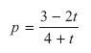

..............................................................................................................................................
(Total for Question is 4 marks)

Q8.
(a) Solve 2x + 3 = x – 4

x = . . . . . . . . . . . . . . . . . .
(2)
(b) Solve 4(x – 5) = 14

x = . . . . . . . . . . . . . . . . . .
(2)
(Total for Question is 4 marks)

Q9.
Dan has some marbles.
Ellie has twice as many marbles as Dan.
Frank has 15 marbles.
Dan, Ellie and Frank have a total of 63 marbles.
How many marbles does Dan have?

..............................................................................................................................................
(Total for Question is 3 marks)

Q10.
Here are some patterns made from white centimetre squares and grey centimetre squares.
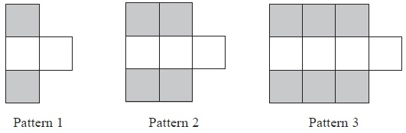
A Pattern has 20 grey squares.
(a) Work out how many white squares there are in this Pattern.
...........................................................
(2)
(b) Find an expression, in terms of n, for the total number of centimetre squares in Pattern n.
...........................................................
(2)
(Total for Question is 4 marks)

Q11.
Here are the first five terms of an arithmetic sequence.
3 5 7 9 11
Write down, in terms of n, an expression for the nth term of the sequence.
...........................................................
(Total for Question is 2 marks)
Q12.
Here are the first five terms of an arithmetic sequence.
2 6 10 14 18
(a) Write down an expression, in terms of n, for the nth term of this sequence.
...........................................................
(2)
(b) Is 86 a term in the sequence?
You must give a reason for your answer.
(1)
(Total for question = 3 marks)

Q13.
Here are the first six terms of a Fibonacci sequence.
1 1 2 3 5 8
The rule to continue a Fibonacci sequence is,
the next term in the sequence is the sum of the two previous terms.
(a) Find the 9th term of this sequence.
...........................................................
(1)
The first three terms of a different Fibonacci sequence are
a b a + b
(b) Show that the 6th term of this sequence is 3a + 5b
(2)
Given that the 3rd term is 7 and the 6th term is 29,
(c) find the value of a and the value of b.
...........................................................
(3)

(Total for question = 6 marks)

Q14.
Here are the first five terms of an arithmetic sequence.
(a) Write down an expression, in terms of n, for the nth term of this sequence.

..............................................................................................................................................
(2)
The nth term of a different number sequence is 3n² + 7
(b) Find the 10th term of this sequence.

..............................................................................................................................................
(2)
(Total for Question is 4 marks)

Examiner's Report
Q1.
Part (a) was done well. Most candidates were able to extract at least one of the factors of the given expression, but a surprising number of candidates omitted to include the right hand bracket of the linear factor. In part (b), most candidates were able to expand the brackets to obtain 4 correct terms which most were then able to simplify correctly. Expansion of the constant term was an obstacle for some candidates. Common errors here were +2, −45 and −12. A popular incorrect answer involving the simplification of the term in x was x² − 2x − 35.
In part (c), the majority of candidates were able score at least 1 mark for simplifying the algebraic fraction. A popular form for the answer was 2m⁻²t⁴, ie not expressed as a fraction.
In part (d), the majority of candidates were able to use the difference of two squares to factorise the quadratic expression. Common incorrect answers here were y(y − 16), (y − 4)², (y − 8)(y − 8) and (y − 8)(y + 2). In part (e), most candidates were able to use the laws of indices to simplify the given expression. A common incorrect answer here was h⁻¹.

Q2.
This question was well attempted but only the most able candidates gained full marks. Many candidates scored M1 for 5x or 7y though these expressions were often found in a jumble of algebraic expressions. Common incorrect responses included just 5x+7y, 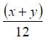 and 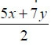
Weaker candidates used ¹⁄₅ and ¹⁄₇ with no letters, described a process, made up numbers to use or wrote 12xy.

Q3.
Candidates were generally quite successful in part (a). Most candidates appeared to know a method for expanding two sets of brackets with many achieving at least one mark. Methods seen included FOIL and the use of a grid. Common errors included ignoring the signs of the terms (–4p was often given as 4p) and adding the final two terms instead of multiplying. Simplifying the four-term expression sometimes resulted in errors, e.g. –4p + 9p being simplified to 13p or –5p or to just 5.
Part (b) was not answered so well. Most candidates realised that they needed to multiply both sides of the equation by 3 but many weren't sure how to carry this out. 15w – 24 = 12w + 6 was seen often and the RHS was sometimes given as 4w + 6 or 12w + 2. Some candidates were able to rearrange their four-term equation correctly but many made errors when attempting to do this. Some candidates who got as far as 14 = –7w were unsure of how to deal with the minus sign.
Candidates who recognised the expression in part (c) as the difference of two squares almost invariably found the correct answer but there were many who gave the answer as either (x + 7)² or (x – 7)². Others tried to find a common factor and x(x – 49) was a common incorrect answer.
Part (d) was answered less well although a good number of candidates did successfully apply the laws of indices to get either a fully correct answer or to gain one mark for having two correct terms within a product. Many candidates did not know that the power of 1/2 indicates square root and 9^{½} was commonly given as '4.5' or left as '9'.

Q4.
Multiplying the first term in the bracket only and leaving the second unchanged, ie 3x + 2, was the most common incorrect answer and 3x + 5 was often seen. A few did not score the final accuracy mark by continuing to 'simplify' their final answer, writing 3x + 6 = 9x. Very few answers reflected no understanding of the algebra involved.
In part (b) most students found some common factors and divided well. Candidates need to ensure that they find the highest common factor, particularly for the number part of each term. They need to look at the terms left in the bracket to see if anything is still a factor. Candidates should be encouraged to check their answer by expanding as answers such as 6xy(2x² – 3xy) were occasionally seen.
In part (c) This question was well answered with a majority of candidates familiar with the need to find four terms and many also correctly dealing with the signs and simplification of the answer. 43% of candidates could expand and simplify correctly with a further 24% able to provide 4 correct terms (ignoring the signs) or 3 correct terms with the correct signs. The most common errors were incorrect signs, incorrect product of 2x and x, an incorrect simplification of –3x + 8x or a constant term of +1
In part (d) it was pleasing to see that nearly 60% of the candidates obtained the correct answer with a further 12% scoring one mark for obtaining 2 correct parts of the expression 10x⁷y⁵. The most common error was to add the coefficients with 7 x⁷y⁵ frequently seen. Others left multiplication signs in their answer or occasionally an addition sign.

Q5.
In part (a) the most common error was to assume 3g meant 3+g, surprising on a Higher paper. Negative numbers caused problems for some. In contrast part (b) was usually well answered.
Brackets were usually multiplied out correctly in part (c), with most errors caused by incorrect simplification, usually leading to 7y+16 and 7y+4 because of an inability to process −10−6.
In parts (d) and (e) it was disappointing to find a significant minority who either multiplied or divided the indices (rather than adding and subtracting).

Q6.
Many candidates showed poor understanding of the order of the steps required and misplaced signs or lost terms caused errors. The most common first step appeared to be showing an intention to add 4 to both sides. There were some candidates that tried dividing through by 3, however this was far less successful.
Most candidates realised they had to find a square root somewhere, but frequently this was done too early in the process, before an equation of the form p²= had been formed.
A significant minority found the square root of the numerator only, but of concern are those candidates whose presentation of the answer was ambiguous: it was not clear whether the square root was intended to go over the entire fraction or not; some missed off the "p=" from their final answer. Full marks could not be awarded in these cases. The use of flow diagrams rarely led to any marks.

Q7.
This question was poorly completed, with few candidates managing to gain more than one mark for an intention to multiply through by 4 + t. Often the bracket was missing and p(4 + t) became 4p + t. Candidates did appear to realise that they needed to find 't = something' but lacked the ability to achieve this. Of those who did successfully isolate the term sin t, only the most able went on to factorise correctly.

Q8.
In part (a), many candidates used incorrect signs when attempting to collect the x's on one side and the numbers on the other, 3x and −1 were common. This was a standard question and candidates at this level should be performing much better; this is a topic in algebra that needs more practice.
Part (b) was very well done by the majority. The most common route was to expand the brackets. Some of those that divided by 4 first made errors.

Q9.
The majority of candidates scored full marks. Some formed an algebraic equation but others just subtracted 15 from the total of 63 and then divided by 3. The most common error was to divide by 2 instead of by 3. Some candidates showed fully correct working but then identified Ellie's total, 32, as the answer, so losing the final mark. Some candidates experimented with combinations of numbers which often gave the correct result.

Q10.
This question was done quite well. In part (a), most candidates were able to work out the number of white tiles in the Pattern. A common approach here was for candidates to draw a diagram to help them count the numbers of grey tiles and white tiles. Those candidates listing the numbers of grey tiles and white tiles in a table were less successful as they often made errors in extending the list beyond the tiles given in the paper. A common error here was to double both the numbers of grey tiles and the numbers of white tiles, eg (6 grey, 4 white) in the diagram was extended to (12 grey, 8 white) in their list (instead of 7 white). In part (b), most candidates were able to write down an expression for the total number of tiles. Some candidates gave their final answer in the form 2n + n + 1, ie unsimplified. Common incorrect answers here 2n + 1, n + 3 and 4n+1.

Q11.
Most students recognised that the numbers went up by 2 each time and many were able to access the first mark by writing 2n. The most common incorrect responses were 2n − 1 and also 3n + 2. Some students did understand that the correct expression was 2n +1 but wrote their answer as n = 2n + 1, losing the accuracy mark.

Q12.
Many were able to give the correct answer of 4n-2 in part (a), with 4n or 2n+4 being the most common incorrect answers.
Irrespective of the quality of response in part (a), many went on to provide a perfectly reasonable explanation in part (b), many by continuing the sequence up to 86. Incomplete answers referred just to the fact that they were even numbers, or had to include 2,6,4,8.

Q13.
No Examiner's Report available for this question

Q14.
Part (a) was well attempted by most candidates with many scoring full marks. In most cases those who didn't score full marks either wrote an expression containing 4n scoring B1 or wrote n + 4 scoring B0. There were very few responses seen with other coefficients of n.
Part (b) was well attempted by most candidates though more candidates were successful in part (a). The most common incorrect response was 907, however, those candidates who presented full working out and initially wrote 3 × 10² + 7 followed by 30² + 7 did earn at least M1, unfortunately in most cases candidates wrote 3 × 10 = 30, 30² = 900, 900 + 7 = 907. Candidates who tried to generate all the terms of the sequence were usually unsuccessful.

Mark Scheme
Q1.
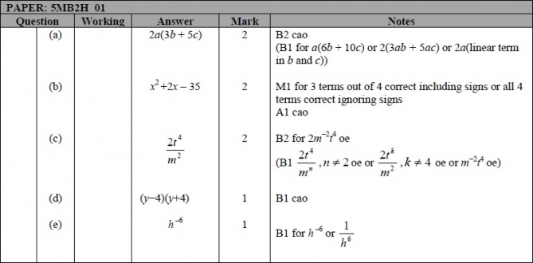

Q2.
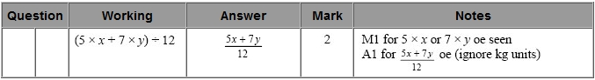

Q3.
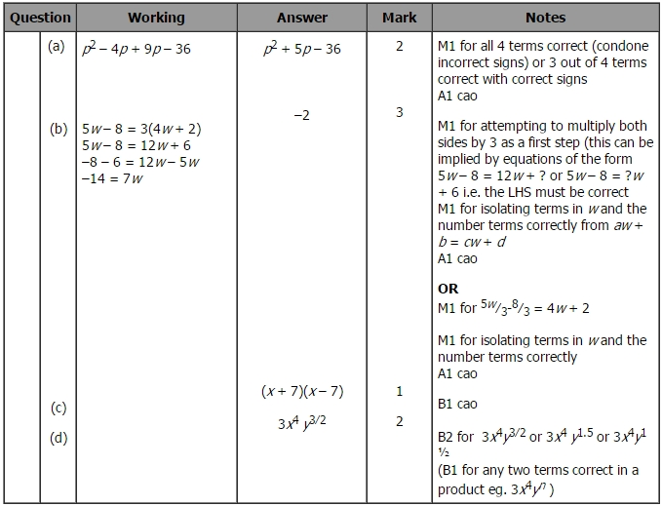

Q4.
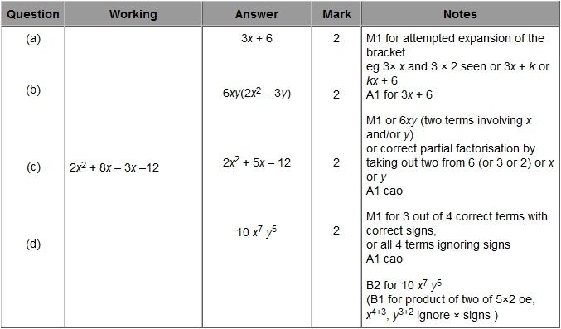

Q5.
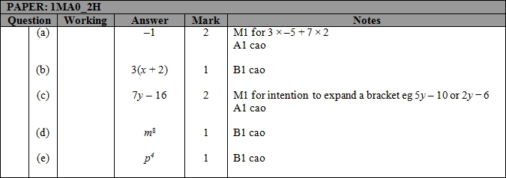

Q6.
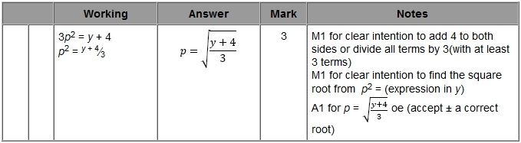

Q7.
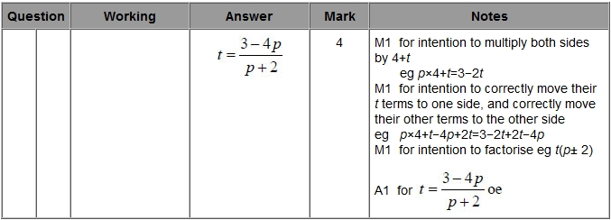

Q8.
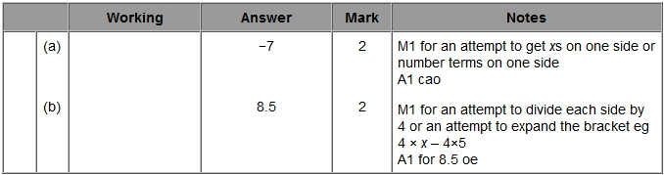

Q9.
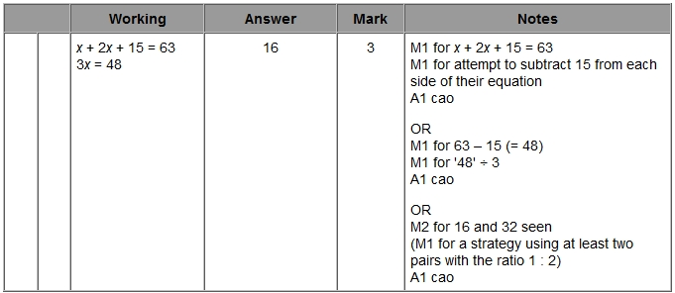

Q10.
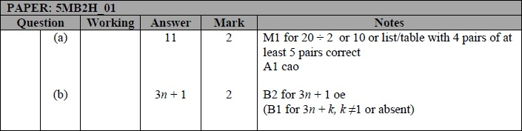

Q11.
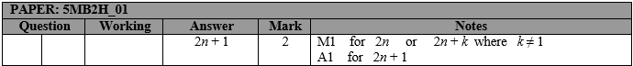

Q12.
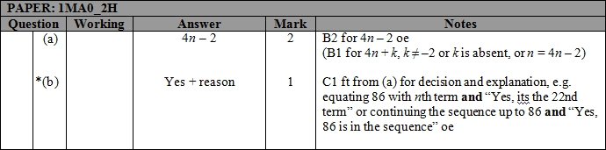

Q13.
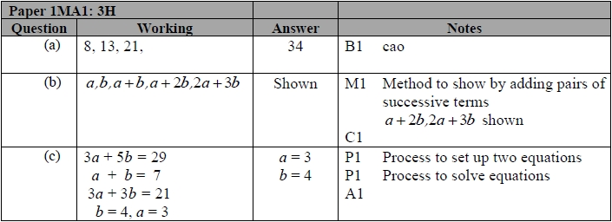

Q14.
