Indices, Powers, Roots, Factors, Multiples and Primes

Total marks available = 38

Total marks achieved = ____
Questions
Q1.
(a) Work out 2 × (8 – 3)
. . . . . . . . . . . . . . . . . . . . . .
(1)
(b) Work out 3² + 4 × 5
. . . . . . . . . . . . . . . . . . . . . .
(2)
(c) Find the value of 5³
. . . . . . . . . . . . . . . . . . . . . .
(1)
(d) Find the square root of 16
. . . . . . . . . . . . . . . . . . . . . .
(1)
(Total for Question is 5 marks)

Q2.
(a) Write down the value of 7²

..............................................................................................................................................
(1)
(b) Write down the value of

..............................................................................................................................................
(1)
(c) Write down the value of 2³

..............................................................................................................................................
(1)
(Total for Question is 3 marks)

Q3.
(a) (i) Work out
Write down all the figures from your calculator display.

..............................................................................................................................................
(ii) Write your answer to (a)(i) correct to 2 significant figures.
..............................................................................................................................................
(2)
(b) Work out the value of 10⁵

..............................................................................................................................................
(1)
(Total for Question is 3 marks)

Q4.
(a) Work out 3⁴

..............................................................................................................................................
(1)
(b) Write down the cube root of 64

..............................................................................................................................................
(1)
(Total for Question is 2 marks)

Q5.
Work out the value of √14.44 × (7.3 − 2.45)²
Write down all the figures on your calculator display.
...........................................................
(Total for Question is 2 marks)
Q6.
Here is a list of numbers.
5 15 30 50 60 90 100 125
From the numbers in the list, write down
(i) two different numbers that add up to an even number

..............................................................................................................................................
(ii) a multiple of 20

..............................................................................................................................................
(iii) a factor of 45

..............................................................................................................................................
(iv) a cube number

..............................................................................................................................................
(Total for Question is 4 marks)

Q7.
Sally has three tiles.
Each tile has a different number on it.
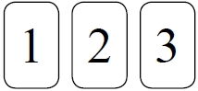
Sally puts the three tiles down to make a number.
Each number is made with all three tiles.
How many different numbers can Sally make?

(Total for question = 2 marks)

Q8.
Here are four cards.
There is a number on each card.
(a) Write down the largest 4-digit even number that can be made using each card only once.
...........................................................
(2)
(b) Write down all the 2-digit numbers that can be made using these cards.
(2)
(Total for question is 4 marks)

Q9.
Express 180 as a product of its prime factors.
...........................................................
(Total for Question is 3 marks)

Q10.
Caroline is making some table decorations.
Each decoration is made from a candle and a holder.
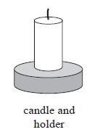
Caroline buys some candles and some holders each in packs.
There are 30 candles in a pack of candles.
There are 18 holders in a pack of holders.
Caroline buys exactly the same number of candles and holders.
(i) How many packs of candles and how many packs of holders does Caroline buy?
........................................................... packs of candles
........................................................... packs of holders
Caroline uses all her candles and all her holders.
(ii) How many table decorations does Caroline make?
........................................................... table decorations
(Total for question = 5 marks)
Q11.
Veena bought some food for a barbecue.
She is going to make some hot dogs.
She needs a bread roll and a sausage for each hot dog.
There are 40 bread rolls in a pack.
There are 24 sausages in a pack.
Veena bought exactly the same number of bread rolls and sausages.
(i) How many packs of bread rolls and packs of sausages did she buy?

. . . . . . . . . . . . . . . . . . . . . . packs of bread rolls
. . . . . . . . . . . . . . . . . . . . . . packs of sausages.
(ii) How many hot dogs can she make?

..............................................................................................................................................
(Total for Question is 5 marks)

Examiner's Report
Q1.
Part (a) was well answered. Part (b) proved to be a good discriminator. Some candidates picked up a method mark by showing the intention to start with either 3×3 or 4×5. However, starting correctly did not always mean the correct answer, those who started with 3×3 = 9 then frequently went onto and 4 and then multiply by 5 to give the common incorrect answer of 65. Another common incorrect answer was 50 from those who started with 3×3 but evaluated this incorrectly as 6 and then went onto add 4 and multiply by 5 rather than add 20. Also, 26 was another common response from those candidates who incorrectly evaluated 3² as 6 but correctly evaluated 4×5 as 20 and added the two together. Finally, 15 was a common incorrect answer in part (c). There were a significant number of blank responses in part (d) with 8 being the most common incorrect response from those who attempted the question.

Q2.
Success rates for the 3 parts of this question were similar with around 40% correctly answering each. In parts (a) and (c) candidates often wrote down the correct calculation 7 × 7 or 2 × 2 ×2 but then did not evaluate it or made an arithmetic error, typically showing 7 × 7 = 48. Candidates misunderstanding indices inevitably gave 14 for 7² and 6 or occasionally 9 for 2³.
Common wrong answers for part (b) were 12.5, 2.5, 5 × 5 and 25 × 25 with or without an attempted evaluation.

Q3.
In part (a), although the actual calculation was often performed correctly, many candidates were unable to write their answer correct to two significant figures. The most common error in part (a)(ii) was to write their answer from part (a)(i) correct to two decimal places. Some gave an answer of 13.0 or 13.00, showing that they do not fully understand the concept of significant figures. Some gave 12 as the answer instead of 13. Sometimes in part (a)(i), insufficient digits were written down to gain the mark.
In part (b), a surprising number of candidates failed to give a correct answer, with 50 or 1 million being the most common mistakes made.

Q4.
Very few candidates knew that 3⁴ is the same as 3 × 3 × 3 × 3 in part (a) and many who did know this could not actually compute an answer of 81 owing to arithmetical errors; 12 was the most common incorrect answer seen.
Part (b) was even less well done, 8 or 4³ being the best of the incorrect answers.

Q5.
Many students used their calculators accurately to reach the correct 89.3855 and the majority picked up at least one mark for evaluating part of the calculation correctly, typically finding the square root of 14.44. The squaring aspect caused difficulties and some answers showed that it had been ignored or the result of (7.3 − 2.45) multiplied by 2 instead.

Q6.
Part (i) was usually answered correctly, but in parts (ii) and (iii) many candidates showed a lack of understanding of factors and multiples and the difference between the two. In part (ii) 5 and in part (iii) 90 were the most common mistakes made. In part (iv), 100 and 30 were common errors as candidates showed their lack of understanding of a cube number.

Q7.
No Examiner's Report available for this question

Q8.
No Examiner's Report available for this question

Q9.
There were many blank responses to this question. Many had little idea of what was required and simply wrote down some factor pairs for 180. It was rare to see continual prime factorisation used and when it was, it was invariably incomplete. The most common and generally successful method seen was the factor tree method with many gaining 2 marks if it was fully correct or 1 mark for a partially correct factor tree. Only a few were able to use the factor tree to write the answer as the product of the factors. It was more usual to see a list of numbers or 15 (the sum of the prime factors).

Q10.
This question was answered very well. In part (i), most students listed multiples of 30 and multiples of 18 and identified 90, or 180, as a common multiple. Students were not quite as successful in part (ii). Instead of giving their common multiple as the number of table decorations some students divided it by 2 or multiplied it by 2.

Q11.
There were many good attempts at this question, with a significant number of correct solutions. Most candidates attempted to list the multiples, but were often handicapped by poor arithmetic, resulting in very long lists without a common multiple being found. Some who achieved 120 in both lists then miscounted the number of 24s or 40s they had in their list. The final mark was quite frequently lost because they thought they needed to add the number of sausages and rolls, arriving at 240 instead of 120.

Mark Scheme
Q1.
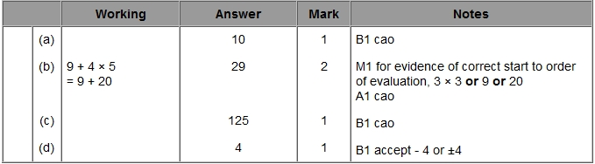

Q2.
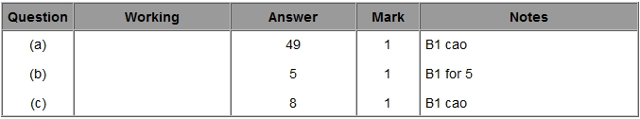

Q3.
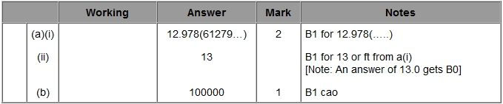

Q4.
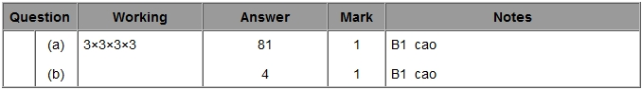

Q5.
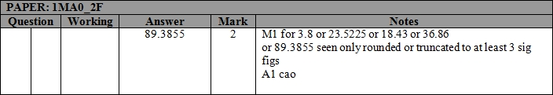

Q6.
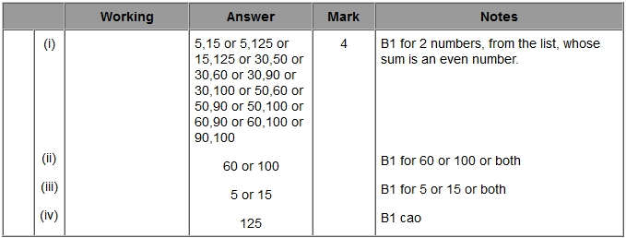

Q7.
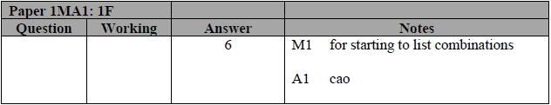

Q8.
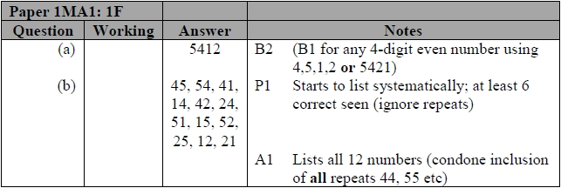

Q9.
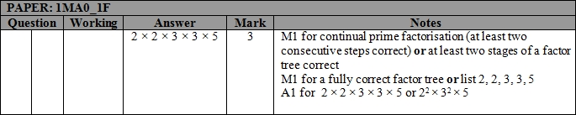

Q10.
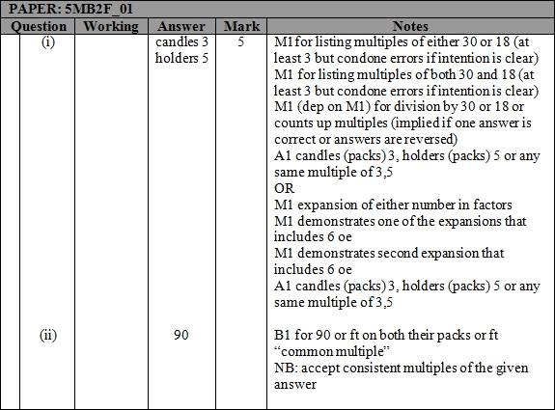

Q11.
