Averages and Range, Collecting and Representing data

Total marks available = 47

Total marks achieved = ____

Questions
Q1.
There are a total of 96 children in Years 4, 5 and 6
37 of these children cannot swim.
11 children in Year 4 cannot swim.
21 children in Year 5 can swim.
There are 30 children in Year 6
18 of these 30 children can swim.
(i) Work out the number of children in Year 4 who can swim.

..............................................................................................................................................

(ii) Work out the total number of children in Year 5

..............................................................................................................................................
(Total for Question is 4 marks)

Q2.
A survey was carried out for a magazine.
90 cat owners were asked to write down the make of cat food their cats liked best.
The bar chart shows information about the results.
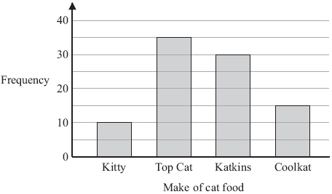
The information in the bar chart is going to be shown in a pie chart.
Use the information in the bar chart to complete the pie chart.

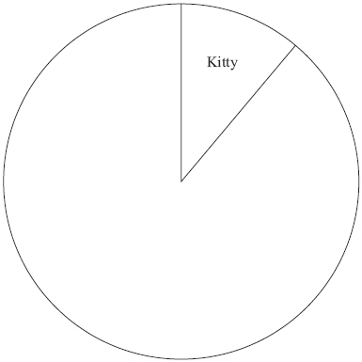

(Total for Question is 3 marks)
Q3.
* Zoe recorded the heart rates, in beats per minute, of each of 15 people.
Zoe then asked the 15 people to walk up some stairs.
She recorded their heart rates again.
She showed her results in a back-to-back stem and leaf diagram.
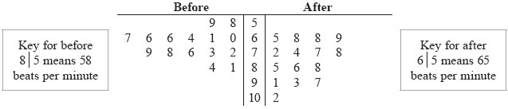
Compare the heart rates of the people before they walked up the stairs
with their heart rates after they walked up the stairs.

(Total for Question is 6 marks)

Q4.
25 students in class A did a science exam.
30 students in class B did the same science exam.
The mean mark for the 25 students in class A is 67.8
The mean mark for all the 55 students is 72.0
Work out the mean mark for the students in class B.
...........................................................
(Total for Question is 3 marks)

Q5.
The table gives information about the temperature, T °C, at noon in a town for 50 days.
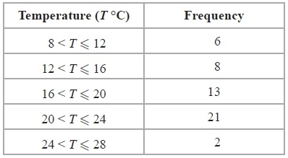
(a) Write down the modal class interval.
...........................................................
(1)
(b) Calculate an estimate for the mean temperature.
........................................................... ° C
(4)

(c) Draw a frequency polygon for the information in the table.
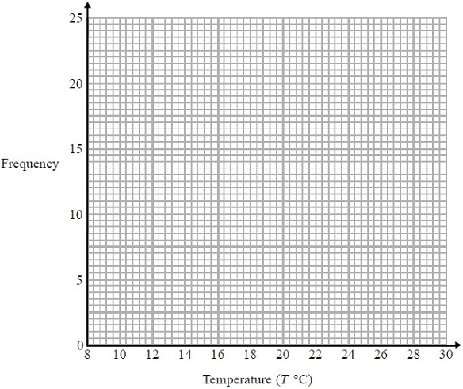
(2)
(Total for Question is 7 marks)

Q6.
The scatter graph shows some information about ten pine cones from the same tree.
It shows the length and the width of each pine cone.
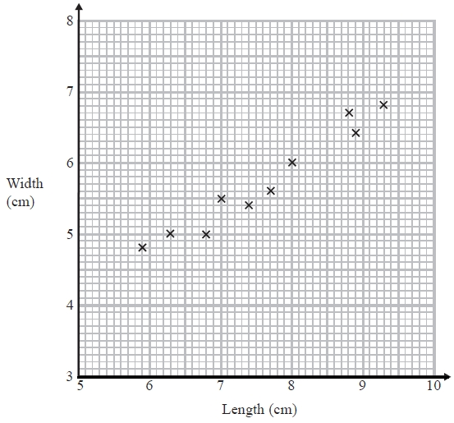
(a) Describe the relationship between the length and the width of a pine cone.
.............................................................................................................................................
.............................................................................................................................................
(1)
Another pine cone from this tree has a length of 8.4 cm.
(b) Estimate the width of this pine cone.
...........................................................cm
(2)
(Total for question = 3 marks)
Q7.
Walkden Reds is a basketball team.
At the end of 11 games, their mean score was 33 points per game.
At the end of 10 games, their mean score was 2 points higher.
Jordan says,
"Walkden Reds must have scored 13 points in their 11th game."
Is Jordan right?
You must show how you get your answer.
...........................................................
(Total for question is 3 marks)

Q8.
Mr Brown gives his class a test.
The 10 girls in the class get a mean mark of 70%
The 15 boys in the class get a mean mark of 80%
Nick says that because the mean of 70 and 80 is 75 then the mean mark for the whole
class in the test is 75%
Nick is not correct.
Is the correct mean mark less than or greater than 75%?
You must justify your answer.
.............................................................................................................................................
.............................................................................................................................................
.............................................................................................................................................
(Total for question = 2 marks)

Q9.
The table shows some information about the foot lengths of 40 adults.
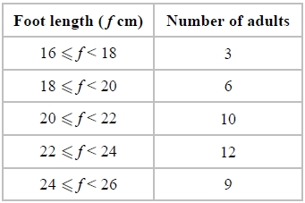
(a) Write down the modal class interval.
...........................................................
(1)
(b) Calculate an estimate for the mean foot length.
........................................................... cm
(3)
(Total for question = 4 marks)

Q10.
The grouped frequency table gives information about the heights of 30 students.
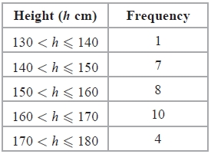
(a) Write down the modal class interval.
...........................................................
(1)
This incorrect frequency polygon has been drawn for the information in the table.
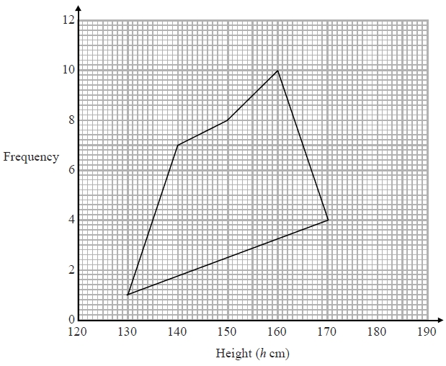
(b) Write down two things wrong with this incorrect frequency polygon.
1
.............................................................................................................................................
2
.............................................................................................................................................
(2)
(Total for question is 3 marks)

Q11.
A car company records the number of miles cars of different engine sizes, in litres, travel using one gallon of fuel.
The scatter graph shows this information.
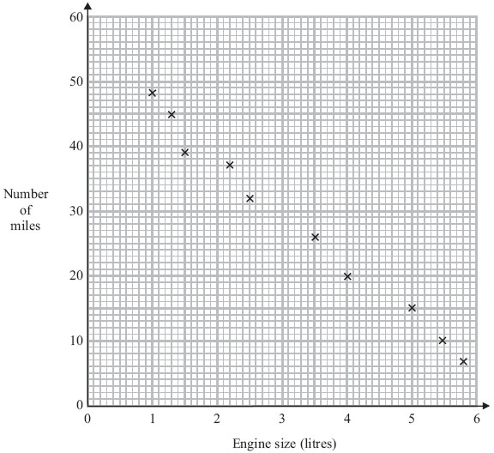
Another car has an engine size of 1.8 litres and travels 42 miles using one gallon of fuel.
(a) Plot this information on the scatter graph.
(1)
(b) What type of correlation does this scatter graph show?
..............................................................................................................................................
(1)
(c) Draw a line of best fit.
(1)
A car has an engine size of 2.8 litres.
(d) Find an estimate for the number of miles this car travels using one gallon of fuel.
..............................................................................................................................................
(1)
(Total for Question is 4 marks)
Q12.
The scatter diagram shows information about 10 students.
For each student, it shows the number of hours spent revising and the mark the student achieved in the Spanish test.
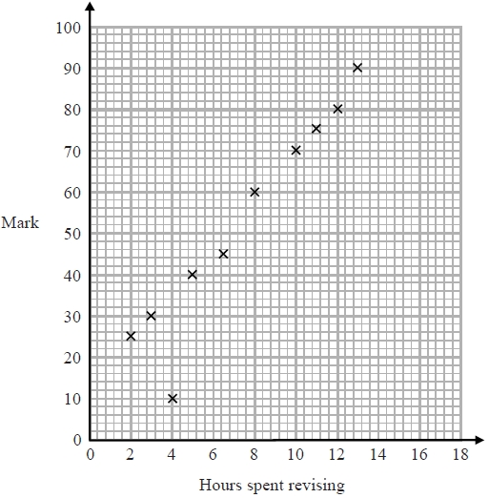
One of the points is an outlier.
(a) Write down the coordinates of the outlier.
...........................................................
(1)
For all the other points
(b) (i) draw the line of best fit,
(ii) describe the correlation.
.............................................................................................................................................
.............................................................................................................................................
(2)
A different student studies for 9 hours.
(c) Estimate the mark gained by this student.
...........................................................
(1)
The Spanish test was marked out of 100
Lucia says,
"I can see from the graph that had I revised for 18 hours I would have got full marks."
(d) Comment on what Lucia says.
.............................................................................................................................................
.............................................................................................................................................
(1)
(Total for question is 5 marks)

Examiner's Report
Q1.
There was a lot of information to be processed in this question. Those candidates who used a suitable two- way table were much more successful than those who tried to reason it out. The most common successful approach was to set up a two way table with rows labelled 'Swim' and 'Not Swim' and with columns labelled 'Year 4' Year 5' and 'Year 6'. Candidates could then work through the given information and put it in the correct cells in the table to produce a table like one in the diagram.
 | Y4 | Y5 | Y6 | Tot
S |  | 21 | 18
NS | 11 |  |  | 37
Tot |  |  | 30 | 96
The table was a huge aid in organising the data, so that the remaining cells could be filled in easily and the correct values picked out. Even so, some candidates managed to put at least one given value (usually the 18) in the wrong cell. A few candidates who did adopt this approach then put the wrong number down on the answer line so losing a mark.

Q2.
This question was attempted by almost all candidates with most scoring full marks and those that did not usually gained M1 for one correct angle. Candidates rarely forgot to label the pie chart and in most cases labelled the angles as well as the require type of cat food. Candidates often did not show their working for the angles which, especially in the cases where candidates did not have a protractor could have earned them M1. Weaker candidates failed to use a ruler which sometimes led to angles outside the tolerance.

Q3.
This question was worth 6 marks so it was somewhat surprising to see that some candidates limited themselves to a brief comment stating that heart rates were higher after people had walked up the stairs. Examiners were able to give this little credit without any supportive evidence. At the other extreme a significant number of candidates worked out the mode, median, mean, range and interquartile range for "before" and "after". Some then made an attempt to interpret their findings whilst others judged that they had completed the question once the calculations were done. What was required, of course, was the calculation and comparison of an appropriate average (i.e. the median or mean) for "before" and "after", the calculation and comparison of an appropriate measure of spread (i.e. the range or interquartile range) and then some interpretation in the context of the question. Most candidates were able to score marks for the calculations, but far fewer were able to deduce that the hearts rates had risen (due to the rise in the average considered ) and that they were more varied after the 15 people had walked up the stairs (due to the rise in the measure of spread considered). Common errors included giving "60" as the median and "81" as the highest heart rate for the people before they walked up the stairs. This seems to have arisen because candidates took the leaf furthest to the right as having the highest value.

Q4.
There were relatively few good answers to this question. The most frequently seen incorrect method was 72 − 67.8 = 4.2 followed by 4.2 + 72 = 76.2. Candidates need to practice mean in a variety of situations rather than just rote learning of calculation of a mean from a total divided by frequency. It is important to know that there are three elements in mean calculations and reversing to find totals is essential. Those who gained partial marks usually found either 3960 or 1695 but then couldn't see how to complete the method, sometimes dividing by 55 instead of by 30.

Q5.
Part (a) was well answered, the most common error being in stating 4 or 21 as the answer, rather than the class interval.
Part (b) was a good discriminator with many getting the correct answer. Some used the lower or upper end of the class interval. Weaker candidates used the class interval width, 50÷5 (=10) or 90÷5 (=18). It was disappointing to see addition or multiplication errors in some work.
In part (c) many good attempts were spoiled by careless error. This could be a failure to use the scale to plot the points correctly, failure to plot at the midpoint, drawing free hand or curves, or joining first to last point. Some only drew the bar chart hey were perhaps hoping to use to draw the polygon.

Q6.
Both parts were answered well. There were only a few in part (a) who gave incomplete references to correlation rather than a description of a relationship.
A mark was sometimes lost in part (b) where poor lines of best fit were drawn, or the scaling was misused.

Q7.
No Examiner's Report available for this question

Q8.
No Examiner's Report available for this question

Q9.
No Examiner's Report available for this question

Q10.
No Examiner's Report available for this question

Q11.
Candidates were able to plot the point successfully, as you would expect on this paper. They were also able to name the type of correlation, some giving strength as well, this was not necessary but was accepted. Only a few candidates gave positive as an incorrect answer. The line of best fit was well drawn by the majority, it most commonly started at the upper limit on the left at (1,48) which was just in tolerance. The most common incorrect answers appeared where the line was drawn just above this point. The reading from the graph was usually accurately given.

Q12.
No Examiner's Report available for this question

Mark Scheme
Q1.
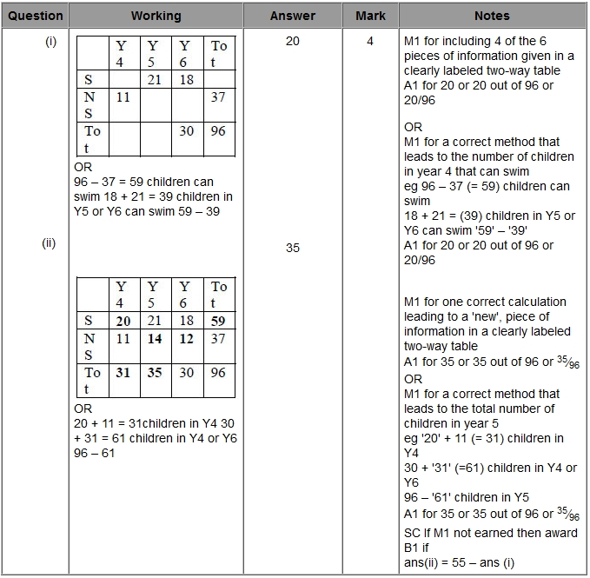

Q2.
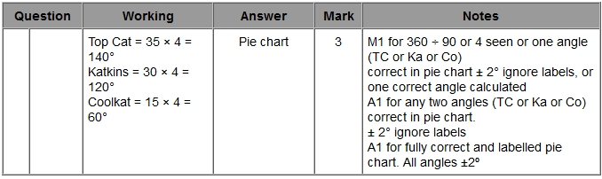

Q3.
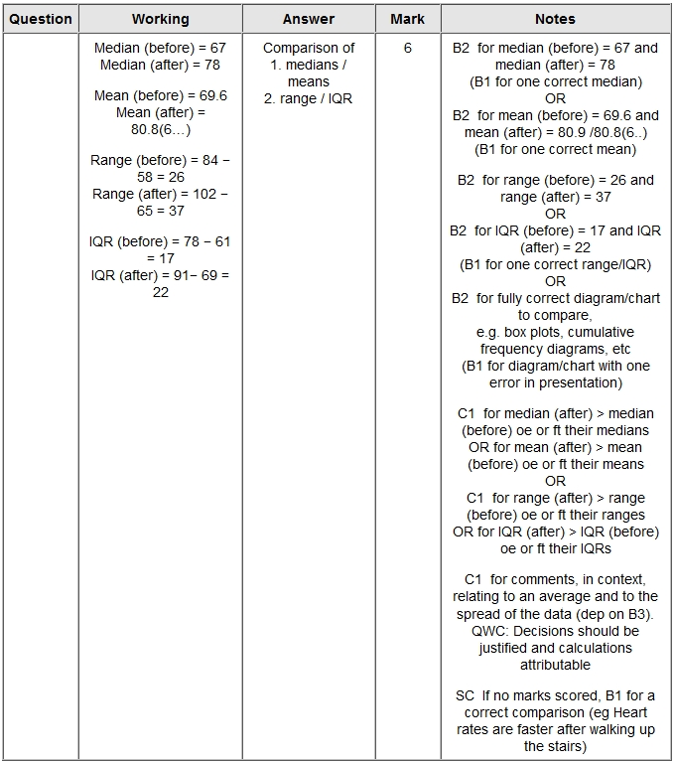

Q4.
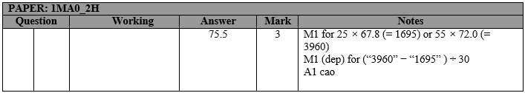

Q5.
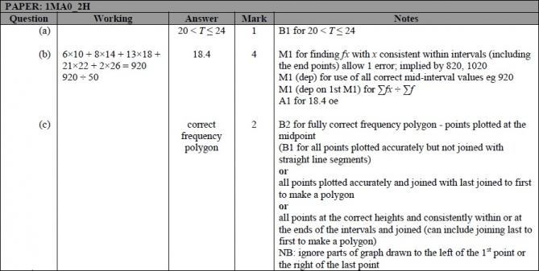

Q6.
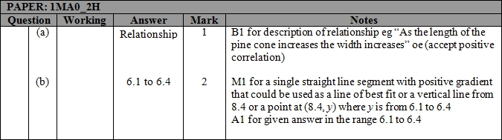

Q7.
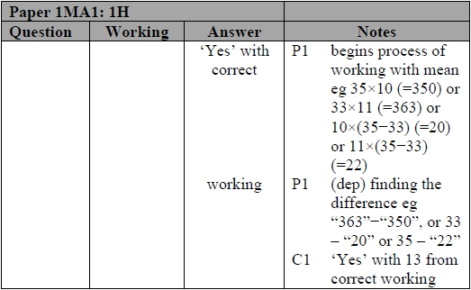

Q8.
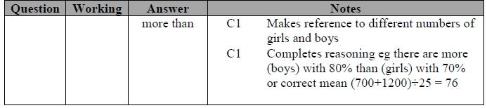

Q9.
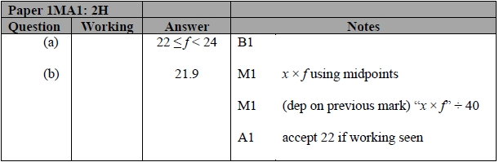

Q10.
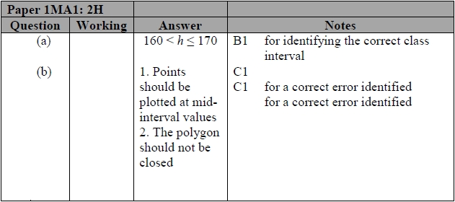

Q11.
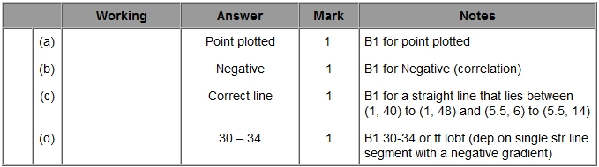

Q12.
