Writing and Simplifying Expressions, Index Laws, Expanding Brackets, Factorising and Substitution

Total marks available = 46

Total marks achieved = ____

Questions
Q1.
(a) Simplify 5a − 2a
...........................................................
(1)
(b) Simplify 3 × 4y
...........................................................
(1)
(c) Simplify 3e + 4f + 2e − f
...........................................................
(2)
(Total for Question is 4 marks)

Q2.
(a) L = 3a + 2c
a = 5
c = 8
Work out the value of L.
L = ...........................................................
(2)
(b) Kirsty buys some buns.
She buys x packs of currant buns and y boxes of iced buns.
There are 6 currant buns in a pack of currant buns.
There are 8 iced buns in a box of iced buns.
Write down an expression, in terms of x and y, for the total number of buns Kirsty buys.
...........................................................
(2)
(Total for Question is 4 marks)
Q3.
(a) Expand 2m(m + 3)
...........................................................
(1)
(b) Factorise fully 3xy² − 6xy
...........................................................
(2)
(Total for Question is 3 marks)

Q4.
(a) Expand and simplify 5(x + 7) + 3(x – 2)

..............................................................................................................................................
(2)
(b) Factorise completely 3a²b + 6ab²

..............................................................................................................................................
(2)
(Total for Question is 4 marks)

Q5.
(a) Simplify 8x − 3x + 2x
...........................................................
(1)
(b) Simplify 4y × 2y
...........................................................
(1)
(Total for question = 2 marks)

Q6.
(a) Simplify 5f − f + 2f
...........................................................
(1)
(b) Simplify 2 × m × n × 8
...........................................................
(1)
(c) Simplify t² + t²
...........................................................
(1)
(Total for question is 3 marks)

Q7.
(a) Expand 3(x + 4)

..............................................................................................................................................
(1)
(b) Expand x(x² + 2)

..............................................................................................................................................
(2)
(c) Factorise x² − 6x

..............................................................................................................................................
(1)
(Total for Question is 4 marks)

Q8.
* Angela and Michelle both work as waitresses at the same restaurant.
This formula is used to work out the total amount of money each waitress gets.
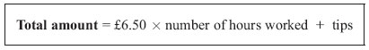
The table shows the number of hours Angela and Michelle each worked last Saturday.
It also shows the tips they got.
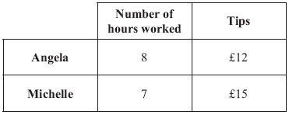
Who got the higher total amount of money last Saturday?
You must show clearly how you got your answer.

(Total for Question is 4 marks)

Q9.
f = 5x + 2y
x = 3 and y = −2
Find the value of f.
...........................................................
(Total for question = 2 marks)

Q10.
(a) Expand and simplify 3(y – 2) + 5(2y + 1)
...........................................................
(2)
(b) Simplify 5u²w⁴ × 7uw³
...........................................................
(2)
(Total for question = 4 marks)

Q11.
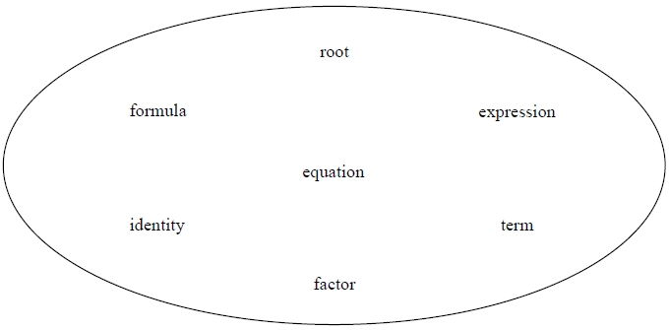
Choose a word from those above that makes this statement correct.
(a) x² is a ............................................... in x² + 4y
(1)
Choose a word from those above that makes this statement correct.
(b) (y + 2) is a ............................................... of 3y + 6
(1)

(Total for question = 2 marks)

Q12.
(a) Factorise y² + 27y
...........................................................
(1)
(b) Simplify (t³)²
...........................................................
(1)
(c) Simplify
...........................................................
(1)
(Total for question = 3 marks)

Q13.
You can use this rule to work out the total cost, in pounds, of hiring a carpet cleaner.
Andy hires a carpet cleaner.
The total cost is £82.20
(a) Work out the number of days Andy hires the carpet cleaner for.
........................................................... days
(2)
Chloe hires a carpet cleaner for y days.
The total cost is £T.
(b) Write down a formula for T in terms of y.
...........................................................
(2)
(Total for question = 4 marks)

Q14.
Dimitar has 20 sweets.
Pip also has 20 sweets.
Dimitar gives Pip x sweets.
Dimitar then eats 5 of his sweets.
Pip then eats half of her sweets.
Write expressions for the number of sweets Dimitar and Pip now have.
Dimitar ........................................................... Pip ...........................................................
(Total for question = 3 marks)

Examiner's Report
Q1.
Students attempted parts (a) and (b) very well, most gained both marks and it was rare to see blank responses. In part (a) incorrect responses were usually due to carelessness e.g. 3, 4a, a, 7a and likewise in part (b) e.g. 12, 7y
(Part (c) was also well attempted by students with very few blank responses seen but students were less successful on this part of the question though more students than not gained both marks. The most common error was to incorrectly merge 5e + 3f to 8ef. Other common errors included e or 5f or missing the add sign and simply writing 5e 3f.

Q2.
Part (a) was generally answered well. Some students showed no understanding of substitution to get 35 + 28 = 63. There were a number of students making very careless errors in the addition when they correctly found 15 and 16 or made errors in the product of 3 and 5 or 2 and 8.
The most common error seen in part (b) was to write x = 6 and y = 8 rather than write a correct expression. It was disappointing to see how many students got the correct answer and then tried to 'simplify' their answer by following this with 14xy. This either lost them a mark when it was preceded by 6x + 8y (or 6x or 8y) or scored no marks at all.

Q3.
In part (a), there was only one mark for this question and so both terms were required. This happened sometimes but often 2m² was correct and 6m was incorrectly given as 6 or 3m or 5m. Occasionally 2m²+6m=8m or 8m² or 8m³ was seen, there is no 'ISW' on algebra questions and so these answers did not score the mark.
Part (b) was not well answered. It appeared to be beyond most candidates. Occasionally 3xy was identified as a factor but the other factor was rarely seen.

Q4.
Two thirds of candidates had no success with this question and the marks that were awarded were generally given in part (a). Here, common mistakes included multiplying out just the first term in the bracket, failing to simplify, or failing to deal correctly with the 2. Some candidates attempted a grid method as if multiplying out a pair of linear expressions. Correct factorisation in part (b) was very rare indeed. When an attempt was made, candidates often worked with factors but gave a final answer involving 2 pairs of brackets. Partial factorisation using only an integer also seen but often not fully correct and when a common factor was identified, there was often an error with the terms inside the bracket.

Q5.
No Examiner's Report available for this question

Q6.
No Examiner's Report available for this question

Q7.
No parts of this question were answered well. Algebra is still an area of uncertainty for this level of candidate. In part (a), answers of 3x + 4 and 7x were the usual errors seen. In part (b), x² + 2x and 2x² + 2x were the best of the incorrect answers of candidates showing some algebraic manipulative ability. Some achieved the correct expansion but then incorrectly tried to simplify their answer, losing the mark. In part (c), x² − 6, x(x − 3) and x(x − 6x) were the best of the 'near misses'.

Q8.
Most candidates were able to work out the total amount of money that Angela and Michelle got and state clearly which of these got the greater amount.
Some candidates simply stated the totals without showing how these were obtained. Candidates should be reminded to show all stages of their work and to write their conclusions in words, not just circle their choice.
A common error seen was for candidates to show the correct working for Michelle as 6.5×7 + 15 but then write the answer to this as 60.05
The majority of candidates gave their answers with the £ sign included.

Q9.
No Examiner's Report available for this question

Q10.
No Examiner's Report available for this question

Q11.
No Examiner's Report available for this question

Q12.
No Examiner's Report available for this question

Q13.
No Examiner's Report available for this question

Q14.
No Examiner's Report available for this question
Mark Scheme
Q1.
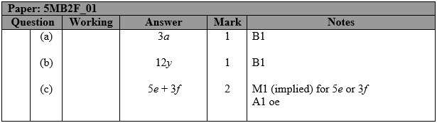

Q2.
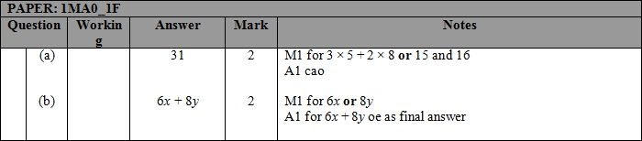

Q3.
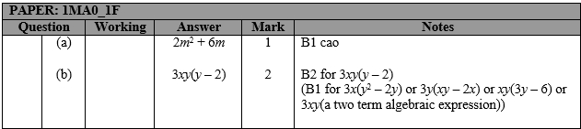

Q4.
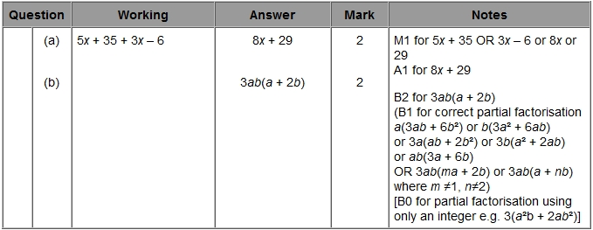

Q5.
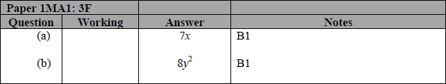

Q6.
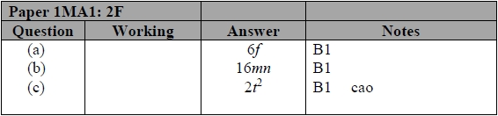

Q7.
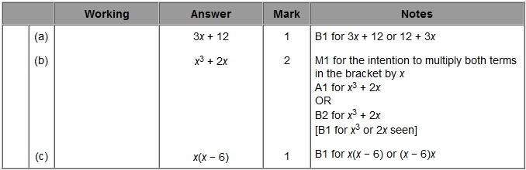

Q8.
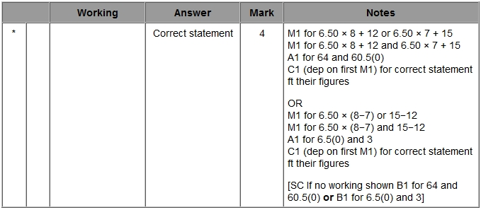

Q9.
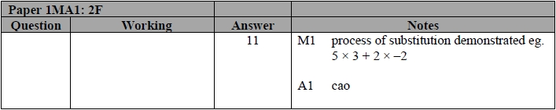

Q10.
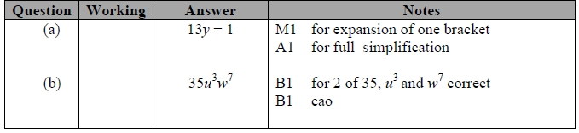

Q11.
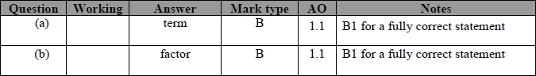

Q12.
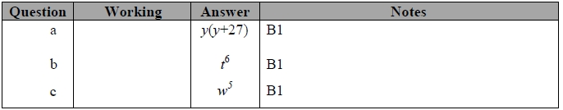

Q13.
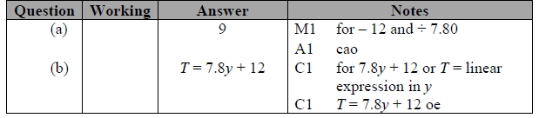

Q14.
