Fractions, Decimals
and
Percentages

Total marks available = 38

Total marks achieved = ____

Questions
Q1.
(a) Write ¼ as a decimal.

. . . . . . . . . . . . . . . . . . . . . .
(1)
(b) Write the fraction ¹⁸⁄₂₄ in its simplest form.

. . . . . . . . . . . . . . . . . . . . . .
(1)
(c) Shade ³⁄₅ of this shape.

(1)

(Total for Question is 3 marks)

Q2.
(a) Work out 16 − 6 × 2
(1)
(b) Write 0.7 as a percentage.
(1)
(c) Write as a decimal.
(1)
(d) Find 15% of 120
(2)

(Total for question = 5 marks)

Q3.
(a) Write ⁷⁄₁₀ as a decimal.
...........................................................
(1)
(b) Write 0.45 as a percentage.
........................................................... %
(1)
(c) Write 30% as a fraction.
Give your fraction in its simplest form.
...........................................................
(2)
(d) Write the number 2.738 correct to 2 decimal places.
...........................................................
(1)
(Total for Question is 5 marks)

Q4.
Work out ³⁄₅ − ¹⁄₃
...........................................................
(Total for Question is 2 marks)

Q5.
∗ Here are two fractions.
²⁄₃ ⁷⁄₈
Which of these fractions has a value closer to ³⁄₄?
You must show clearly how you get your answer.

(Total for Question is 3 marks)

Q6.
Write as a decimal.

...........................................................
(Total for question = 1 mark)

Q7.
Here are four numbers.
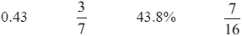
Write these numbers in order of size.
Start with the smallest number.
...........................................................
(Total for question = 2 marks)
Q8.
(a) Write ½ as a decimal.

..............................................................................................................................................
(1)
(b) Write 0.75 as a fraction.

..............................................................................................................................................
(1)
(c) Write 19 out of 30 as a fraction.

..............................................................................................................................................
(1)
(Total for Question is 3 marks)

Q9.
Work out 65% of 300
...........................................................
(Total for question = 2 marks)

Q10.
Callum wins £300 in a raffle.
He gives 5% of the £300 to charity.
He saves of the £300
He uses the rest of the money to buy clothes.
Work out how much of the money Callum uses to buy clothes.
£...........................................................
(Total for question = 3 marks)
Q11.
Greg sells car insurance and home insurance.
The table shows the cost of these insurances.
Insurance | car insurance | home insurance
Cost | £200 | £350
Each month Greg earns
£530 basic pay
5% of the cost of all the car insurance he sells
and 10% of the cost of all the home insurance he sells
In May Greg sold
6 car insurances
and 4 home insurances
Work out the total amount of money Greg earned in May.

..............................................................................................................................................
(Total for Question is 5 marks)

Q12.
* Zara is the manager of a shop.
The table gives information about the expenses the shop had last year.
Expense | Wages | Rent | Goods | Other expenses
Amount | £92 000 | £10 800 | £72 000 | £7000
This year
the wages will increase by 7.5%,
the rent will be ⁷⁄₉ of the rent last year,
the other expenses will halve.
Zara wants to increase the amount of money she spends on goods.
She also wants the total expenses the shop has this year to be the same as last year.
Can Zara increase the amount of money she spends on goods?

(Total for Question is 4 marks)

Examiner's Report
Q1.
Part (a) was well answered, but in part (b) the common error was to partially cancel perhaps leaving the answer as ⁹⁄₁₂. In part (c) too many answers consisted of a random number of squares shaded, not always totalling 9. Shading 3 then 5 was common, or just 3, indicating little understanding of the fraction.

Q2.
No Examiner's Report available for this question

Q3.
Parts (a) and (b) were done very well by nearly all students with just occasional place value errors leading to 0.07 or 7 instead of 0.7 and 4.5% rather than 45%. There were occasional instances of 7.10 which would appear to indicate a misunderstanding of the relationship between fractions and decimal notation.
A high proportion of students were able to gain the first mark in (c) for writing 30% as or another equivalent fraction, often . They then either stopped a simplification process or made subsequent errors. Full marks were awarded for the student's final answer so a few lost the second mark by an incorrect simplification after had been reached, often giving
A few students chose to write their answer as a decimal and others thought that 30% is equivalent to
Part (d) proved the most challenging part of this question for weaker students. Rounding errors were apparent with 2.73 and 2.80 the most common incorrect answers. There were also various answers offered with errors involving the re-positioning of the decimal point such as 27.38 or 273.8

Q4.
Candidates appear to find arithmetic with fractions difficult, all too often ²⁄₂ or ²⁄₂=1 were given as the final answer. Even when candidates were able to give 15 as the lowest common multiple of 5 and 3 they could not go on to find the correctly associated numerators.
Some candidates used the grid method to find the answer, this worked for some candidates but others could fill in the boxes and then did not provide a final answer.

Q5.
This question differentiated very well as most candidates could make a start by writing two equivalent fractions but only the best could give the correct conclusion from three correct equivalent fractions, decimals or percentages. Some candidates tried to use a diagram but didn't realise that their diagrams were not comparable because they hadn't split them into the same number of sections. It was disappointing to see so many candidates rounding prematurely thinking that ²⁄₃ is equivalent to 0.6 so losing marks.

Q6.
No Examiner's Report available for this question

Q7.
No Examiner's Report available for this question

Q8.
Fractions often cause problems on a foundation paper but it was pleasing to see some good responses to this question. Many candidates wrote 1.2 instead of 0.5 as the decimal equivalent of ¹⁄₂ whilst ⁵⁄₇ or ⁷⁄₅ was often seen instead of ³⁄₄ or ⁷⁵⁄₁₀₀ or equivalent when the fractional equivalent of 0.75 was asked for. Interestingly about 4 out of 5 candidates could write 19 out of 30 as a fraction.

Q9.
This question was generally answered well. The most common approach was to start by finding 10% of 300.

Q10.
The majority of students were successful. Those who could not work out both 5% of 300 and of 300 were few in number. Some students, having found 5% of £300 and subtracted it from £300, worked out of the money left instead of of £300.

Q11.
This was a multi-stage problem but using relatively easy mathematics. Very few candidates did formal percentage calculations, with most stating '10% is...'.
Candidates who were able to follow the question through were often successful.
Most candidates used the method of 6 × 200 and 4 × 350 first and then worked out the percentages and a number got to £200 and did not add this to £530.
Occasionally candidates worked out 10% and 5% of £530. Others mixed up the calculations for the car and home insurance. Too many added 1200 and 1400, and gave an answer of £2600.

Q12.
Many candidates were able to find 7.5% of £92 000, but several used a breakdown method of finding 10%, 5% and then 2 ½ %, and often made errors in the process. This led to the loss of the first method mark. When finding ⁷⁄₉ of 10 800, several candidates tried to convert to a decimal but truncated their answer to 0.7, so using an incorrect method and losing both the second and third method mark.
There were a number of candidates who assumed that goods should be halved as well, because they treated them as an expense. These candidates were still able to score the method marks and often did so.
There were a few candidates who included the difference in rent rather than the rent itself when reaching their overall total.
A minority of candidates compared the increase in wages to the net savings in the other items when making their decision. These were often successful.
The final mark was only awarded where correct values were calculated to support the decision made. Overall around a quarter of candidates scored three or four marks, and around a third failed to score.

Mark Scheme
Q1.
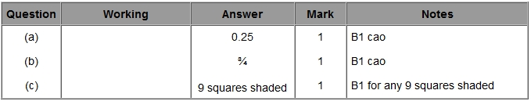

Q2.
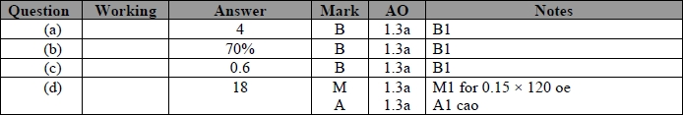

Q3.
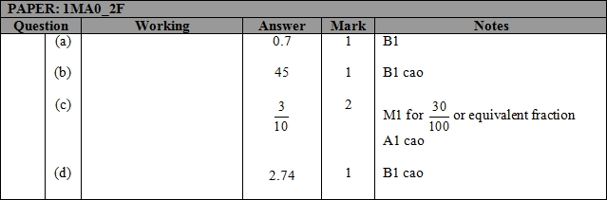

Q4.
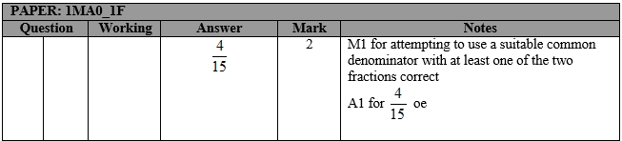

Q5.
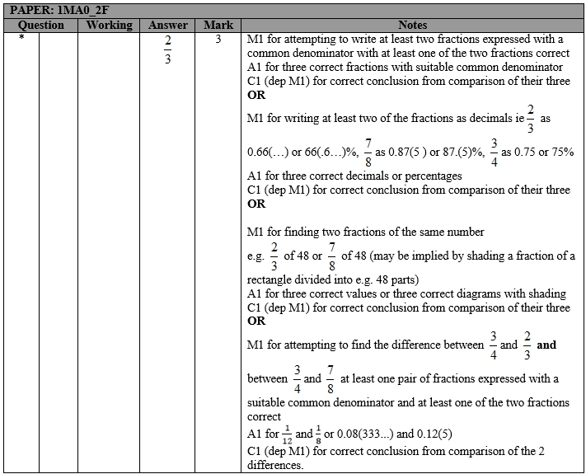

Q6.
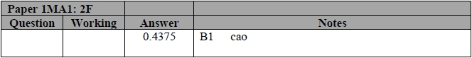

Q7.
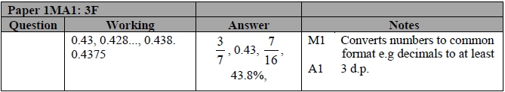

Q8.
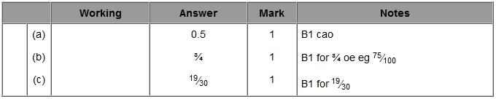

Q9.
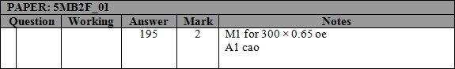

Q10.
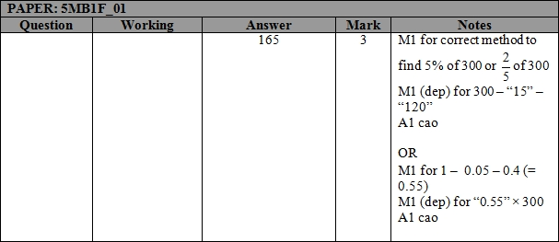

Q11.
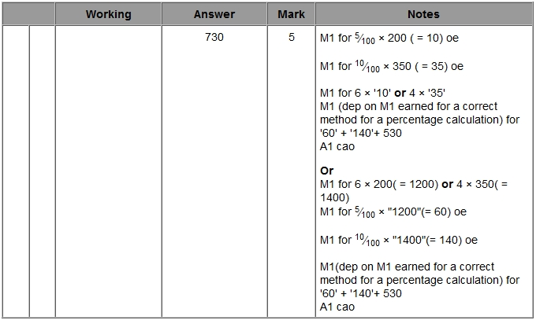

Q12.
