Polygons, Angles
and Parallel Lines

Total marks available = 49

Total marks achieved = ____

Questions
Q1.
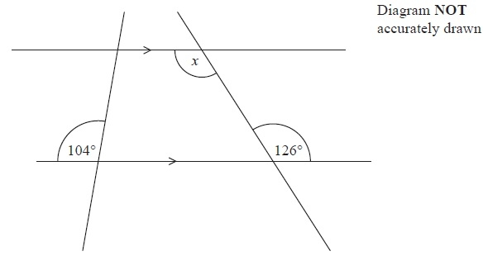
(i) Find the size of the angle marked x.
........................................................... °
(ii) Give a reason for your answer.
.............................................................................................................................................
(Total for Question is 2 marks)

Q2.
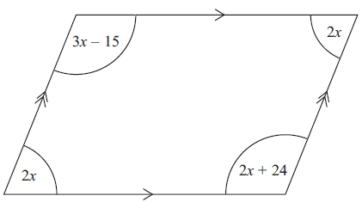 Diagram NOT accurately drawn
The diagram shows a parallelogram.
The sizes of the angles, in degrees, are
2x
3x – 15
2x
2x + 24
Work out the value of x.

x = . . . . . . . . . . . . . . . . . . . . . .
(Total for Question is 3 marks)

Q3.
ABCDEF is a regular hexagon.
AJFGH is a regular pentagon.
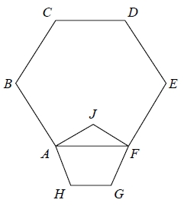
Work out the size of angle BAJ.

(Total for question = 4 marks)

Q4.
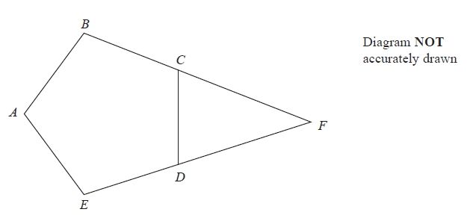
ABCDE is a regular pentagon.
BCF and EDF are straight lines.
Work out the size of angle CFD.
You must show how you got your answer.
...........................................................°
(Total for Question is 3 marks)

Q5.
*
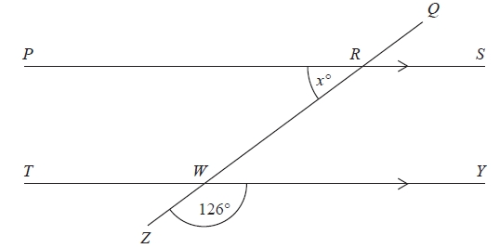
Diagram NOT accurately drawn
PRS and TWY are parallel straight lines.
QRWZ is a straight line.
Work out the value of x.
Give reasons for your answer.
(Total for Question is 3 marks)

Q6.
*
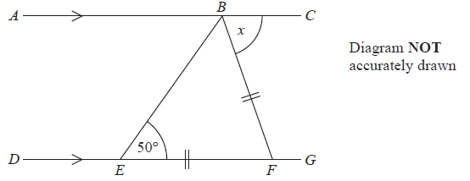
ABC is a straight line.
DEFG is a straight line.
AC is parallel to DG.
EF = BF.
Angle BEF = 50°.
Work out the size of the angle marked x.
Give reasons for your answer.
...........................................................°
(Total for Question is 4 marks)

Q7.
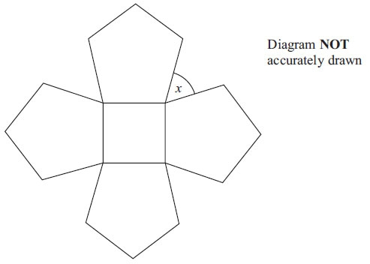
The diagram shows a square and 4 regular pentagons.
Work out the size of the angle marked x.

..............................................................................................................................................
(Total for Question is 3 marks)

Q8.
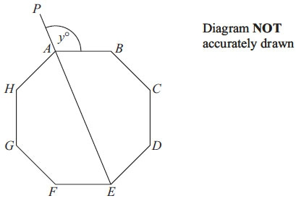
ABCDEFGH is a regular octagon.
PAE is a straight line.
Angle PAB = y°
Work out the value of y

y = . . . . . . . . . . . . . . . . . .
(Total for Question is 4 marks)

Q9.
The diagram shows a pattern using four identical rhombuses.
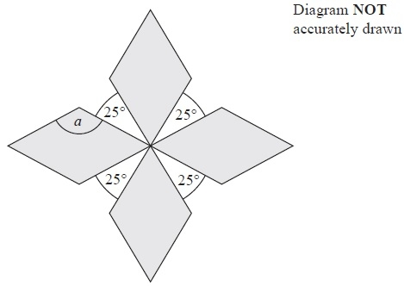
Work out the size of the angle marked a.
You must show your working.
........................................................... °
(Total for Question is 4 marks)

Q10.
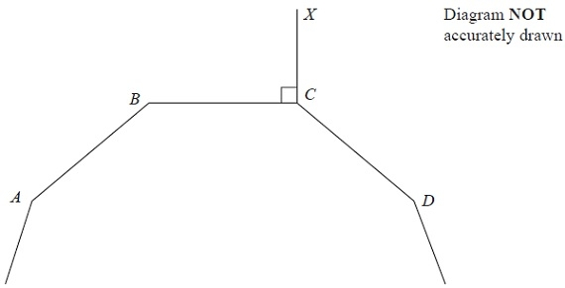
A, B, C and D are four vertices of a regular 10-sided polygon.
Angle BCX = 90°.
Work out the size of angle DCX.
........................................................... °
(Total for Question is 3 marks)

Q11.
The diagram shows 3 sides of a regular polygon.
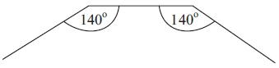 Diagram NOT accurately drawn
Each interior angle of the regular polygon is 140°.
Work out the number of sides of the regular polygon.

..............................................................................................................................................
(Total for Question is 3 marks)

Q12.
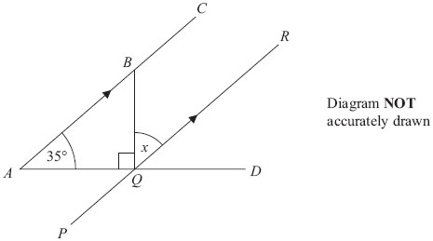
ABC, PQR and AQD are straight lines.
ABC is parallel to PQR.
Angle BAQ = 35°
Angle BQA = 90°
Work out the size of the angle marked x.
Give reasons for each stage of your working.

x = . . . . . . . . . . . . . . . . . . . . . . °
(Total for Question is 4 marks)

Q13.
Here is a parallelogram.
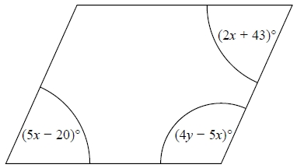
Work out the value of x and the value of y.
x = ...........................................................
y = ...........................................................
(Total for question = 5 marks)

Q14.
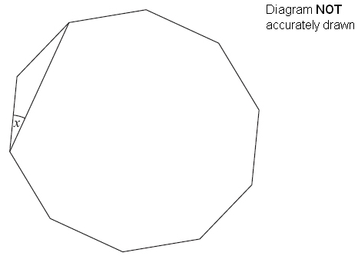
The diagram shows a regular decagon.
Work out the size of angle x.

..............................................................................................................................................
(Total for Question is 4 marks)

Examiner's Report
Q1.
Generally this question was done well. In part (i), most candidates were able to find the size of the required angle either directly or by initially finding some or all of the other angles in the diagram. A common incorrect answer here was 104. In part (ii), a significant number of candidates were unable to give a correct reason using the properties of parallel lines. A common incorrect answer was "opposite angle are equal".

Q2.
There were a number of possible equations that could be formed from the diagram. Generally speaking those who managed to form a correct equation went on to score at least two marks. Some candidates experienced difficulty in carrying out the final division, usually 351 ÷ 9. As the answer was an integer value it was necessary to give the final answer as 39 rather than a top-heavy fraction. The most popular method of solution was to find an expression for the sum of the angles and then equate this to 360. A large number of candidates did find the correct sum of the angles but then either equated this to zero or 180 or tried to solve 9x = 9, none of these approaches enabled any marks to be awarded. A minority of candidates realised that a more efficient method of solution was to equate the opposite angles or sum the co-interior angles to 180. There was very little evidence of the checking of final solutions which may have helped come candidates to reconsider their answer.

Q3.
No Examiner's Report available for this question

Q4.
Candidates attempts generally fell into three groups.
(a) Those who worked out 360 ÷ 5 or 540 ÷ 5 and were able to identify that they were finding the exterior angle or interior angle respectively. They generally went on to score all 3 marks.
(b) Those who worked out 360 ÷ 5 or 540 ÷ 5 but were confused over which angle they had worked out – they generally scored 0 marks as the mark scheme was such that if it was clear they had confused interior and exterior, then they got 0 marks.
(c) Those who had little idea – too commonly thinking that the interior angles were 60° for example. They invariably scored 0 marks.
Once again, some candidates lost marks because of numerical weaknesses. In this question this was often an error of the form 360 ÷ 5 = 62, for example. It was pleasing to see some candidates giving reasons at each stage of their calculation.

Q5.
Most candidates were able to achieve 2 marks for correctly calculating the angle as 54 degrees. However, many candidates were not awarded the mark for correct reasons for their chosen method. Frequently only one reason was offered, or the vocabulary used was ambiguous or not sufficiently rigorous for geometrical reasoning. It was not uncommon to see confusion between alternate and corresponding angles.

Q6.
This was well answered by many students with many working out that the angle marked x was 80°. However not many students scored the communication mark for providing all 3 reasons that included all the relevant words underlined in the mark scheme. The most common error was to either make angles EBC and EFG each 65° or to write that angle EFB was 50°. These students could only score a maximum of 1 mark for indicating that angle ABE was 50° either by writing a statement or putting 50° in the correct place on the diagram. A few students extended EB or BF and used the rule that corresponding angles are equal. This was also acceptable.

Q7.
Although few candidates gave a fully correct answer to this question, there was much misunderstanding of the relevance of dividing 360° by 5. A small number of candidates found 108° as the interior angle in a regular pentagon but could make no further progress and those who understood the question but showed inaccurate calculations scored 2 marks.
It was also clear that many candidates did not use the diagram, as they did not appreciate that the interior angle of a regular pentagon was obtuse and could not be 72°.

Q8.
The most common approach was 360 ÷ 8 = 45 and 180 – 45 = 135. Candidates felt it useful to write their angles on the diagram, aiding them to work through to a solution. It was clear candidates knew how to calculate interior and exterior angles but many were confused as to which angles they were calculating, leading some to write interior angles as exterior on the diagram, or vice versa, even when this meant them showing obtuse angles in the space for an acute angle. A common arithmetic error was 360 ÷ 8 = 40.

Q9.
Most found an acute angle of a rhombus by considering the angles around the point at the centre of the diagram. Some went no further but gained 2 marks credit to this point, having stated this angle as 65°. A few spoiled their working by using 180° as the sum of the angles of a quadrilateral. Some worked out 360/9 but in many cases the labelling and their explanations suggested that they thought that they were finding an exterior angle of a quadrilateral. It is particularly important for candidates to realise that the instruction "you must show your working" must be adhered to in order to gain full marks.

Q10.
This question was done quite well but it was evident that many candidates could not distinguish between the calculation needed for the interior angle and the calculation needed for the exterior angle. A very common incorrect answer here was 234. Usually obtained by calculating 360 ÷ 10 (= 36), marking the interior angle on the diagram as 36 and then calculating angle DCX as 360 − 90 − 36 (= 234).

Q11.
Where candidates calculated the correct exterior angle, the correct answer usually followed although 360 ÷ 40 = 8 was quite common. Some candidates added that the shape was a nonagon. Many candidates chose the less efficient and more error prone strategy of listing multiples of 140 to compare with a list of the multiples of 180. Some did not appreciate that only part of a regular polygon was shown and instead drew horizontal and/or vertical lines to close the shape and form a trapezium or hexagon.

Q12.
Nearly all candidates worked within the right angled triangle to find angle ABQ, and most then went on to give angle x as 55°
The mark for giving an appropriate reason within the context of the question was not always earned since a geometrical reference had to be precise such as "alternative" or "corresponding". Hence merely stating "parallel lines" or "Z angles" was insufficient. It is always useful to show the angles on the diagram as well as in working.

Q13.
No Examiner's Report available for this question

Q14.
Two common approaches were seen in answers to this question. Most candidates calculated the size of each exterior angle as a first step. The best candidates went on to produce concise and clear working leading to a correct answer while weaker candidates could not see how to complete the method or made errors along the way. A second approach started with the calculation of the size of each interior angle. This was not as successful as most of the candidates using this method needed to work out the sum of the interior angles by splitting the decagon into 8 triangles, often making mistakes with the arithmetic on the way.
Many candidates were confused between interior and exterior angles – a surprising number of candidates marked an angle on the diagram with 36° even though it should have been obvious that it was obtuse. Other candidates assumed a decagon had 8 sides despite a diagram being given. The diagram was not always fully utilised and annotation and working were not always clearly presented. Approximately 30% of candidates scored full marks. A further 30% of candidates were awarded 2 or 3 marks.

Mark Scheme
Q1.
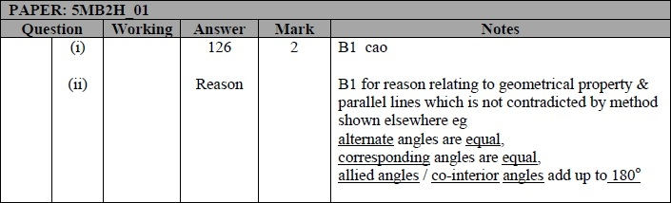

Q2.
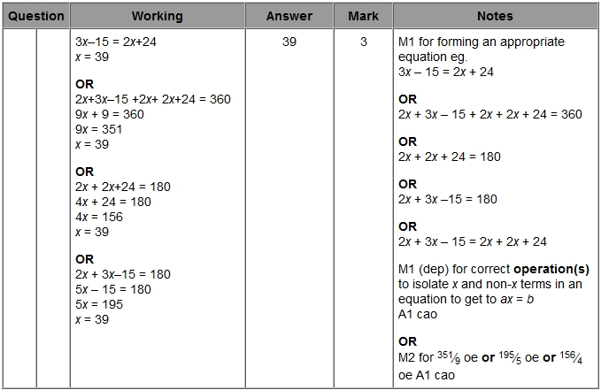

Q3.
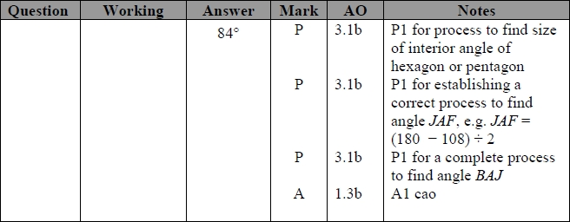

Q4.
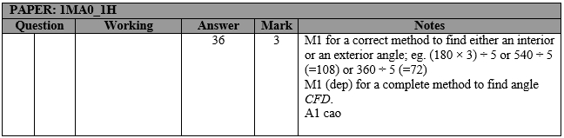

Q5.
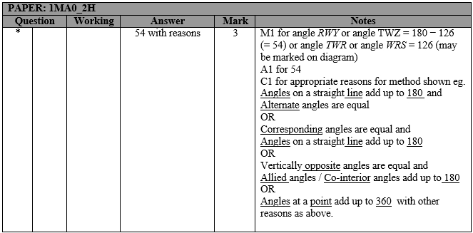

Q6.
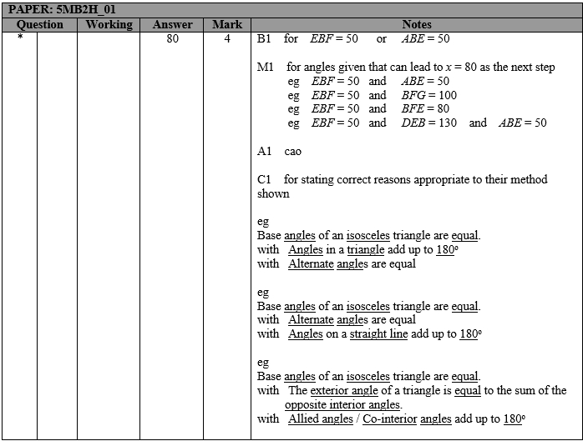

Q7.
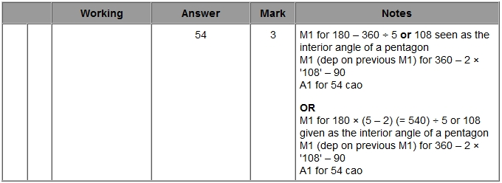

Q8.
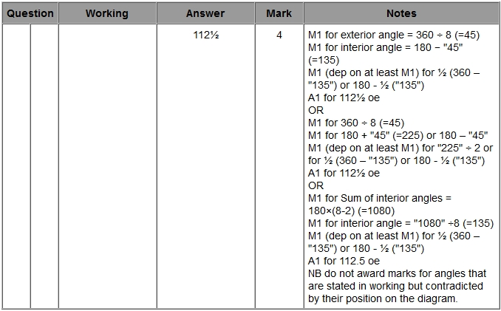

Q9.
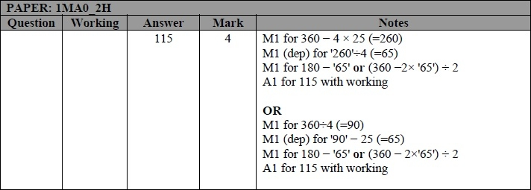

Q10.
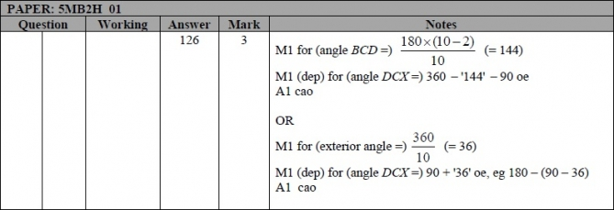

Q11.
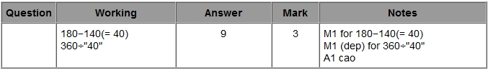

Q12.
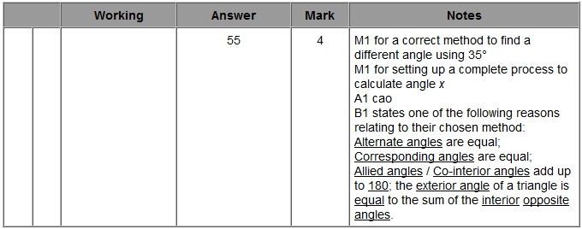

Q13.
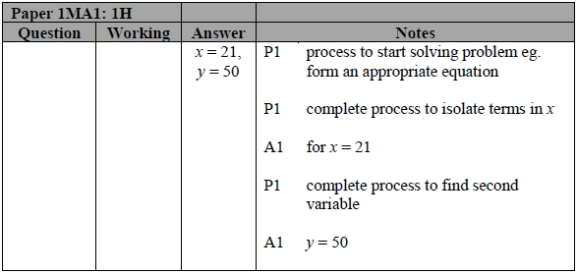

Q14.
