Equations and
Inequalities

Total marks available = 51

Total marks achieved = ____

Questions
Q1.
Katie has x pets.
Agatha has twice as many pets as Katie.
Isabel has 3 more pets than Katie.
Write an expression, in terms of x, for the total number of pets that Katie, Agatha and Isabel have.

..............................................................................................................................................
(Total for Question is 2 marks)

Q2.
ABC is a triangle.
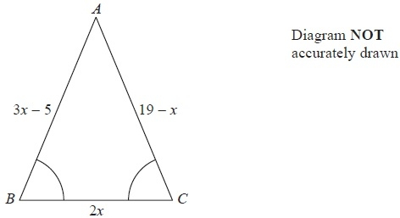
Angle ABC = angle BCA.
The length of side AB is (3x − 5) cm.
The length of side AC is (19 − x) cm.
The length of side BC is 2x cm.
Work out the perimeter of the triangle.
Give your answer as a number of centimetres.
........................................................... cm
(Total for Question is 5 marks)

Q3.
Rob buys p packets of plain crisps and c packets of cheese crisps.
(a) Write down an expression for the total number of packets of crisps Rob buys.
(1)
The formula
F = 1.8C + 32
can be used to convert between temperatures in degrees Celsius (C) and temperatures in degrees Fahrenheit (F).
(b) Change 28° Celsius into degrees Fahrenheit.
(2)
(c) Solve 4x + 2 = 20
(2)
(d) Factorise 3x² − 2x
(1)

(Total for question = 6 marks)

Q4.
(a) Solve a + a = 18

a = . . . . . . . . . . . . . . . . . . . . .
(1)
(b) Solve b – 4 = 8

b = . . . . . . . . . . . . . . . . . . . . .
(1)
(c) Solve 7c = 28

c = . . . . . . . . . . . . . . . . . . . . .
(1)
P = 2x + 3y
x = 5
y = 4
(d) Work out the value of P.

p = . . . . . . . . . . . . . . . . . . . . .
(2)
(Total for Question is 5 marks)

Q5.
(a) Solve 5x = 45
x = ...........................................................
(1)
(b) Solve w − 8 = 20
w = ...........................................................
(1)
(c) Solve = 5
t = ...........................................................
(1)
(d) Solve 4x − 9 = 41
x = ...........................................................
(2)
(Total for Question is 5 marks)

Q6.
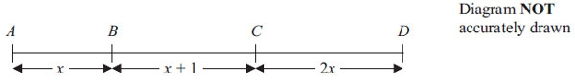
In the diagram,
AB = x cm
BC = (x + 1) cm
CD = 2x cm
AD = 19 cm
(a) Show that 4x + 1 = 19

(2)
(b) Solve 4x + 1 = 19

x = . . . . . . . . . . . . . . . . . . . .
(2)
(c) Work out the length of BD.

BD = . . . . . . . . . . . . . . . . . . . .cm
(2)
(Total for Question is 6 marks)

Q7.
* This formula is used to work out the body mass index, B, for a person of mass M kg and height H metres.
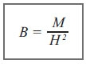
A person with a body mass index between 25 and 30 is overweight.
Arthur has a mass of 96 kg.
He has a height of 2 metres.
Is Arthur overweight? You must show all your working.

(Total for Question is 3 marks)

Q8.
Here is a rule for working out the area of a triangle.
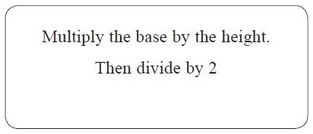
A triangle has a base of 12 cm and a height of 6 cm.
(a) Use the rule to work out the area of the triangle.
........................................................... cm²
(2)
A different triangle has an area of 55 cm².
It has a height of 11 cm.
(b) Work out the base of this triangle.
........................................................... cm
(2)
(Total for Question is 4 marks)

Q9.
(a) n is an integer.
–1 ≤ n < 4
List the possible values of n.

..............................................................................................................................................
(2)
(b)
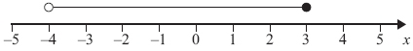
Write down the inequality shown in the diagram.

..............................................................................................................................................
(2)
(c) Solve 3y – 2 > 5

..............................................................................................................................................
(2)
(Total for Question is 6 marks)

Q10.
(a) Solve 3p + 4 = 6
...........................................................
(2)
−5 < y ≤ 0
y is an integer.
(b) Write down all the possible values of y.
...........................................................
(2)
(Total for Question is 4 marks)
Q11.
–2 < n ≤ 3
n is an integer.
(a) Write down all the possible values of n.

..............................................................................................................................................
(2)
3x + 5 > 16
x is an integer.
(b) Find the smallest value of x.

..............................................................................................................................................
(3)
(Total for Question is 5 marks)

Examiner's Report
Q1.
This question was answered surprisingly poorly. Many candidates gave an incorrect answer with no working and got no marks. Those who first wrote down separate expressions for the number of pets Agatha and Isabel each had could often be awarded one mark for a correct expression. Common errors included writing x² rather than 2x for the number of pets Agatha had and either 3x or x³ instead of x + 3 for the number of pets Isabel had. Some candidates wrote the correct expressions but did not add them or forgot to add x for Katie. Many candidates did not appear to appreciate that Isabel had three more pets than Katie or that the question asked for the total number of pets. A very common incorrect answer was 2x + 3. Some candidates wrote ×2 + 3 or tried to substitute numbers to give the total number of pets.

Q2.
Fully correct algebraic solutions were rare and where sometimes attempted with an assumption that the question would involve a perimeter or even angle total equation.
Some candidates set up a correct equation and found x = 6 from incorrect algebra so failed to gain maximum marks. Many candidates used trial and improvement to find x = 6 and proceeded to gain full marks following correct substitution in individual side lengths that were then added

Q3.
No Examiner's Report available for this question

Q4.
The majority of candidates were successful in solving each of the three equations. Common incorrect answers to part (a) were 6 or 18, to part (b) were 4 and occasionally 8, and a very common incorrect answer to part (c) was 21, where candidates subtracted the 7 from 28 to give 21, instead of dividing 28 by 7 to give 4.
Most candidates answered part (d) well to gain full marks. Common incorrect responses included 10 + 12 = 24, replacing x and y to make 25 + 34 and performing 2 + 5 and 3 + 4 instead of multiplying.

Q5.
Candidates were successful in solving the equations in parts (a) and (b) and there was a lot of success in solving part (c). However part (d) proved far more challenging with (41 − 9) ÷ 4 = 8 being a common incorrect answer.

Q6.
In part (a), quite a few candidates gained the method mark for writing a correct expression but then failed to complete their proof.
Candidates were most successful in part (b) with many correctly solving the equation. These candidates often showed their working to part (b) in part (a), thinking that was what was required in the proof. Several candidates used trial and improvement to solve the equation rather than an algebraic method and lost the method mark if their answer was incorrect. Some candidates gained the method mark from a flow chart. A few candidates added 1 to 19 rather than subtracting 1 from 19.
A smaller number of candidates were successful in part (c). Many failed to realise that they needed to use their answer from part (b). Those that had an incorrect value in part (b) could still gain full marks in part (c) on follow through.
Overall just under half of the candidates scored four or more marks on the three parts with around a quarter failing to score.

Q7.
This question tested whether candidates could substitute correctly into a formula with squares in it and it turned out that many could not as 48 was a common wrong answer. Candidates that did give 48 as their answer were awarded 1 mark if they gave the correct conclusion. 12% did manage to write down the substitution correctly and a further 7% gave the correct answer of 24 but only 29% of candidates managed the fully correct solution with the correct conclusion.

Q8.
Arithmetic errors for both 6 × 12 and 72 ÷ 2 caused most errors in part (a) where candidates appeared confident using a familiar formula.
Use of the inverse formula caused more difficulties in part (b) with failure to multiply by 2 leading to many answers of 5. Some did not present their final answer but left it embedded in the formula in the working.
In both parts there was evidence that the need for a 2 stage process was beyond the weaker candidates who stopped working after attempting just one calulation.

Q9.
Over half of the candidates scored at least one mark for their responses to parts (a) and (b) of this question which tested an understanding of the notation and diagrams used to illustrate inequalities. About 1 in 20 candidates scored all four marks.
In part (a) most candidates did not interpret the "≤" and "<" signs correctly and either did not include "-1" in their list of integers and/ or did include "4".
There were few totally correct answers to part (b) of the question. It was common to see "-4 ≤ 3" or "-4 < 3". These answers could not be awarded any marks. Of those candidates who could be awarded partial credit, many gave an answer in the form ""-4 ≤ x < 3" showing an incorrect understanding of the notation using empty and full circles. Many candidates gave the range of the two endpoints, "7", as their answer.
In part (c) of this question, candidates rarely tackled the inequality with confidence. Of those candidates who did show some correct working, many either spoilt their answer by rounding ⁷⁄₃ to 2.3 or treated the question as one with an equation rather than an inequality. These candidates could not, of course, be awarded full marks but often could be awarded 1 mark.

Q10.
The equation solving in this question certainly gave most candidates a problem as they did not know how to deal with the fractional answer less than 1. Few candidates gave the answer correctly as ²⁄₃ preferring to give it incorrectly as 1.5. Candidates were also poor at showing the steps algebraically, often showing just the arithmetic required and that scored no marks unless a fully correct answer was given though a few scored a mark for showing 3p = 2. Part (b) was better answered with many candidates gaining one mark as they either omitted the zero or included the −5 in the inequality.

Q11.
In part (a), most candidates gained at least one mark giving at least 4 of the correct integers. There were some errors interpreting the difference between the inequality symbols with confusion as to whether -2 and 3 should be included. Some candidates appeared to have misunderstood the question and gave a final answer of 5 to indicate how many integers met the inequality. Candidate's answers for part (b) included both formal algebraic solutions and trial and improvement methods. Trial and improvement often yielded the correct integer answer from straightforward inspection whereas, many candidates who reached ¹¹⁄₃ did not go on to give 4 as their final answer and so lost the final mark.

Mark Scheme
Q1.
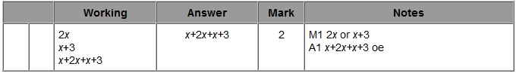

Q2.
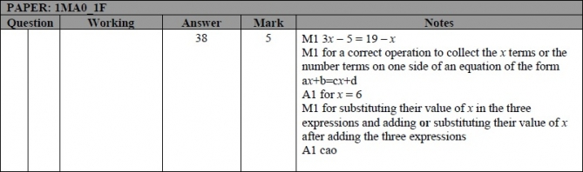

Q3.
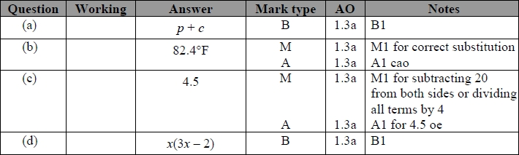

Q4.
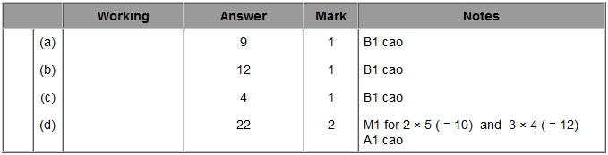
Q5.
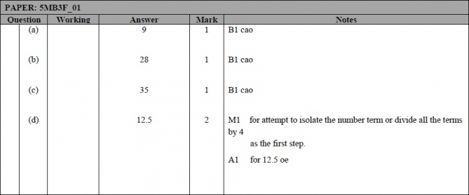

Q6.
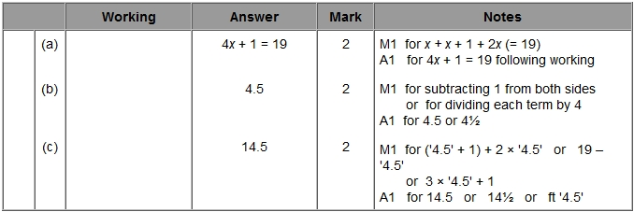

Q7.
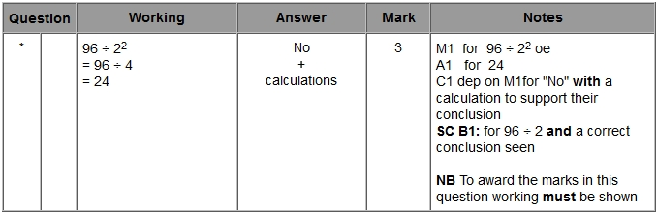

Q8.
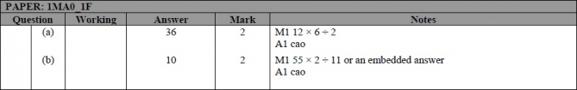

Q9.
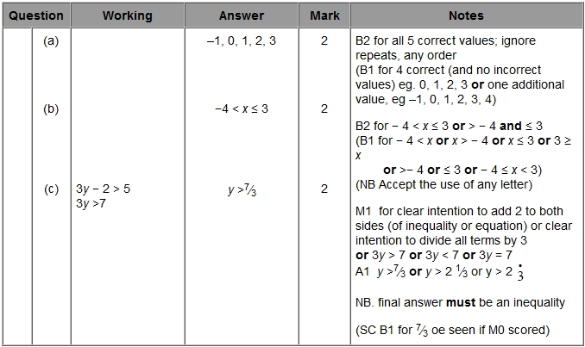

Q10.
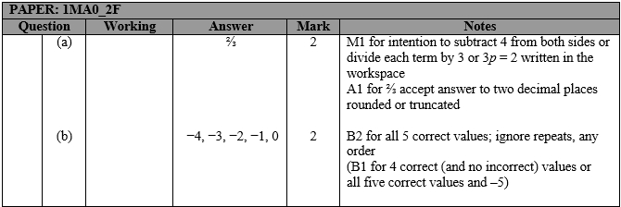

Q11.
