Pythagoras’ Theorem
Trigonometry

Total marks available = 50

Total marks achieved = ____

Questions
Q1.
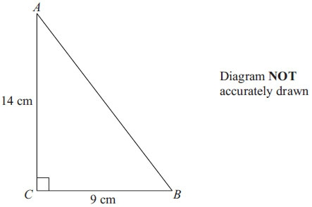
Calculate the length of AB.
Give your answer correct to 1 decimal place.

..............................................................................................................................................
(Total for Question is 3 marks)
Q2.
ABCD is a trapezium.
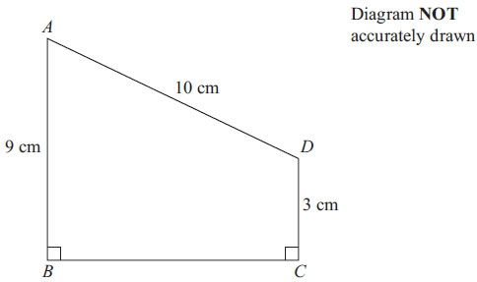
AD = 10 cm
AB = 9 cm
DC = 3 cm
Angle ABC = angle BCD = 90°
Calculate the length of AC.
Give your answer correct to 3 significant figures.

..............................................................................................................................................
(Total for Question is 5 marks)
Q3.
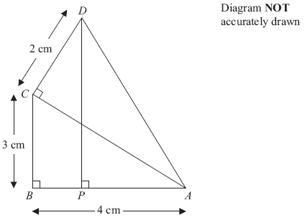
In the diagram,
ABC, ACD and APD are right-angled triangles.
AB = 4 cm.
BC = 3 cm.
CD = 2 cm.
Work out the length of DP.

..............................................................................................................................................
(Total for Question is 5 marks)
Q4.
The diagram represents a metal frame.
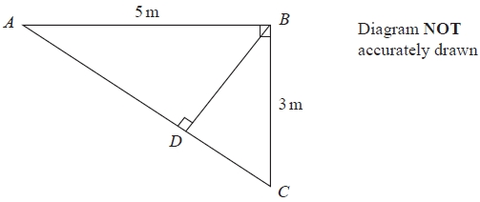
The frame is made from four metal bars, AB, AC, BC and BD.
Angle ABC = angle ADB = 90°
AB = 5 m
BC = 3 m
Work out the total length of the four metal bars of the frame.
Give your answer correct to 3 significant figures.
........................................................... m

(Total for question = 5 marks)
Q5.
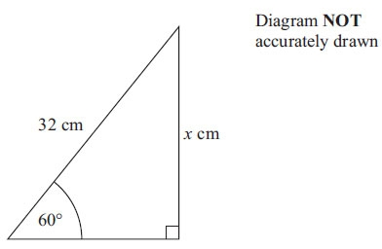
Calculate the value of x.
Give your answer correct to 3 significant figures.

..............................................................................................................................................
(Total for Question is 3 marks)

Q6.
Triangle ABC has a right angle at C.
Angle BAC = 48°.
AB = 9.3 cm.
Calculate the length of BC.

(Total for question = 3 marks)
Q7.
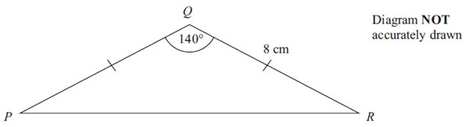
Calculate the length of PR.
Give your answer correct to 3 significant figures.

. . . . . . . . . . . . . . . . . . . . . cm
(Total for Question is 3 marks)

Q8.
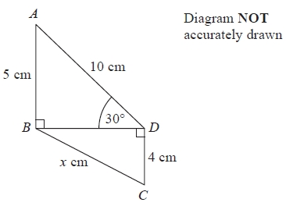
In the diagram,
triangles ABD and BCD are right-angled triangles
AB = 5 cm
AD = 10 cm
CD = 4 cm
Angle ADB = 30°
Work out the value of x.
Give your answer correct to 2 decimal places.
...........................................................cm

(Total for question = 4 marks)
Q9.
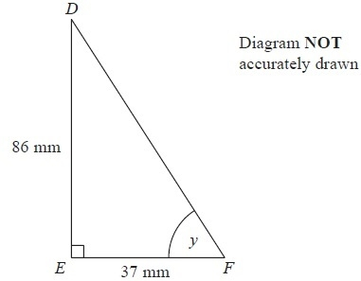
DEF is a right-angled triangle.
DE = 86 mm
EF = 37 mm
Calculate the size of the angle marked y.
Give your answer correct to 1 decimal place.
...........................................................°
(Total for Question is 3 marks)
Q10.
The diagram shows a ladder leaning against a vertical wall.
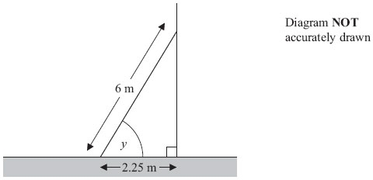
The ladder stands on horizontal ground.
The length of the ladder is 6 m.
The bottom of the ladder is 2.25 m from the bottom of the wall.
A ladder is safe to use when the angle marked y is about 75°.
Is the ladder safe to use?
You must show all your working.

(Total for Question is 3 marks)

Q11.
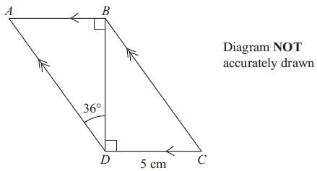
ABCD is a parallelogram.
DC = 5 cm
Angle ADB = 36°
Calculate the length of AD.
Give your answer correct to 3 significant figures.

..............................................................................................................................................
(Total for Question is 4 marks)

Q12.
The diagram shows a quadrilateral ABCD.
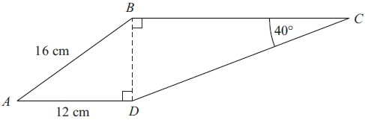
Diagram NOT accurately drawn
AB = 16 cm.
AD = 12 cm.
Angle BCD = 40°.
Angle ADB = angle CBD = 90°.
Calculate the length of CD.
Give your answer correct to 3 significant figures.

. . . . . . . . . . . . . . . . . . . . . . cm
(Total for Question is 5 marks)

Q13.
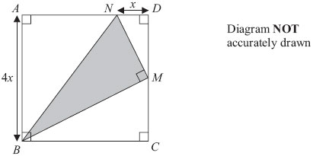
ABCD is a square with a side length of 4x
M is the midpoint of DC.
N is the point on AD where ND = x
BMN is a right-angled triangle.
Find an expression, in terms of x, for the area of triangle BMN.
Give your expression in its simplest form.

..............................................................................................................................................
(Total for Question is 4 marks)

Examiner's Report
Q1.
This standard Pythagoras question was well answered. A few candidates tried to use the cosine rule. They did not earn any marks until they had got to the equivalent stage to using the Theorem of Pythagoras.

Q2.
A common incorrect answer was 10.4 cm which came from attempting to use Pythagoras's theorem in triangle ADC which clearly does not contain a right angle. Other incorrect assumptions were that BC was 9 cm and/or angle ACB was 45°. Those candidates who drew a line parallel to BC from D generally went onto gain either full marks or at least one mark as errors occurred while using Pythagoras's theorem. It was disappointing that relatively few candidates realised that the trapezium could be divided in such a way that the length of the base could be found using Pythagoras's theorem. Many candidates stated the length of the upper part of AB was 6 but then did not always use the information correctly. A significant minority of candidates calculated the area of the trapezium. A few candidates used trigonometry to find angle ADC and then used the cosine rule in triangle ACD.

Q3.
This question was poorly done except by the most able candidates. The vast majority only managed to gain the first method mark for Pythagoras and generally AC = 5. Very few recognised the need to use trigonometry and many attempted to use the cosine formula badly. Of those who did use trigonometry, the sine rule was seen most commonly.

Q4.
Again there were quite a number of nil attempts. However, most students identified that they needed to use Pythagoras as a first step, and AC was usually found correctly. It was rare to find students proceeding further in a logical way, since many incorrectly assumed that CBD or ABD was 45°. Any attempt at using trigonometry was usually based on an incorrect side or angle. No student used a similar triangle approach.

Q5.
On the whole, candidates either scored full marks or no marks in this question. A few candidates were unable to recognise the correct trigonometric function even having written SOHCAHTOA, others were able to start with a correct trigonometric statement and then made errors when rearranging their initial statement but most who got this far went onto obtain full marks. It was evident that some candidates had their calculator in the wrong angle mode. It was surprising the number of candidates who confused lengths and angles in their calculations. Some candidates seemed to take a lucky guess that the adjacent side was half of 32 with no evidence of the use of cos 60 and were then able to use Pythagoras to find x correctly.

Q6.
No Examiner's Report available for this question

Q7.
The most common correct method seen was the use of the cosine rule; other candidates used the sine rule successfully; others dropped a perpendicular line and used the two right-angled triangles. The majority of candidates who could see an appropriate method to use went on to gain full marks. Those who used the sine rule method often substituted the numbers correctly, but were unable to proceed further. The most common incorrect method was to attempt to use Pythagoras' Theorem.

Q8.
This question was not always attempted. When it was attempted, a common error was for students to calculate 10² + 5² rather than 10² − 5² in their application of Pythagoras' Theorem. Premature rounding led some students to lose accuracy in their answers and consequently score 3 out of the 4 marks available.

Q9.
The correct answer was often seen but not always the result of the most straightforward method. Many candidates found the length DF by Pythagoras and then used sine or cosine. Some even attempted to use the sine rule. However, many choosing these alternative approaches made careless mistakes in their algebraic manipulation and failed to score as a result.
A significant number started well with "tan = " but could go no further.

Q10.
Many correctly identified Cosine as the method of solution, found the angle and wrote an appropriate statement to go with it. Some candidates however tried Pythagoras with either the Sine or Cosine Rule with varying degrees of success.

Q11.
Most candidates scored either 1 mark (for AB = 5 cm), or full marks for finding the length of AD correctly. It was very common to see the sine rule being used in the right angled triangle ABD, sometimes involving the right angle and sometimes the 54°. A few candidates used tan and Pythagoras in triangle ABD. Providing all the steps involved were logically correct, they were awarded the two method marks. Often this approach led to an answer outside the acceptable range, due to accumulation of rounding errors.

Q12.
This question required the candidates to first find the side BD and then to use that to find the length of the side CD. Many got off to a good start by correctly using Pythagoras to find BD. At that point a number of candidates stopped, possibly believing that they had answered the question, and so lost the remaining three marks. Of those that realised they needed to continue, a good many managed to use a correct trigonometric expression to gain the third mark, although incorrect rearrangement often meant that they gained no further marks. Those that chose to use 'tan' often missed out on the remaining method mark for not realising that they had worked out the side BC and so still needed to do one further calculation. Candidates who used Pythagoras incorrectly in the first stage were still able to gain the two marks for the second stage if they used their value for the length BD correctly. Early rounding of the length BD to 10.6 in this question was not penalised as it still gave an answer within the range. Candidates should, however, be reminded not to prematurely round answers to 1dp at the intermediate stages of calculations.

Q13.
The best candidates gave clear and concise solutions to this question. However most candidates were unable to make much headway in giving accurate expressions for the area of the square or for the area of the unshaded triangles or for the sides of the shaded triangle. A large proportion of the algebra seen was spoiled by the omission of brackets, for example by expressing the area of the square as 4x × x or as 4x² instead of 4x × 4x, (4x)², or 16x² or in attempts to use Pythagoras rule. The square root sign was often used wrongly or ambiguously. These errors led to many candidates failing to score any credit for their attempts. Most candidates used the method of finding the area of the square and subtracting the areas of the three unshaded triangles but there were some excellent solutions harnessing Pythagoras rule to find the lengths of the sides NM and BM and then the area of triangle BNM. A significant proportion of candidates did not attempt this question.

Mark Scheme
Q1.
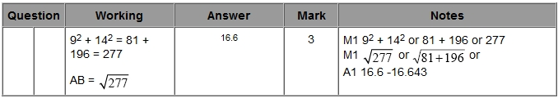

Q2.
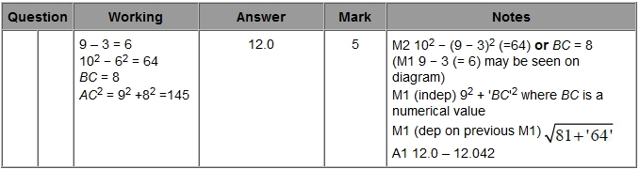

Q3.
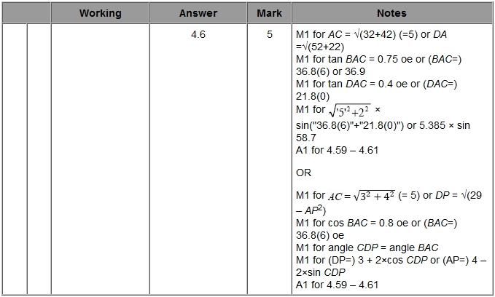

Q4.
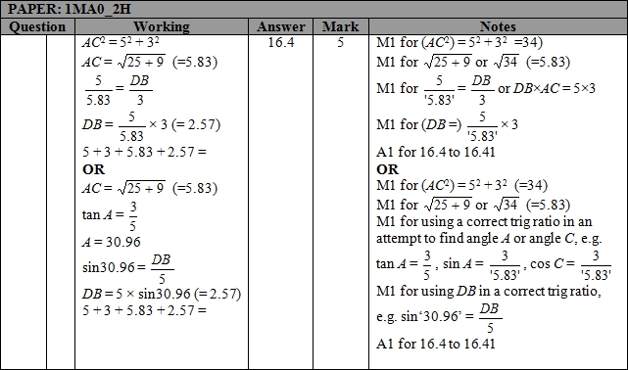

Q5.
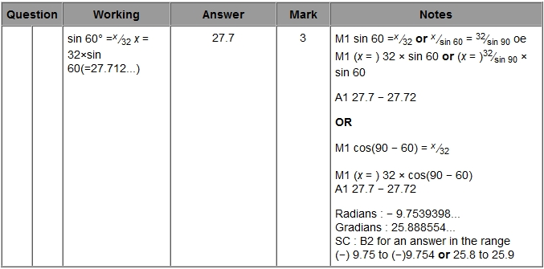

Q6.
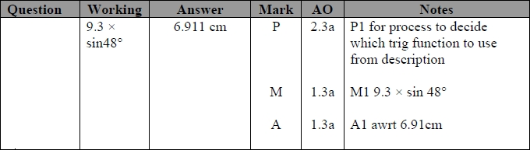

Q7.
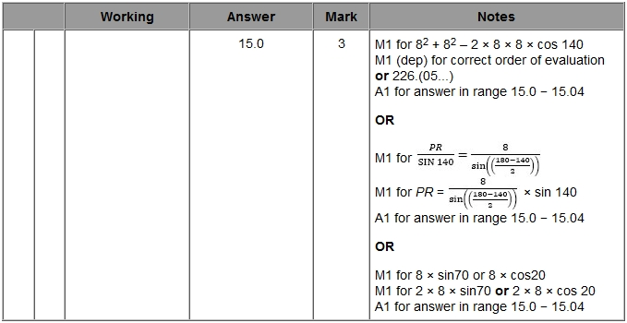

Q8.
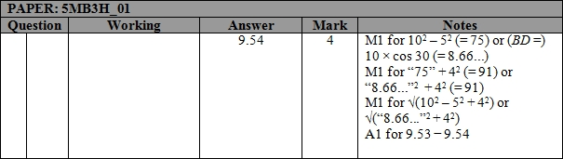

Q9.
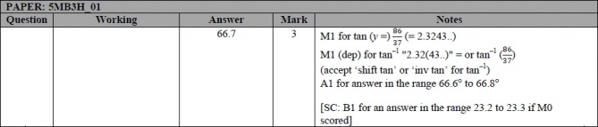

Q10.
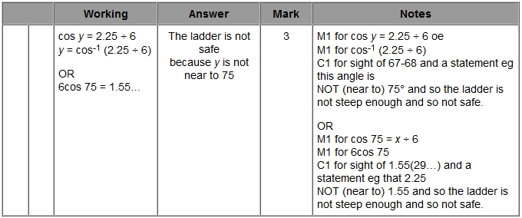

Q11.
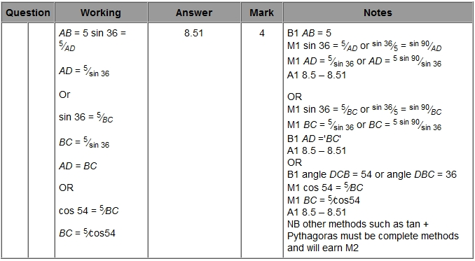

Q12.
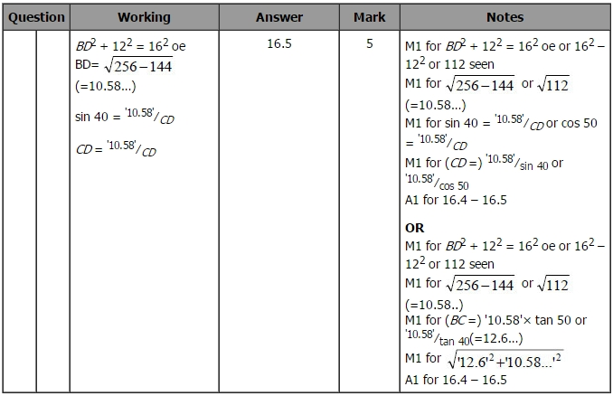

Q13.
