Biology Paper 1
Sample of content during year 10
Topics B1 – B3

B1 – Cells, Specialised Cells and Microscopy

Animal, Plant and Bacterial Cells
Label the animal cell below.
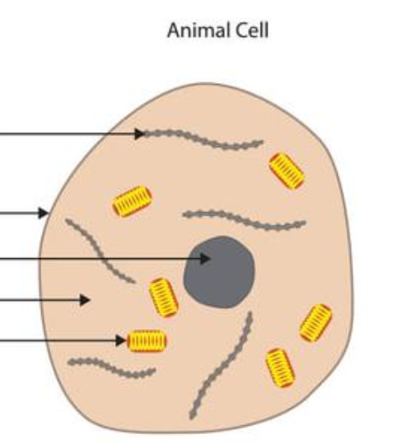

Label the plant cell below.
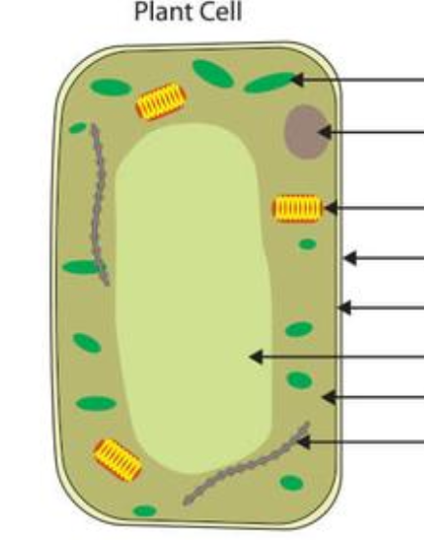

Label the bacterial cell below.

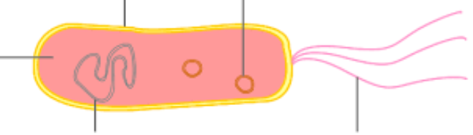
Functions of Parts of Cells
Part of the Cell | Function
Nucleus
Cytoplasm
Mitochondria
Cell Membrane
Ribosome
Chloroplast
Vacuole
Cell Wall

Eukaryotes and Prokaryotes
Eukaryotic cells are complex cells. Examples are _______________ and _________________ cells.
Prokaryotic cells are more simple. They do not have a ____________________. An example is a __________________ cell.

Using a Microscope
Put this method of using a light microscope into the correct order.
Move the fine adjustment to get a clear image
Move the stage down until the image is roughly in focus
Clip the slide onto the stage
Twist the coarse adjustment to move the stage up to just below the objective lens
Get a bigger image by using an objective lens with a higher magnification
Start with the lowest magnification objective lens

Microscope Calculations
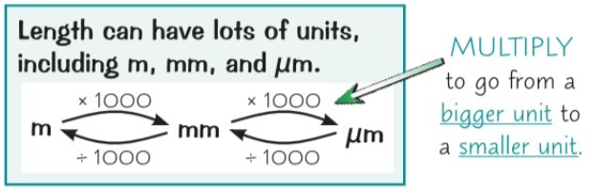
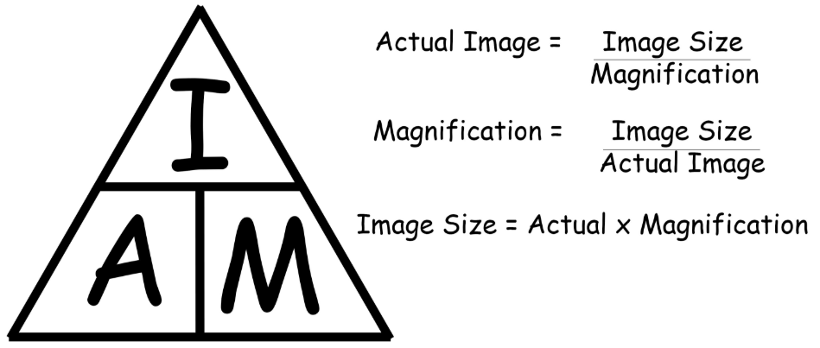

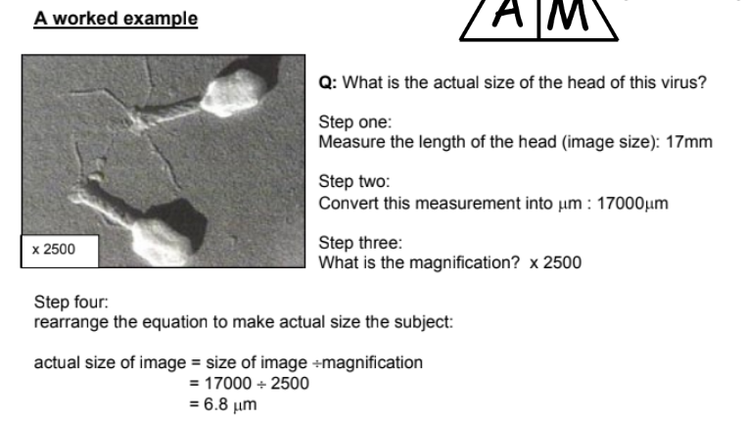

Question 1
Magnification is x100. What is the actual size of one of these epithelial cells?
……………………………………………………………………………………………………………………………………………………………….……………………………………………………………………………………………………………………………………………………………….……………………………………………………………………………………………………………………………………………………………….……………………………………………………………………………………………………………………………………………………………….

Question 2
If the actual length of this chloroplast is 10μm, what is the magnification?
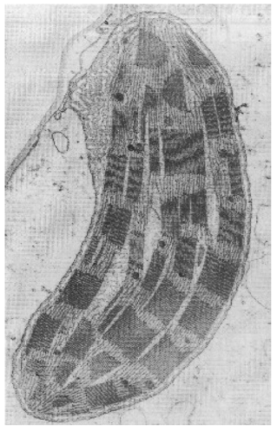
……………………………………………………………………………………………………………………………………………………………….……………………………………………………………………………………………………………………………………………………………….……………………………………………………………………………………………………………………………………………………………….……………………………………………………………………………………………………………………………………………………

Specialised Cells
- What does undifferentiated mean?
…………………………………………………………………………………………………………………
- What does differentiate mean?
…………………………………………………………………………………………………………………

B1 – Chromosomes, Cell Division and Stem Cells – Revision Guide Pages 15-16

Mitosis
Mitosis is part of the cell cycle, where cells divide. This kind of cell division is done so organisms can grow and repair themselves. Cells which have divided by mitosis are genetically identical to the parent cell.
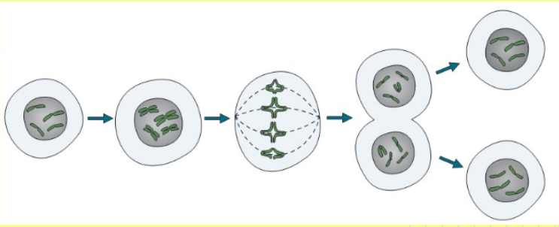

Task - Put the stages of the cell cycle in order. Use the diagram to help.

DNA replicates to make 2 copies of each chromosome
One set of DNA is pulled to each side of the cell
The nucleus divides
The cytoplasm and cell membranes divide and two identical cells are formed
The cell grows and increase the number of mitochondria and ribosomes
The DNA lines up down the centre of the cell

Stem Cells – Key Facts
A stem cell is an undifferentiated cell which can become another type of cell. There are 2 sources of stem cells in humans:

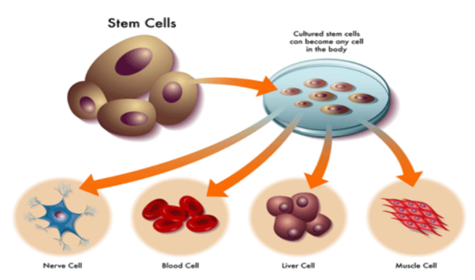
Embryos
Advantages: can become most other types of cell. Used to treat disease e.g. diabetes/paralysis. Not rejected by the body
Disadvantages: can cause transfer of viruses, ethical issues - embryos area potential life, religious objections - should not ‘play god’.

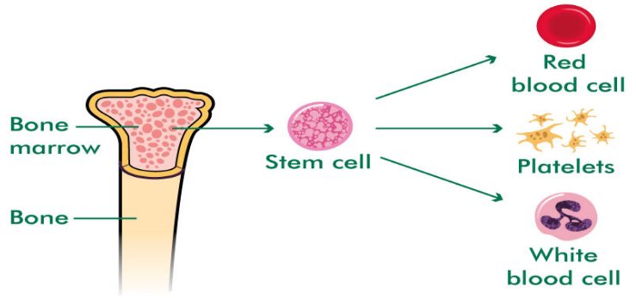
Adult Stem Cells
Advantages: can form some other types of cell e.g. blood cells from bone marrow. Not rejected by the body
Disadvantages: can cause transfer of viruses, can differentiate into fewer types of cells than embryos

Plant Stem Cells – meristem tissue
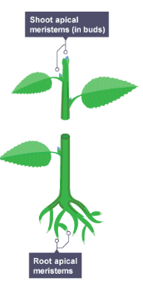
Meristem tissue can differentiate into any other type of plant cell, at any point in the plant’s life

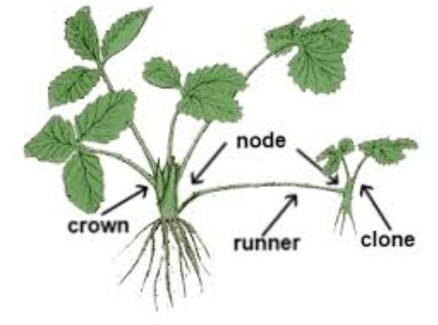
Advantages: can clone rare plants to stop them from going extinct. Can clone plants which have special features, e.g. resistance to a disease or a very nice tasting fruit.

B1 – Transporting Substances (Diffusion, Osmosis, Active Transport)
Revision Guide Pages 17 – 22

Diffusion
- What is the definition of diffusion?
…………………………………………………………………………………………………………………
…………………………………………………………………………………………………………………
- List 4 factors that speed up the rate of diffusion.
…………………………………………………………………………………………………………………
…………………………………………………………………………………………………………………
…………………………………………………………………………………………………………………
…………………………………………………………………………………………………………………
Diffusion – Examples in Organisms
Diffusion takes place in other areas of our bodies and the bodies of plants.

For example:
- In alveoli in our lungs
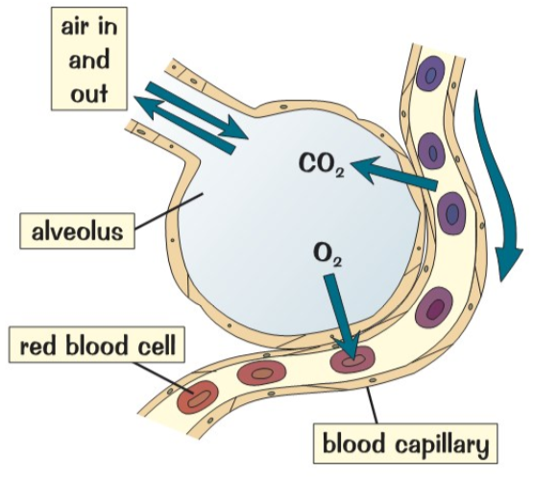
- The villi of our small intestine
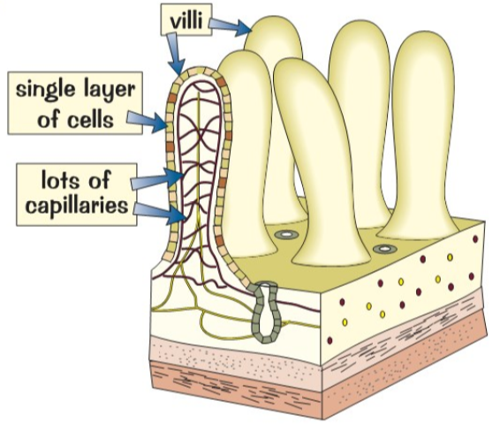
- The leaves and roots of plants
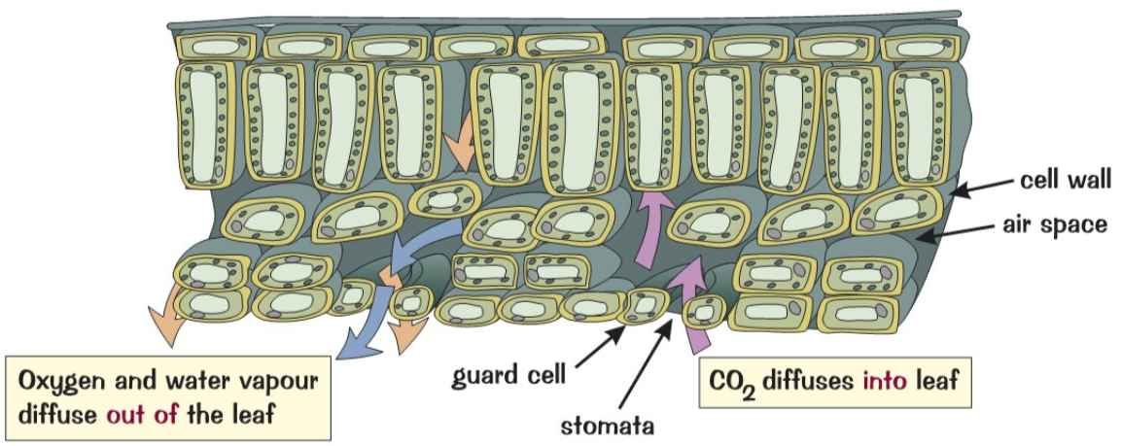

Osmosis
- What is the definition of osmosis?
…………………………………………………………………………………………………………………
…………………………………………………………………………………………………………………
…………………………………………………………………………………………………………………
- Describe what is happening in each beaker.
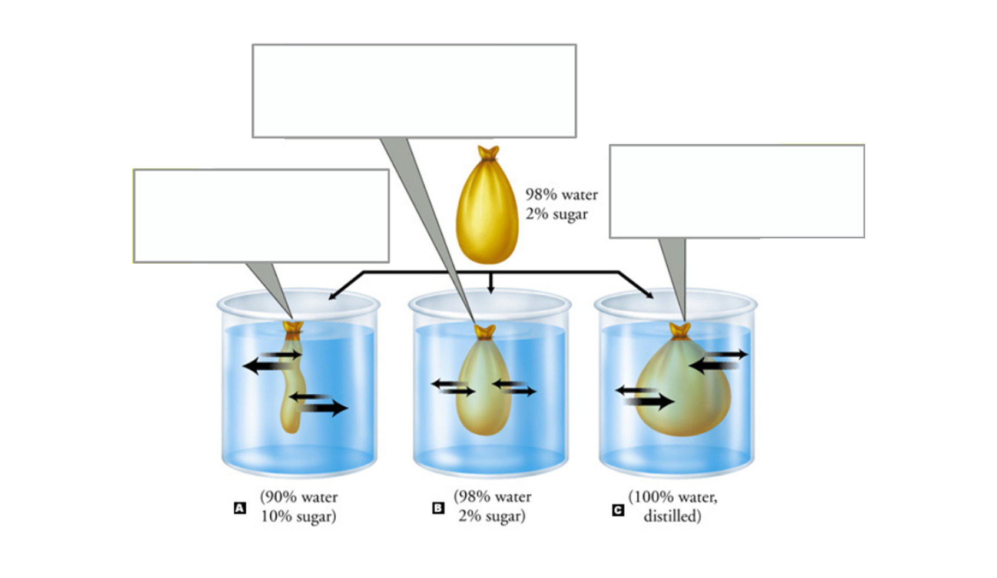

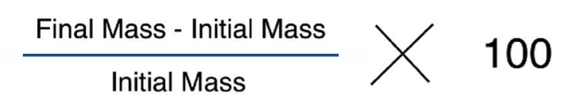
Change in mass = final mass – initial mass
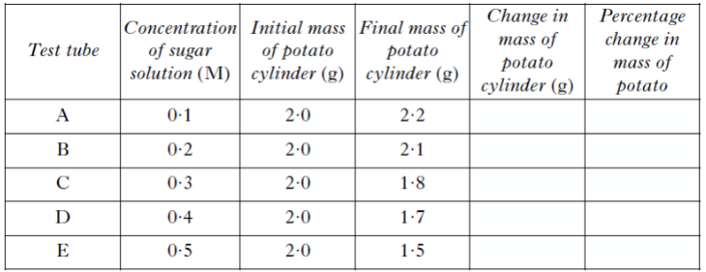
Active Transport
Active transport moves substances from a low to a high concentration against the concentration gradient.
This needs energy which comes from respiration.

Examples
- Root hair cells absorb minerals ions which are in a low concentration in the soil. Plants need ions for
healthy growth.
- Sugar is absorbed from a low concentration in small intestine, into the blood which has a higher sugar concentration. Sugar molecules are used for cell respiration.
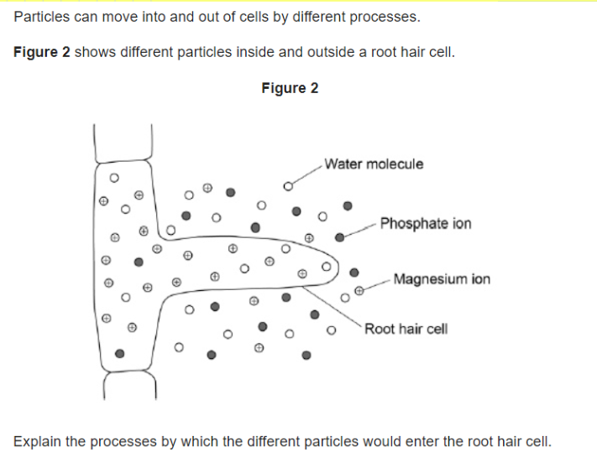
…………………………………………………………………………………………………………………
…………………………………………………………………………………………………………………
…………………………………………………………………………………………………………………
…………………………………………………………………………………………………………………
…………………………………………………………………………………………………………………
…………………………………………………………………………………………………………………
…………………………………………………………………………………………………………………
…………………………………………………………………………………………………………………
B2 –Enzymes
Enzymes
Our body has many chemical reactions going on.

Enzymes are protein molecules which can speed up reactions.

We say they are biological catalysts.

Describing Graphs
Graph 1: At first, the increase in temperature makes the rate of reaction _________________up to the ______________ temperature. After this, the active site of the enzyme starts to change ___________, the _____________won’t fit and the enzyme is ______________.
Graph 2: If the pH is too low or too high the ______________ of the enzyme starts to change shape, the substrate won’t fit and the enzyme is ___________________. The pH the enzyme works best at is called the __________________ pH.

Enzymes and Digestion
Complete the table below:
Enzyme | Breaks down... | Into... | Made in the...
Carbohydrase
(e.g. ________)
Protease
(e.g. ________)
Lipase

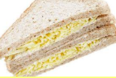
Digestion Summary
Use your knowledge of the digestive system to describe the journey of a cheese sandwich from mouth to anus.
You will need to:
- Ensure that your journey follows the correct order of organs in the digestive system
- Describe what is happening to the food at each stage in the digestive system
- Describe what the pancreas and liver do, making sure you name the chemical and enzymes involved

…………………………………………………………………………………………………………………
…………………………………………………………………………………………………………………
…………………………………………………………………………………………………………………
…………………………………………………………………………………………………………………
…………………………………………………………………………………………………………………
…………………………………………………………………………………………………………………
…………………………………………………………………………………………………………………
…………………………………………………………………………………………………………………

Food Tests – Summary Table

Food Molecule | Chemical Test | If it is present | If it is absent
Sugar
Starch
Protein
Fats

B2 – Circulatory System, Blood and Cardiovascular Disease

Structure of the Heart - Key Facts
The heart is an organ that pumps blood around the body in a double circulatory system.

The right ventricle pumps blood to the lungs where gas exchange takes place.

The left ventricle pumps blood around the rest of the body.
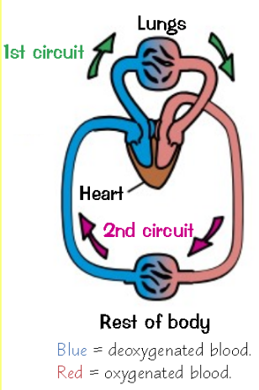
- What are pacemaker cells?
…………………………………………………………………………………………………………………
…………………………………………………………………………………………………………………
- Why does the left ventricle have to work harder than the rest of the heart?
…………………………………………………………………………………………………………………
…………………………………………………………………………………………………………………
- Why do we need valves in our heart?
…………………………………………………………………………………………………………………
…………………………………………………………………………………………………………………
- What is the coronary artery?
…………………………………………………………………………………………………………………
…………………………………………………………………………………………………………………Label the diagram of the heart.
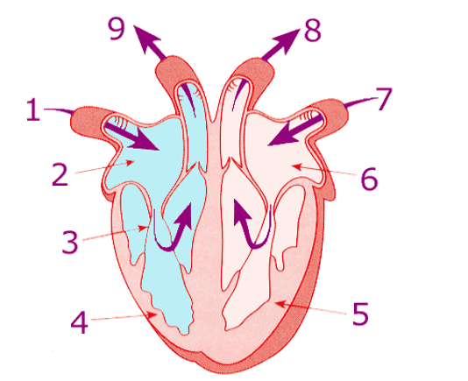
Extension: which side of the heart pumps the oxygenated blood around the body?
…………………………………………………………………………………………………………………

Put the parts of the heart in the order they would be in on the diagram.
Left atrium, right ventricle, pulmonary vein, right atrium, aorta, vena cava, pulmonary artery, left ventricle, lungs, body cells
Extension: add arrows to the diagram to show the blood flow
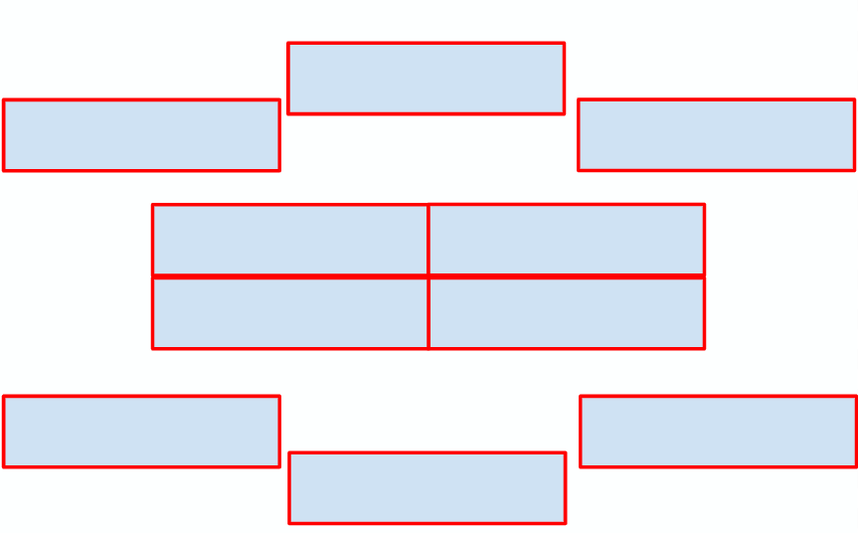
Put the statements into the correct order
Deoxygenated blood passes through the pulmonary artery towards the lungs
Blood emptied into the left ventricle
Oxygenated blood pumped through the aorta to the rest of the body (inc. heart)
Deoxygenated blood from the body enters the right atrium through the vena cava
The blood then empties into the right ventricle
Oxygenated blood from the lungs enters the left atrium through the pulmonary vein

Extension Task
Write a description of the journey of a red blood cell around the body.
Include:
- The movement of blood through the heart and the 4 main blood vessels.
- The role of the valves
- When the blood is oxygenated or not
- Keywords: aorta, pulmonary artery, pulmonary vein, vena cava, atrium, ventricle, oxygenated
…………………………………………………………………………………………………………………
…………………………………………………………………………………………………………………
…………………………………………………………………………………………………………………
…………………………………………………………………………………………………………………
…………………………………………………………………………………………………………………
…………………………………………………………………………………………………………………
…………………………………………………………………………………………………………………
…………………………………………………………………………………………………………………
…………………………………………………………………………………………………………………
Blood Vessels
- Label each diagram: artery, vein and capillary

- Explain how the structure of the artery is adapted to its function
…………………………………………………………………………………………………………………
…………………………………………………………………………………………………………………
…………………………………………………………………………………………………………………
- Explain how the structure of the vein is adapted to its function
…………………………………………………………………………………………………………………
…………………………………………………………………………………………………………………
…………………………………………………………………………………………………………………
- Explain how the structure of the capillary is adapted to its function
…………………………………………………………………………………………………………………
…………………………………………………………………………………………………………………
…………………………………………………………………………………………………………………
Components of Blood
Blood is a tissue made of plasma, in which the red blood cells, white blood cells and platelets are suspended.

Complete the table below to show the percentage of each component in blood and the function (job) of each part.
Blood Component | % Composition | Function (job)
Red Blood Cell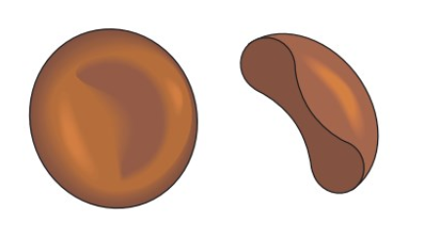
White Blood Cell
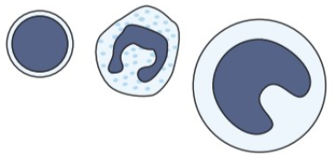
Platelets
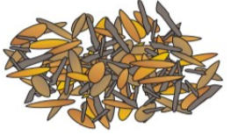
Plasma
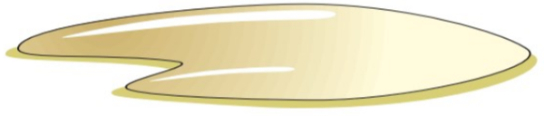
Adaptations of Red Blood Cells
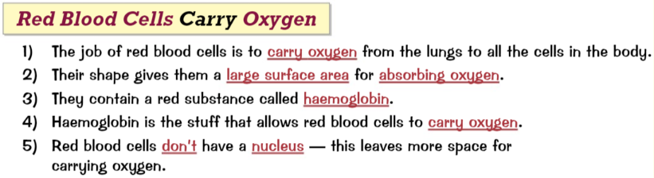
Questions
- Haemoglobin is a chemical found in red blood cells. What is its function?
…………………………………………………………………………………………………………………
…………………………………………………………………………………………………………………
- State two adaptations of a red blood cell. For each one, state how the adaptation helps the blood cell to carry out its function
…………………………………………………………………………………………………………………
…………………………………………………………………………………………………………………
…………………………………………………………………………………………………………………
…………………………………………………………………………………………………………………
Coronary Heart Disease – Key Facts
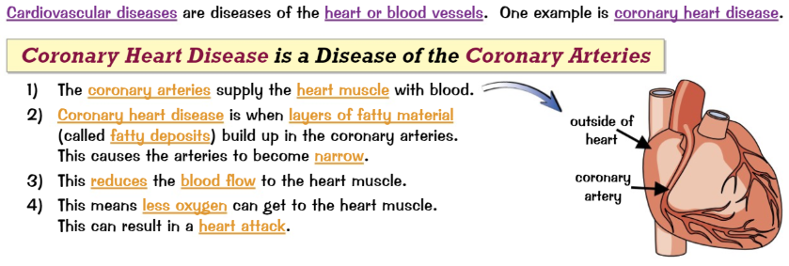
- What is the function of the coronary artery
…………………………………………………………………………………………………………………
…………………………………………………………………………………………………………………
- Where is it found?
…………………………………………………………………………………………………………………
- What happens in coronary heart disease?
…………………………………………………………………………………………………………………
…………………………………………………………………………………………………………………
…………………………………………………………………………………………………………………
- What effect can this have on the heart muscle?
…………………………………………………………………………………………………………………
…………………………………………………………………………………………………………………
…………………………………………………………………………………………………………………
Coronary Heart Disease – Treatments

Treatment | How it Works | Advantages | Disadvantages
Stents
Statins
Artificial Hearts
Valve Replacement

Cancer
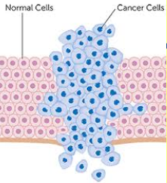
- What is cancer?
…………………………………………………………………………………………………………………
- What is a benign tumour?
…………………………………………………………………………………………………………………
…………………………………………………………………………………………………………………
- What is a malignant tumour?
…………………………………………………………………………………………………………………
…………………………………………………………………………………………………………………
- How do cancers spread?
…………………………………………………………………………………………………………………
…………………………………………………………………………………………………………………
- Name 5 risk-factors for cancer
(be clear if the risk factor causes a particular type of cancer)
…………………………………………………………………………………………………………………
…………………………………………………………………………………………………………………
…………………………………………………………………………………………………………………
- Why have cancer survival rates improved?
…………………………………………………………………………………………………………………
…………………………………………………………………………………………………………………

B2 – Plant Systems – Revision Guide Page 39-41

Plant Tissues and Organs
Plants are made from a range of different cells, tissues and organs.
Label the leaf diagram with the name of the tissue and how it is adapted to its function.

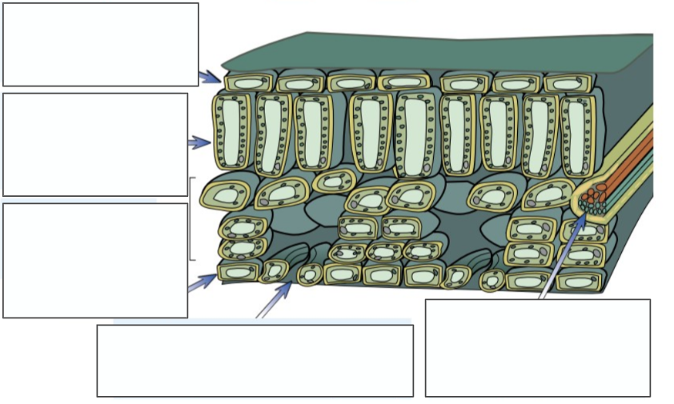

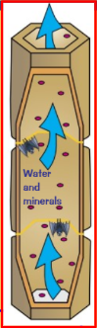
Specialised Cells
Xylem tubes are made of ________ ________. They are hollow tubes, strengthened by ___________ and travel from the __________ to the __________. They carry _____________ and ___________ __________. This process of moving water is called _____________________.
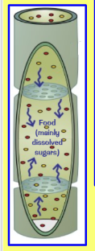
Phloem tubes are made of _______________ ________. They carry __________ from the ___________ all around the plant to be used or ______________. This process of moving food is called _____________________.
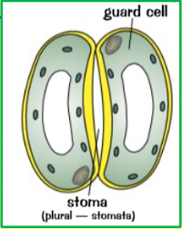

The guard cells change ______________ to control the size of the ______________. This controls the rate of ___________ ________________ and water loss.

Transpiration
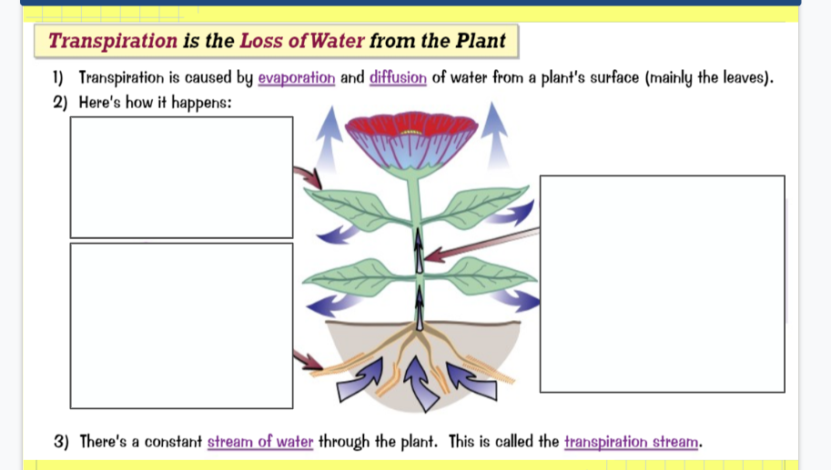
B3 – Communicable Diseases – Revision Guide Page 43-45

Communicable Diseases
- What is a pathogen?
…………………………………………………………………………………………………………………
- What is a communicable disease?
…………………………………………………………………………………………………………………
- Name the 4 types of pathogen
…………………………………………………………………………………………………………………
- Why do bacteria make us feel ill?
…………………………………………………………………………………………………………………
- Where are viruses found in the body?
…………………………………………………………………………………………………………………
- How do viruses make us feel ill?
…………………………………………………………………………………………………………………
…………………………………………………………………………………………………………………

Spread of Disease
Describe how diseases can spread and how we can prevent the spread of disease.
…………………………………………………………………………………………………………………
…………………………………………………………………………………………………………………
…………………………………………………………………………………………………………………
…………………………………………………………………………………………………………………
…………………………………………………………………………………………………………………
…………………………………………………………………………………………………………………
…………………………………………………………………………………………………………………
…………………………………………………………………………………………………………………
…………………………………………………………………………………………………………………
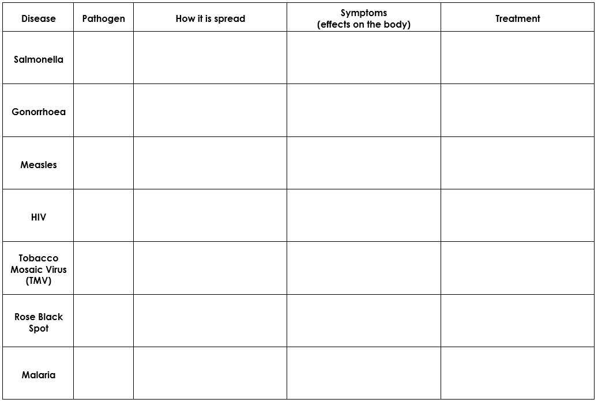
Treatment and Prevention
B3 – Natural Defence Systems – Revision Guide Page 45-47

Human Defence System
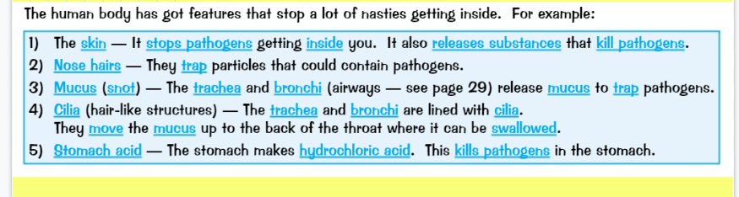
What is the role of the following parts of the defence system?:
- The skin
- Nose hair
- Mucus
- Cilia
- Stomach acid
…………………………………………………………………………………………………………………
…………………………………………………………………………………………………………………
…………………………………………………………………………………………………………………
…………………………………………………………………………………………………………………
…………………………………………………………………………………………………………………
…………………………………………………………………………………………………………………
…………………………………………………………………………………………………………………
…………………………………………………………………………………………………………………

White Blood Cells
There are 3 functions of white blood cells:
- Phagocytosis
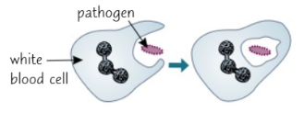
…………………………………………………………………………………………………………………
…………………………………………………………………………………………………………………
- Producing antibodies
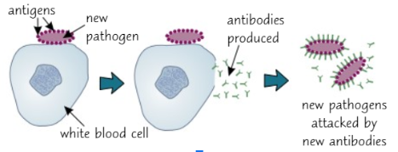
…………………………………………………………………………………………………………………
…………………………………………………………………………………………………………………
…………………………………………………………………………………………………………………
…………………………………………………………………………………………………………………
…………………………………………………………………………………………………………………
- Producing antitoxins
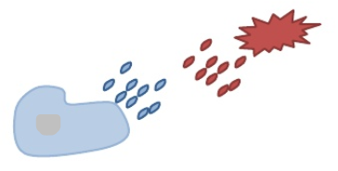
…………………………………………………………………………………………………………………
…………………………………………………………………………………………………………………

Vaccination
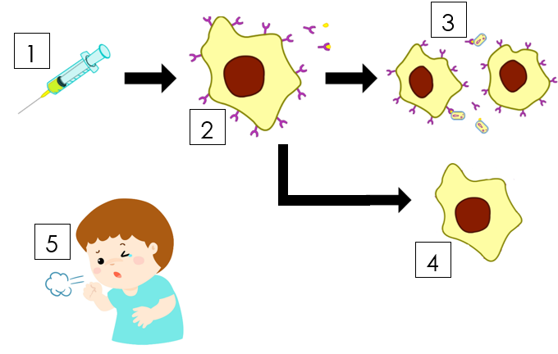

Describe how vaccines help to protect against future infections.
- Vaccination given
…………………………………………………………………………………………………………………
…………………………………………………………………………………………………………………
- Antibodies produced
…………………………………………………………………………………………………………………
…………………………………………………………………………………………………………………
- Attract more white blood cells
…………………………………………………………………………………………………………………
…………………………………………………………………………………………………………………
- Memory cells
…………………………………………………………………………………………………………………
…………………………………………………………………………………………………………………
- Infection with same pathogen later on
…………………………………………………………………………………………………………………
…………………………………………………………………………………………………………………
Vaccination – Advantages and Disadvantages
Advantages
Vaccinations have helped to control diseases which used to be common
e.g. _________________.
When a large disease outbreak happens, we call this an ________________. This is stopped from happening if many people have been __________________. This is because the disease cannot easily _________________.

Disadvantages
Sometimes they do not work. We say the person has not got _______________.
Cannot be used on people with a weakened ________ ________.
Sometimes you can have a bad ________________ to the vaccine. E.g. _____________ or a fever.

B3 – Drugs – Revision Guide Page 48-49
Antibiotics and Painkillers
- What is an antibiotic?
…………………………………………………………………………………………………………………
- What is a pain killer?
…………………………………………………………………………………………………………………
…………………………………………………………………………………………………………………
- Why is it pointless to give antibiotics to someone suffering from measles?
…………………………………………………………………………………………………………………
…………………………………………………………………………………………………………………
- Some bacteria can no longer be treated by antibiotics. Explain why.
…………………………………………………………………………………………………………………
…………………………………………………………………………………………………………………
- What is the source of most drugs?
…………………………………………………………………………………………………………………

Examples of Drugs
Name of Drug | Where it’s produced | What it’s used for
Aspirin
Digitalis
Penicillin
Developing Drugs
- New drugs are tested for toxicity, efficacy and dose. What do these words mean?
…………………………………………………………………………………………………………………
…………………………………………………………………………………………………………………
…………………………………………………………………………………………………………………
…………………………………………………………………………………………………………………
…………………………………………………………………………………………………………………
- What is pre-clinical testing?
…………………………………………………………………………………………………………………
…………………………………………………………………………………………………………………
- Who takes part in clinical trials?
…………………………………………………………………………………………………………………
…………………………………………………………………………………………………………………
- Why are healthy people used at the start of clinical trials?
…………………………………………………………………………………………………………………
…………………………………………………………………………………………………………………
…………………………………………………………………………………………………………………
- What precautions are taken at the start of clinical trials?
…………………………………………………………………………………………………………………
…………………………………………………………………………………………………………………
- What does the ‘optimum dose’ mean?
…………………………………………………………………………………………………………………
…………………………………………………………………………………………………………………
- When the drug is tested on patients, some are given a placebo. What is this and why is it given?
…………………………………………………………………………………………………………………
…………………………………………………………………………………………………………………
…………………………………………………………………………………………………………………
- What is a double blind trial?
…………………………………………………………………………………………………………………
…………………………………………………………………………………………………………………
…………………………………………………………………………………………………………………

