Dear Parent/Carer and Students of our Arena,

I hope you are having an enjoyable weekend with your loved ones.

Attendance
As you are aware, attendance to school is a key focus at Our Arena. Students who have high attendance are far more likely to achieve good grades. Attendance for the week ending 14th November highlighted that on average 925 students out of our total students on roll achieved the expected attendance across the week. Whilst the number of students reported ill has decreased, we have continued to experience high levels of illness across the week in the academy. I will need you to work closely with us to ensure that unless your child is incredibly unwell, they attend the academy every day.
Friday attendance remains a concern at the academy. We need to work together to ensure that students are building the routine to attend the academy across the week. Every single day is an opportunity for your child to learn and progress.

Students are expected to arrive on time to school every single day. Our academy doors open at 8.25am and finish at 8.35am. Students are welcome to attend the breakfast club in the morning.

After School Clubs
I am pleased to inform that after-school clubs will commence next week. We will provide you with further updates on the after-school club timetable and how your child can access them.
Whilst we will ensure that there is a clear registration process for these clubs, could I please ask you to double check with your child which clubs they will be attending.
Further information regarding clubs will be sent to you via class charts.

Year 11 Parents evening
Thank you to all Year 11 parent/carers for your incredible support. We had a 92% attendance to parents evening with some parent/carers making appointments with subject teachers due to work commitments. This is once again a testament to the hard work all stake holders are putting in to ensure that.
We are now working incredibly hard to analyse the GCSE mock results to shape the support children need to success in the summer GCSE examinations.
We have upcoming Saturday sessions where students will be invited to attend. This invitation will come to you in the form of an Invitation letter. Please make every effort to ensure your child attends.
To support your child’s success in the upcoming GCSE exams, it is imperative that they are revising at least two hours daily.

Mobile Phone Pouches Launch
Thank you for your ongoing support with regards to children's phones being locked into the pouches. This intervention has made a considerable difference to the way our young people are approaching their learning in the classroom. The vast majority of students are now embedded into the routines we have established.
Can I ask you to remind your child each day around the expectation of their mobile phone. It is important that we work together to remove any distractions around learning.

Year 11 Impress the examiner-Saturday 22nd November and Saturday 29th November. (English and Maths)
I am pleased to confirm that we have two sessions for impress the examiner on this side of half term. The purpose of the session will be invitation only and students will work closely with expert examiners to prepare for their key English and Math's examinations.
We will be writing to parent/carers to highlight sessions timings this coming week. Attendance to these sessions is mandatory.

Flu Vaccinations-Friday 21st November
Flu Vaccinations take place at the academy during the course of Friday. We will have a team of medical practioners who will be supporting the process.
Please email your child's Head of Year if you have any further questions regarding the flu vaccinations.

Have a great wonderful week ahead.
November 26th 2025
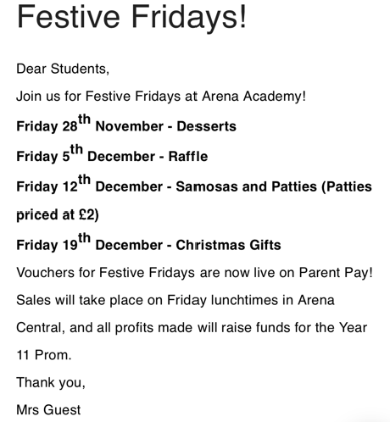

November 24th 2025
