Chemistry Paper 1
Content Booklet
Topics C1-C4
Booklet should be used with your school working book or a revision guide.

Contents Page
Topic | Booklet Pages | Revision Guide Pages
Atoms, Elements and Compounds | 4-10 | 96-99
Mixtures and Separation | 11-16 | 100-102
Atomic Structure | 17-20 | 96, 103-104
Structure of the Periodic Table | 21-22 | 105-106
Groups of the Periodic Table | 23-29 | 107-110

Topic | Booklet Pages | Revision Guide Pages
Ionic Compounds | 30-34 | 112-114
Simple Covalent Molecules | 35-39 | 115-116
Giant Covalent Structures (including carbon) | 40-43 | 117-118
Metallic Bonding and Alloys | 44-47 | 119
States of Matter | 48-52 | 120-121

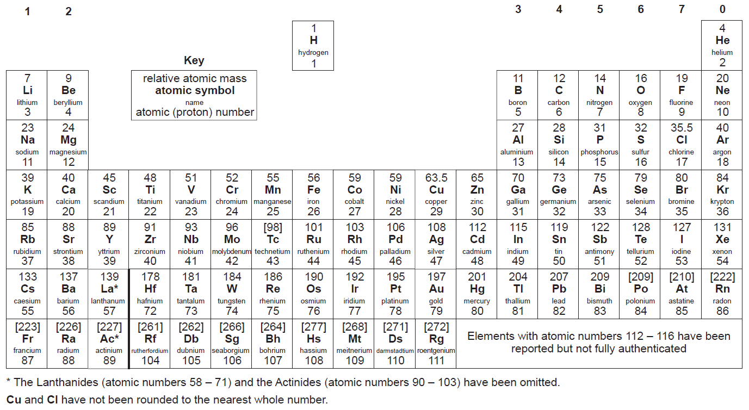
C1 – Atoms, Elements and Compounds – Revision Guide Pages 96-99

Atoms
Add labels to the atom.
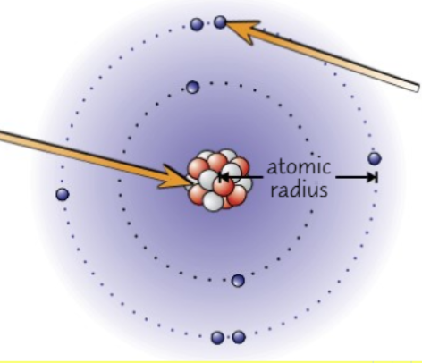
Sub-Atomic Particles
Particle | Mass | Charge
Proton
Neutron
Electron

- Which particles are found in the nucleus?
…………………………………………………………………………………………………………………
- Compare a proton and a neutron
…………………………………………………………………………………………………………………
…………………………………………………………………………………………………………………

Atoms – Using the Periodic Table
- What does the atomic number of an atom tell you?
…………………………………………………………………………………………………………………
- What is the mass number of an atom?
…………………………………………………………………………………………………………………
- Why do we not count the number of electrons in the mass number?
…………………………………………………………………………………………………………………
- How do you calculate the number of neutrons in an atom?
…………………………………………………………………………………………………………………
- Why is the number of electrons always the same as the atomic number?
…………………………………………………………………………………………………………………

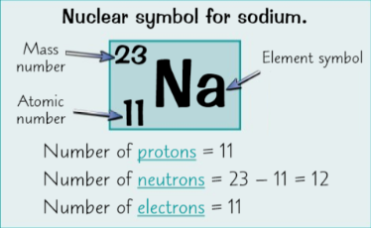
Task: Calculate the number of protons, electrons and neutrons in atoms of:
- Boron
…………………………………………………………………………………………………………………
…………………………………………………………………………………………………………………
- Nitrogen
…………………………………………………………………………………………………………………
- Aluminium
…………………………………………………………………………………………………………………
…………………………………………………………………………………………………………………
- Gallium
…………………………………………………………………………………………………………………

Atoms – Looking at Charges
- Why are all atoms of an element neutral (even though they contain positive and negative charges)?
…………………………………………………………………………………………………………………
…………………………………………………………………………………………………………………
…………………………………………………………………………………………………………………
- What is an ion?
…………………………………………………………………………………………………………………
…………………………………………………………………………………………………………………
- What has happened to an ion with a 1- charge?
…………………………………………………………………………………………………………………
- What has happened to an ion with a 2+ charge?
…………………………………………………………………………………………………………………
Elements
- What is an element?
…………………………………………………………………………………………………………………
…………………………………………………………………………………………………………………
- Where could we find a list of all the elements?
…………………………………………………………………………………………………………………
- Do the diagrams show an element or not?

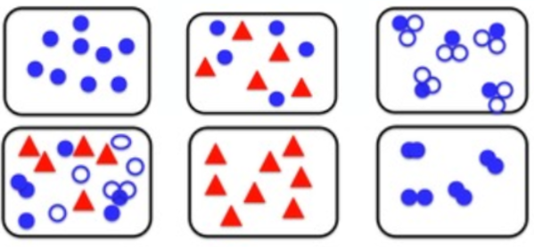

Isotopes
- What is the definition of an isotope?
…………………………………………………………………………………………………………………
…………………………………………………………………………………………………………………
- Explain why these diagrams show isotopes of carbon.
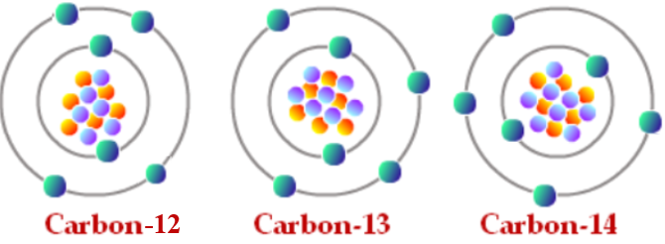
…………………………………………………………………………………………………………………
…………………………………………………………………………………………………………………
…………………………………………………………………………………………………………………
Compounds
- What is the definition of a compound?
…………………………………………………………………………………………………………………
…………………………………………………………………………………………………………………
- What holds the elements together in compounds?
…………………………………………………………………………………………………………………
- Why are compounds difficult to separate?
…………………………………………………………………………………………………………………
…………………………………………………………………………………………………………………
- For each of the compounds listed, state what elements it is made of and how many atoms of each element there are:
e.g. CO₂ - 1 atom of carbon, 2 atoms of oxygen

- Ammonia, NH₃
…………………………………………………………………………………………………………………
…………………………………………………………………………………………………………………
- Calcium chloride, CaCl₂
…………………………………………………………………………………………………………………
…………………………………………………………………………………………………………………
- Sulphuric acid, H₂SO₄
…………………………………………………………………………………………………………………
…………………………………………………………………………………………………………………
- Copper hydroxide, Cu(OH)₂
…………………………………………………………………………………………………………………
…………………………………………………………………………………………………………………
- Magnesium nitrate, Mg(NO₃)₂
…………………………………………………………………………………………………………………
…………………………………………………………………………………………………………………

Writing Equations
Write word and balanced symbol equations for these reactions:
- Methane reacts with oxygen to form carbon dioxide and water
…………………………………………………………………………………………………………………
…………………………………………………………………………………………………………………
- Magnesium oxide is the product when magnesium burns in oxygen
…………………………………………………………………………………………………………………
…………………………………………………………………………………………………………………
- A neutralisation reaction with reactants of copper hydroxide and sulphuric acid will make copper sulphate and water.
…………………………………………………………………………………………………………………
…………………………………………………………………………………………………………………
Balancing Equations
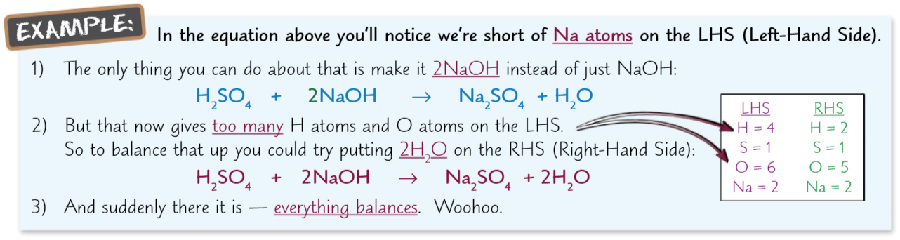
H₂ + O₂ → H₂O

Mg + HCl → MgCl₂ + H₂

Li + H₂O → LiOH + H₂

Na + O₂ → Na₂O
C1 – Mixtures and Separation – Revision Guide Pages 100-102

Mixtures
- What is the definition of a mixture?
…………………………………………………………………………………………………………………
…………………………………………………………………………………………………………………
- Why are mixtures easy to separate?
…………………………………………………………………………………………………………………
…………………………………………………………………………………………………………………
- Name the 5 methods we can use to separate mixtures.
…………………………………………………………………………………………………………………
…………………………………………………………………………………………………………………
…………………………………………………………………………………………………………………
- In the following diagram, identify the elements, compounds and mixtures.
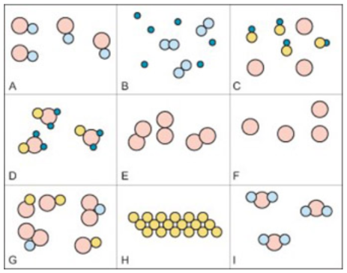
A. | B. | C.
D. | E. | F.
G. | H. | I.
Chromatography
Sort the method below for how to do chromatography.
Add a spot of the ink/chemical to the line.
Place a lid on top of the container, to stop the solvent from evaporating.
Draw a line in pencil near the bottom of the piece of chromatography paper.
Place the paper into the beaker of solvent. Making sure the ink is not touching the solvent.
When the solvent has nearly reached the top of the paper, take the paper out of the beaker and leave it to dry.
Pour a small amount of solvent into the beaker, making sure not to go over the pencil line.

- Why might we need to use a different solvent than water?
…………………………………………………………………………………………………………………
…………………………………………………………………………………………………………………
- Why do we draw the baseline in pencil?
…………………………………………………………………………………………………………………
- Why is it important that the solvent isn’t filled above the baseline?
…………………………………………………………………………………………………………………
…………………………………………………………………………………………………………………
- What is the paper with the results on called?
…………………………………………………………………………………………………………………
- Why do the different inks in the mixture separate?
…………………………………………………………………………………………………………………
…………………………………………………………………………………………………………………
…………………………………………………………………………………………………………………
- How will you know if the test substance is pure?
…………………………………………………………………………………………………………………
- How will you know if the test substance is insoluble?
…………………………………………………………………………………………………………………
…………………………………………………………………………………………………………………
- How will you know if two different mixtures contain the same chemical
…………………………………………………………………………………………………………………
…………………………………………………………………………………………………………………
Separating Soluble and Insoluble Substances – Filtration, Evaporating and Crystallisation
Sort the method below to describe how to separate rock salt.
The salt will dissolve, but the sand will not.
Filter the mixture using a filter funnel and paper.
Grind the rock salt (mixture of salt and sand) using a pestle and mortar.
The sand will remain in the filter paper, the salt and water will pass through.
Or, separate the salt from water using crystallisation: heat the solution and then allow solution to cool to allow crystals to form.
Add water to the rock salt and stir.
Separate the salt from water using evaporation: heat the solution to evaporate the water.

- What is meant by a soluble substance?
…………………………………………………………………………………………………………………
- What type of mixture can be separated using filtration?
…………………………………………………………………………………………………………………
…………………………………………………………………………………………………………………
- Why is the rock salt ground up in the first step of the practical?
…………………………………………………………………………………………………………………
…………………………………………………………………………………………………………………
- Why does the sand remain in the filter paper?
……………………………………………………………………………………………………………………………………………………………………………………………………………………………………
- Why does the salt pass through the filter paper?
…………………………………………………………………………………………………………………
…………………………………………………………………………………………………………………
- What are the names of the 2 methods used to separate a soluble salt from a solution?
……………………………………………………………………………………………………………………………………………………………………………………………………………………………………
- Which method should be used to develop large crystals?
…………………………………………………………………………………………………………………
Distillation
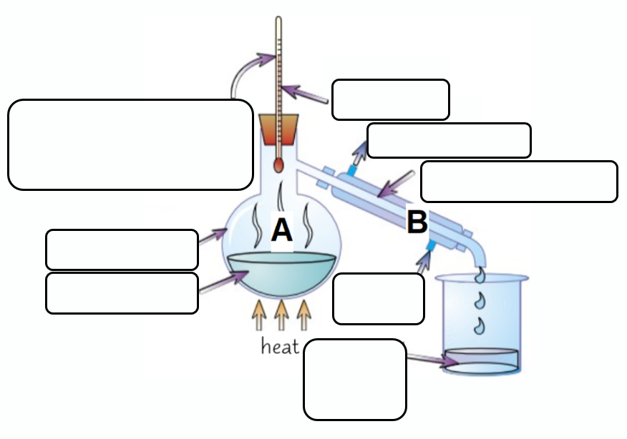

- Label the diagram above.
- State the name of the processes which are happening at A and B.
…………………………………………………………………………………………………………………
…………………………………………………………………………………………………………………
- What type of substances is this method used to separate?
…………………………………………………………………………………………………………………
…………………………………………………………………………………………………………………
Fractional Distillation
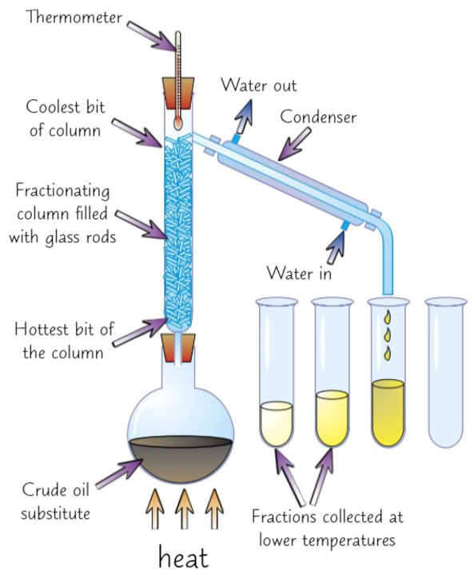
Explain how fractional distillation is used to separate a mixture of liquids with different boiling points.
…………………………………………………………………………………………………………………
…………………………………………………………………………………………………………………
…………………………………………………………………………………………………………………
…………………………………………………………………………………………………………………
…………………………………………………………………………………………………………………
…………………………………………………………………………………………………………………
…………………………………………………………………………………………………………………

Separating Techniques
Which separation technique would you use in each of the cases below?

- Separate insoluble copper oxide from a solution
…………………………………………………………………………………………………………………
- Collect pure water from inky water
…………………………………………………………………………………………………………………
- Collect fine table salt from seawater
…………………………………………………………………………………………………………………
- Collect flaked sea salt from seawater
…………………………………………………………………………………………………………………
- Separating a range of food colourings from a sample
…………………………………………………………………………………………………………………
- Separating the colours in a nail varnish
…………………………………………………………………………………………………………………
- Petrol from crude oil
…………………………………………………………………………………………………………………
- Collect pure water from seawater
…………………………………………………………………………………………………………………

C1 – Atomic Structure – Revision Guide Pages 96, 103-104

History of the Atom
Atomic Model | Scientist | Contribution to Model
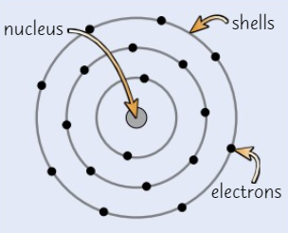
Plum Pudding Model
Label the diagram of the Plum Pudding Model

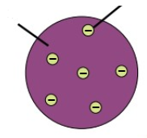
Describe the plum pudding model in words.
…………………………………………………………………………………………………………………
…………………………………………………………………………………………………………………
…………………………………………………………………………………………………………………
…………………………………………………………………………………………………………………
…………………………………………………………………………………………………………………
…………………………………………………………………………………………………………………

Electronic Structure
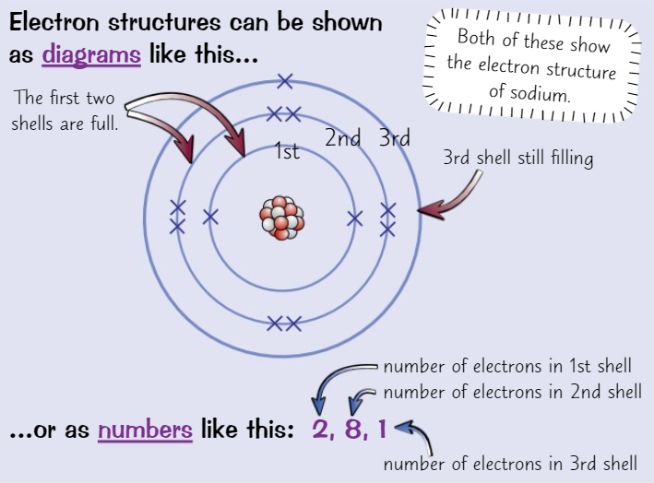
- How do you know where to find the number of electrons in an atom?
…………………………………………………………………………………………………………………
- What is the maximum number of electrons in the first shell?
…………………………………………………………………………………………………………………
- What is the maximum number of electrons in the second shell?
…………………………………………………………………………………………………………………
- What is the maximum number of electrons in the third shell?
…………………………………………………………………………………………………………………
- What effect will a full outer shell have on an atom?
…………………………………………………………………………………………………………………
- What do atoms do if their outer shell is not full?
…………………………………………………………………………………………………………………
- Draw the electronic structure for the following:
  - Nitrogen

  - Argon

  - Sodium

- Write the electronic configuration under each diagram
- What does the number of electrons in the outer shell tell us?
…………………………………………………………………………………………………………………
- What does the number of shells tell us?
…………………………………………………………………………………………………………………

C1 – Structure of the Periodic Table – Revision Guide Pages 105-106

Mendeleev’s Periodic Table
- What did Mendeleev use to order the elements in his periodic table?
…………………………………………………………………………………………………………………
- Why was his table not complete?
…………………………………………………………………………………………………………………
…………………………………………………………………………………………………………………
- Why did Mendeleev sometimes switch the order of elements on the table
…………………………………………………………………………………………………………………
…………………………………………………………………………………………………………………
- What did the gaps he left enable him to do?
…………………………………………………………………………………………………………………
…………………………………………………………………………………………………………………

The Modern Periodic Table
- Roughly how many elements are there?
…………………………………………………………………………………………………………………
- In the modern periodic table, how are the elements arranged?
…………………………………………………………………………………………………………………
- What are the columns on the periodic table called?
…………………………………………………………………………………………………………………
- What are the rows on the periodic table called?
…………………………………………………………………………………………………………………
- What does the group number of an element tell you?
…………………………………………………………………………………………………………………
- What is similar about elements in the same group?
…………………………………………………………………………………………………………………
…………………………………………………………………………………………………………………
- Give an example of a ‘trend’ (pattern) on the periodic table
…………………………………………………………………………………………………………………
…………………………………………………………………………………………………………………

C1 – Groups of the Periodic Table – Revision Guide Pages 107-110

Metals and Non-Metals
Order the following properties into the table.
- Low melting and boiling points
- Strong
- Dull looking
- Can be liquid or gas at room temperature
- Good conductors of heat and electricity
- High melting and boiling points
- Poor conductors of heat and electricity
- Brittle
- Malleable
- Lower density
Metals | Non-Metals

Group 1 – The Alkali Metals
- Explain the trend in reactivity of the group 1 elements.

…………………………………………………………………………………………………………………
…………………………………………………………………………………………………………………
…………………………………………………………………………………………………………………
…………………………………………………………………………………………………………………
…………………………………………………………………………………………………………………
…………………………………………………………………………………………………………………
…………………………………………………………………………………………………………………

Group 7 – The Halogens
- What are group 7 elements called?
…………………………………………………………………………………………………………………
- Why is the symbol for chlorine gas Cl₂ and not just Cl?
…………………………………………………………………………………………………………………
…………………………………………………………………………………………………………………
- Explain the trends in the halogens as you move down the group.
…………………………………………………………………………………………………………………
…………………………………………………………………………………………………………………
…………………………………………………………………………………………………………………
…………………………………………………………………………………………………………………
…………………………………………………………………………………………………………………

Group 0 – The Noble Gases
- What are group 0 elements called?
…………………………………………………………………………………………………………………
- Describe the appearance of these elements at room temperature.
…………………………………………………………………………………………………………………
…………………………………………………………………………………………………………………
- What electronic structure do they all have in common?
…………………………………………………………………………………………………………………
- What feature of all the noble gases is caused by this stable electronic structure?
…………………………………………………………………………………………………………………
…………………………………………………………………………………………………………………
- Describe the trends in the noble gases as you move down the group.
…………………………………………………………………………………………………………………
…………………………………………………………………………………………………………………

C2 – Ionic Compounds – Revision Guide Pages 112-114

Formation of Ions
- What is an ion?
…………………………………………………………………………………………………………………
- How do metals form ions? What charge will they have?
…………………………………………………………………………………………………………………
…………………………………………………………………………………………………………………
- How do non-metals form ions? What charge will they have?
…………………………………………………………………………………………………………………
…………………………………………………………………………………………………………………
- What has happened to an ion with a charge of +1?
…………………………………………………………………………………………………………………
- What has happened to an ion with a charge of -2?
…………………………………………………………………………………………………………………
- Explain what ions group 7 elements will form.
…………………………………………………………………………………………………………………
…………………………………………………………………………………………………………………
- Predict the ions formed by sodium, sulphur and bromine
…………………………………………………………………………………………………………………
…………………………………………………………………………………………………………………
…………………………………………………………………………………………………………………

Ionic Bonding
Metals and ________________ react together to make ____________ compounds.
The metal loses ____________ to form _____________ charged ions. The non-metals ______________ these electrons to form ______________ charged ions.
The oppositely charged ions are strongly attracted to each other by ____________________ forces. This attraction is called an ionic bond.
Ionic Bonding – Worked Example
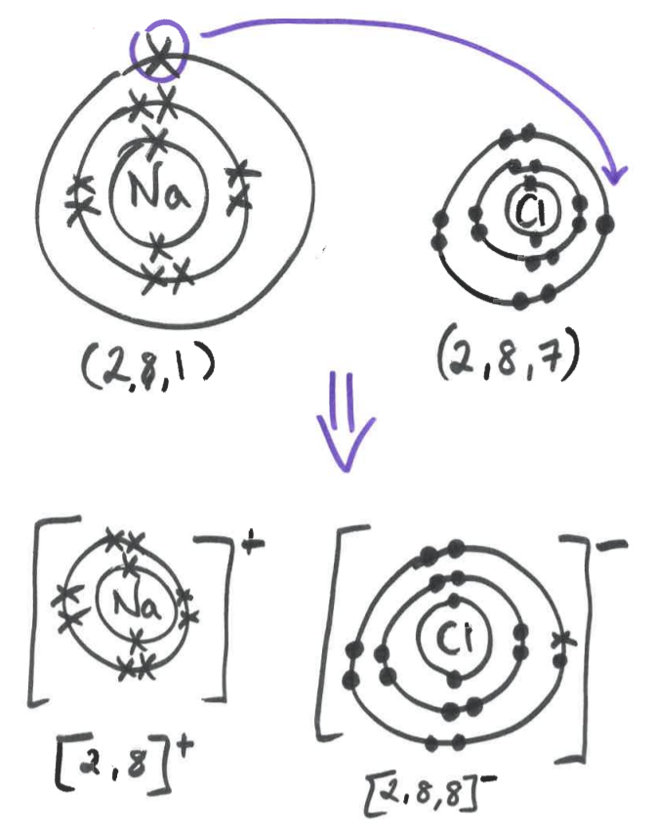

The sodium atom loses 1 electron to form a positive sodium ion, Na+.
The chlorine atom gains this electron to form a chloride ion, Cl⁻.
The oppositely charged ions are attracted together by strong electrostatic forces.
This forms the ionic compound sodium chloride.
Ionic Bonding – Magnesium Oxide
Draw the bonding of magnesium oxide.

Explain what the diagram shows in words.
…………………………………………………………………………………………………………………
…………………………………………………………………………………………………………………
…………………………………………………………………………………………………………………
…………………………………………………………………………………………………………………

Ionic Bonding – Beryllium Fluoride
Draw the bonding of beryllium fluoride.

Explain what the diagram shows in words.
…………………………………………………………………………………………………………………
…………………………………………………………………………………………………………………
…………………………………………………………………………………………………………………
…………………………………………………………………………………………………………………
…………………………………………………………………………………………………………………
Ionic Bonding – Lithium Oxide
Draw the bonding of lithium oxide.

Explain what the diagram shows in words.
…………………………………………………………………………………………………………………
…………………………………………………………………………………………………………………
…………………………………………………………………………………………………………………
…………………………………………………………………………………………………………………

Ionic Compounds
Sodium chloride is an example of an ionic compound. It can be shown in a couple of different ways.
What are the advantages and disadvantages of each model?
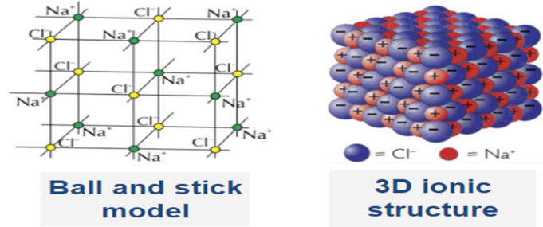
…………………………………………………………………………………………………………………
…………………………………………………………………………………………………………………
…………………………………………………………………………………………………………………
…………………………………………………………………………………………………………………
…………………………………………………………………………………………………………………
…………………………………………………………………………………………………………………
Properties of Ionic Compounds
All ionic compounds have similar _____________________. They all have high _________________ and boiling points. This is because a lot of _________________ is needed to break the ________________ ionic bonds.
Solid ionic compounds cannot ______________ electricity because the __________ cannot move.
When an ionic compound is _____________ or _______________ in water, the ions can ___________ so they can ________________________ electricity.

C2 – Simple Covalent Molecules – Revision Guide Pages 115-116
Comparing Covalent Drawings
- What type of elements join together to form covalent bonds?
…………………………………………………………………………………………………………………
- What is a covalent bond made of?
…………………………………………………………………………………………………………………
- What does an atom need to do to become stable?
…………………………………………………………………………………………………………………
- How can you work out how many covalent bonds each atom will form?
…………………………………………………………………………………………………………………
…………………………………………………………………………………………………………………
- State the 3 different ways that covalent bonds can be drawn
…………………………………………………………………………………………………………………
…………………………………………………………………………………………………………………
- Draw ammonia (NH₃) using both the dot and cross and the displayed formula methods

Simple Molecular Substances
Example – Chlorine, Cl₂
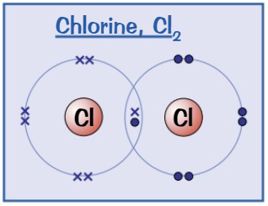
Task – Draw the following covalent molecules.

Hydrogen, H₂

Hydrogen chloride, HCl

Water, H₂O

Methane, CH₄

Oxygen, O₂

Nitrogen, N₂

Ammonia, NH₃

C2 – Giant Covalent Structures (including carbon) – Revision Guide Pages 117-118

Polymers
- What is a polymer?
…………………………………………………………………………………………………………………
…………………………………………………………………………………………………………………
- Describe the bonding in polymers
…………………………………………………………………………………………………………………
…………………………………………………………………………………………………………………
…………………………………………………………………………………………………………………
- What is a ‘repeating unit’?
…………………………………………………………………………………………………………………
…………………………………………………………………………………………………………………
- Write the molecular formula for these polymers:
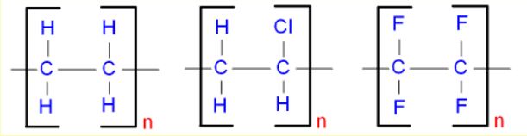
…………………………………………………………………………………………………………………
- Explain why most polymers are solid at room temperature.
…………………………………………………………………………………………………………………
…………………………………………………………………………………………………………………
…………………………………………………………………………………………………………………
…………………………………………………………………………………………………………………
- Why are the melting points of polymers still lower than ionic compounds?
…………………………………………………………………………………………………………………
…………………………………………………………………………………………………………………
…………………………………………………………………………………………………………………
…………………………………………………………………………………………………………………

Giant Covalent Compounds
- What type of bonding is found in giant covalent structures?
…………………………………………………………………………………………………………………
- Explain why the melting and boiling points of giant covalent structures are high.
…………………………………………………………………………………………………………………
…………………………………………………………………………………………………………………
…………………………………………………………………………………………………………………
- Explain why giant covalent structures do not conduct electricity.
…………………………………………………………………………………………………………………
…………………………………………………………………………………………………………………
…………………………………………………………………………………………………………………
- Name the exception to this rule.
…………………………………………………………………………………………………………………
- Give 3 examples of giant covalent structures.
…………………………………………………………………………………………………………………
…………………………………………………………………………………………………………………
…………………………………………………………………………………………………………………
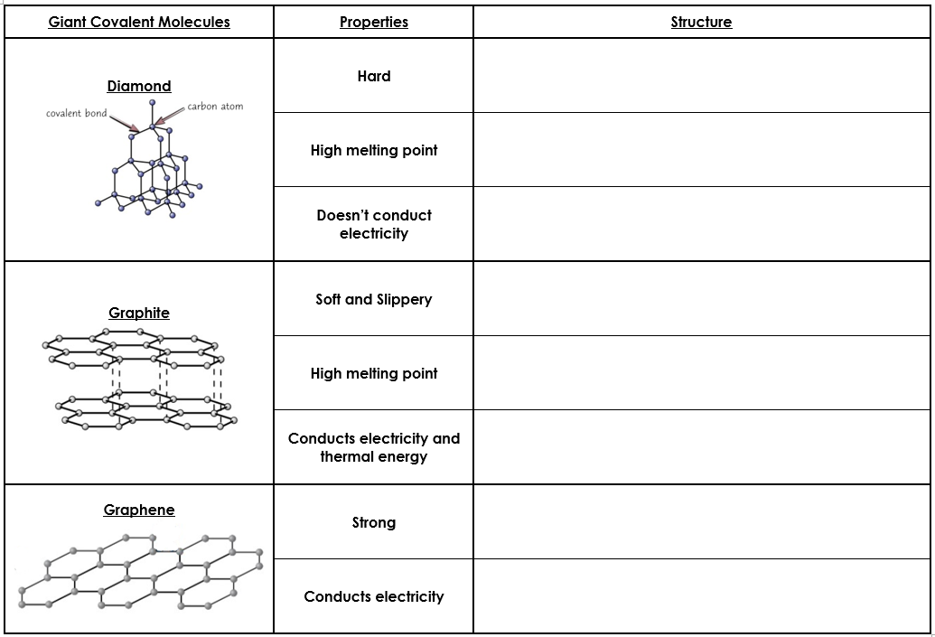
Structures of Carbon
- What are fullerenes?
…………………………………………………………………………………………………………………
…………………………………………………………………………………………………………………
- What shape are they usually found in?
…………………………………………………………………………………………………………………
- How are the carbon atoms arranged?
…………………………………………………………………………………………………………………
…………………………………………………………………………………………………………………
- What was the first fullerene to be discovered?
…………………………………………………………………………………………………………………
- Give 2 uses of fullerenes
…………………………………………………………………………………………………………………
…………………………………………………………………………………………………………………
- What are carbon nanotubes?
…………………………………………………………………………………………………………………
…………………………………………………………………………………………………………………
…………………………………………………………………………………………………………………
- Compare the length of a nanotube with its width
…………………………………………………………………………………………………………………
…………………………………………………………………………………………………………………
…………………………………………………………………………………………………………………
…………………………………………………………………………………………………………………
- Suggest why nanotubes can be used in electronics
……………………………………………………………………………………………………………………………………………………………………………………………………………………………………
…………………………………………………………………………………………………………………
- Suggest why nanotubes are used to strengthen tennis rackets.
…………………………………………………………………………………………………………………
…………………………………………………………………………………………………………………
…………………………………………………………………………………………………………………

C2 – Metallic Bonding and Alloys – Revision Guide Pages 119
Metallic Bonding
Draw the structure of a metal to show metallic bonding.

Metals are ________________ structures of metal ions in a ________________________ pattern, surrounded by a sea of ________________________ electrons.
The electrons from the ___________________ shells of the metal atoms are free to move around and there are strong ______________________________ forces between these electrons and the metal ions. These forces are called ______________________ bonds.
Properties of Metals
- Explain why metals have high melting and boiling points.
…………………………………………………………………………………………………………………
…………………………………………………………………………………………………………………
…………………………………………………………………………………………………………………
- Explain why metals are good conductors of heat and electricity.
…………………………………………………………………………………………………………………
…………………………………………………………………………………………………………………
…………………………………………………………………………………………………………………
- Explain why metals can be bent and formed into different shapes.
…………………………………………………………………………………………………………………
…………………………………………………………………………………………………………………
…………………………………………………………………………………………………………………
Metals and Alloys
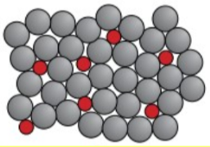
- What is meant by an ‘alloy’? (Not a wheel!!)
…………………………………………………………………………………………………………………
…………………………………………………………………………………………………………………
…………………………………………………………………………………………………………………
- How are alloys made?
…………………………………………………………………………………………………………………
…………………………………………………………………………………………………………………
- Use the diagram above to explain why alloys are stronger than pure metals. Use these key phrases in your answer:
- different sized atoms
- disrupting layers
- cannot slide
…………………………………………………………………………………………………………………
…………………………………………………………………………………………………………………
…………………………………………………………………………………………………………………
…………………………………………………………………………………………………………………
…………………………………………………………………………………………………………………
…………………………………………………………………………………………………………………
…………………………………………………………………………………………………………………
…………………………………………………………………………………………………………………

C4 – Reactivity and Reactions of Metals – Revision Guide Pages 132-134

Reactivity Series
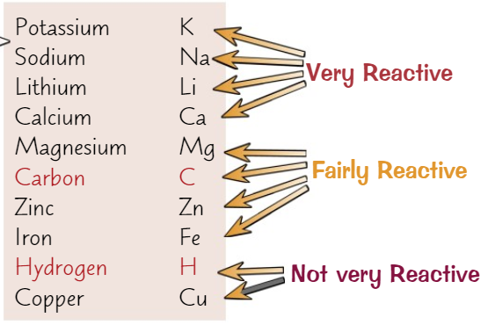
- What is the reactivity series?
…………………………………………………………………………………………………………………
- What does the reactivity of a metal depend on?
…………………………………………………………………………………………………………………
…………………………………………………………………………………………………………………
…………………………………………………………………………………………………………………
- Name the 5 metals which are more reactive than carbon in order of most to least reactive
…………………………………………………………………………………………………………………
…………………………………………………………………………………………………………………
- Name the 3 metals that are less reactive than carbon in order of most to least reactive
…………………………………………………………………………………………………………………
…………………………………………………………………………………………………………………
- Which 2 non-metals are included in the reactivity series?
…………………………………………………………………………………………………………………
…………………………………………………………………………………………………………………
Determining Reactivity
Order the method below.
To compare reactivity, you could watch how quickly bubbles of hydrogen form.
This is because they react too violently with acids.
The more reactive the metal, the faster the bubbles form.
Can test magnesium, zinc and iron with acids.
Copper doesn’t react with water or acid.
We test potassium, sodium, lithium and calcium with water.
Displacement Reactions
For example:
Iron + copper sulphate → iron sulphate + copper
Fe(s) + CuSO₄ (aq) → FeSO₄ (aq) + Cu (s)

Because the iron is _______ reactive than the _________, the copper will be ______________ from the compound.
There would be no reaction between iron sulphate and copper. Copper is _________ reactive than __________, so cannot displace iron from the __________________.

Task: 2 of the following reactions will not work. Complete the equations for the 3 reactions which will take place.

- zinc + copper nitrate →
- calcium + lithium sulphate →
- calcium + magnesium chloride →
- Iron + copper nitrate →
- sodium + potassium chloride →

Task: now write balanced equations for the 3 reactions which would take place.
…………………………………………………………………………………………………………………
…………………………………………………………………………………………………………………
…………………………………………………………………………………………………………………
…………………………………………………………………………………………………………………

Extracting Metals
- How are some metals extracted from their ores?
…………………………………………………………………………………………………………………
…………………………………………………………………………………………………………………
- We say the ore has been reduced. What does this mean?
…………………………………………………………………………………………………………………
…………………………………………………………………………………………………………………
- We say the carbon is oxidised, what does this mean?
…………………………………………………………………………………………………………………
…………………………………………………………………………………………………………………
- How are metals more reactive than carbon extracted from their ores?
…………………………………………………………………………………………………………………
…………………………………………………………………………………………………………………
- What is the main disadvantage of this method?
…………………………………………………………………………………………………………………
…………………………………………………………………………………………………………………
- Why is this method sometimes necessary?
…………………………………………………………………………………………………………………
…………………………………………………………………………………………………………………
- Name the metals in the reactivity series which can be extracted by heating them with carbon
…………………………………………………………………………………………………………………
…………………………………………………………………………………………………………………
…………………………………………………………………………………………………………………
- Why is the position of the metals in the reactivity series important when deciding on the most suitable method?
…………………………………………………………………………………………………………………
…………………………………………………………………………………………………………………
…………………………………………………………………………………………………………………
…………………………………………………………………………………………………………………
- Gold exists as pure metal. Explain why gold does not form ores?
…………………………………………………………………………………………………………………
…………………………………………………………………………………………………………………

C4 – Neutralisation and the pH Scale – Revision Guide Pages 129-131

Neutralisation of Acids
There are 3 types of bases:
- Oxides
- _____________
- Carbonates
You need to know how to write equations for the reactions of all of these ____________ with different acids.
All the reactions make _______________ and water. The name of the salt depends on the _________________ ion of the base and the type of _____________ used.
Naming Salts
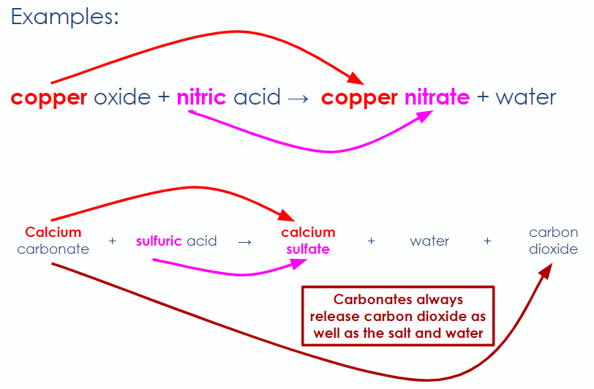
Task: Complete the table.
Name of Acid | Formula of Acid | Salt Produced
Hydrochloric Acid
Sulphuric Acid
Nitric Acid
Now complete the 3 general equations:
- acid + metal oxide → ____________________ + ____________________
- acid + metal hydroxide → ____________________ + ____________________
- acid + metal carbonate → _______________ + _______________ + _______________
Reactions of Acids – Balanced Equations
When writing balanced equations, it is useful to remember the following ions so you can work out the formula for each reactant and product.
Writing Word and Balanced Symbol Equations
Complete the word, and write the balanced symbol equation for the following reactions:

Copper hydroxide + sulphuric acid → _______________________ + _______________________ …………………………………………………………………………………………………………………

Lithium oxide + hydrochloric acid → _______________________ + _______________________
…………………………………………………………………………………………………………………

Sodium carbonate + nitric acid → _______________ + _______________ + _______________
…………………………………………………………………………………………………………………

_______________ + _______________ → potassium chloride + _______________
…………………………………………………………………………………………………………………

___________ carbonate + __________ → magnesium nitrate + ____________ + __________
…………………………………………………………………………………………………………………
Summary of Reactions

Reactants | Products
acid + metal oxide
acid + metal hydroxide
acid + metal carbonate
metal + acid
metal + water
metal oxide + carbon

pH Scale
- What is the pH scale?
…………………………………………………………………………………………………………………
- What would the typical pH be for a strong acid?
…………………………………………………………………………………………………………………
- What numbers on the pH scale are for alkalis?
…………………………………………………………………………………………………………………
- What number represents a neutral substance?
…………………………………………………………………………………………………………………
- What is an indicator?
…………………………………………………………………………………………………………………
- Give an example of a wide range indicator.
…………………………………………………………………………………………………………………
- What colours could this indicator turn in an acid?
…………………………………………………………………………………………………………………
- What colour represents neutral?
…………………………………………………………………………………………………………………
- What colours could this indicator turn in an alkali?
…………………………………………………………………………………………………………………
- Describe a more accurate way of measuring the pH of a solution.
…………………………………………………………………………………………………………………
…………………………………………………………………………………………………………………

Making Soluble Salts (RP)
Watch the video and answer the questions.
- What is the purpose of the experiment?
…………………………………………………………………………………………………………………
- What reactants are being used?
…………………………………………………………………………………………………………………
- Name the salt which will be made
…………………………………………………………………………………………………………………
- Why is the acid gently heated?
…………………………………………………………………………………………………………………
- An ‘excess’ of copper oxide is added. What does ‘excess’ mean and why is this done?
…………………………………………………………………………………………………………………
…………………………………………………………………………………………………………………
- Why does the excess copper oxide need to be removed?
…………………………………………………………………………………………………………………
…………………………………………………………………………………………………………………
- How is this done?
…………………………………………………………………………………………………………………
…………………………………………………………………………………………………………………
…………………………………………………………………………………………………………………
- Describe the process of drying the crystals
…………………………………………………………………………………………………………………
…………………………………………………………………………………………………………………
…………………………………………………………………………………………………………………
C4 – Electrolysis – Revision Guide Pages 135-136
Electrolysis
- What is electrolysis?
…………………………………………………………………………………………………………………
…………………………………………………………………………………………………………………
- What is the electrolyte?
…………………………………………………………………………………………………………………
…………………………………………………………………………………………………………………
- What is an electrode?
…………………………………………………………………………………………………………………
…………………………………………………………………………………………………………………
- What happens during electrolysis?
…………………………………………………………………………………………………………………
…………………………………………………………………………………………………………………
…………………………………………………………………………………………………………………
- What charge does the cathode have?
…………………………………………………………………………………………………………………
- Why do positive ions (cations) move to the cathode?
…………………………………………………………………………………………………………………
…………………………………………………………………………………………………………………
…………………………………………………………………………………………………………………
- What do the ions do when they get to the cathode?
…………………………………………………………………………………………………………………
…………………………………………………………………………………………………………………
- What charge does the anode have?
…………………………………………………………………………………………………………………
- Why do negative ions (anions) move to the anode?
…………………………………………………………………………………………………………………
…………………………………………………………………………………………………………………
- What do the ions do when they get to the anode?
…………………………………………………………………………………………………………………
…………………………………………………………………………………………………………………
- The ions form the element when they lose or gain electrons. What do we say has happened to the ions?
…………………………………………………………………………………………………………………
…………………………………………………………………………………………………………………
- Why do ionic compounds have to be molten or dissolved for electrolysis to work?
…………………………………………………………………………………………………………………
…………………………………………………………………………………………………………………
…………………………………………………………………………………………………………………
Electrolysis of Molten Ionic Compounds
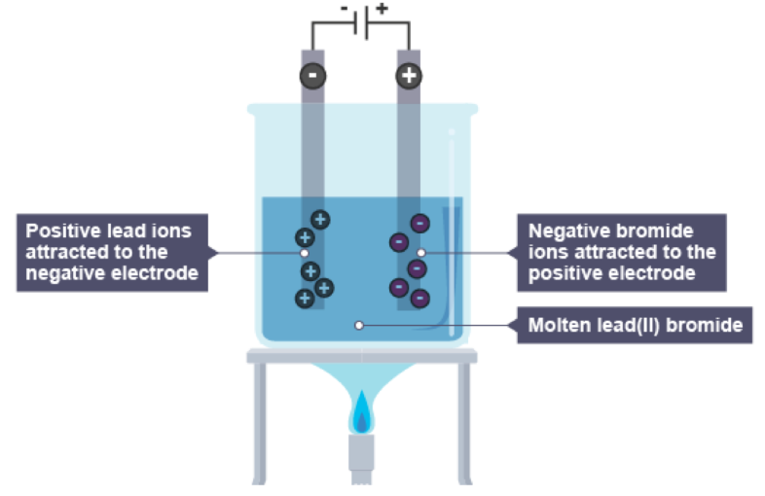
Lead bromide is heated so it becomes _________________. The positive lead ions are _______________ to the ______________ where they __________ electrons to form atoms of lead.
The ________________ bromide ____________ are attracted to the _______________ where they _____________ electrons to form __________________ gas.

Task: Use the same structure to describe the electrolysis of the following molten ionic compounds:
Iron chloride
…………………………………………………………………………………………………………………
…………………………………………………………………………………………………………………
…………………………………………………………………………………………………………………
…………………………………………………………………………………………………………………
…………………………………………………………………………………………………………………
…………………………………………………………………………………………………………………
…………………………………………………………………………………………………………………
…………………………………………………………………………………………………………………
…………………………………………………………………………………………………………………
…………………………………………………………………………………………………………………

Reaction Profile – Exothermic Reaction
Add these labels to the diagram:

- Reactants
- Products
- Activation energy
- Energy given out

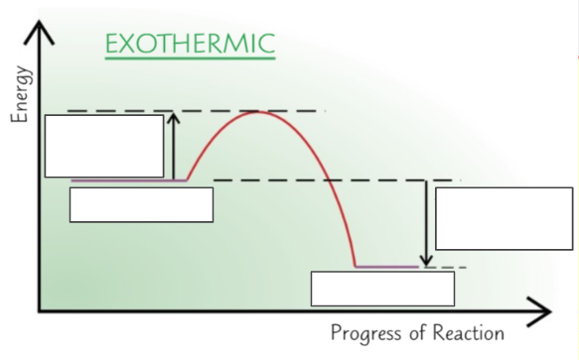

In an exothermic reaction, the energy level of the products is ________________ than the energy level of the reactants.
This is because energy has been _______________ ___________ during the reaction.
The ______________________ in the height of the reactants and products shows the overall ______________________ ___________________ in the reaction.
The rise in energy at the start shows the ___________________________ energy.

Reaction Profile – Endothermic Reaction
Add these labels to the diagram:

- Reactants
- Products
- Activation energy
- Energy taken in

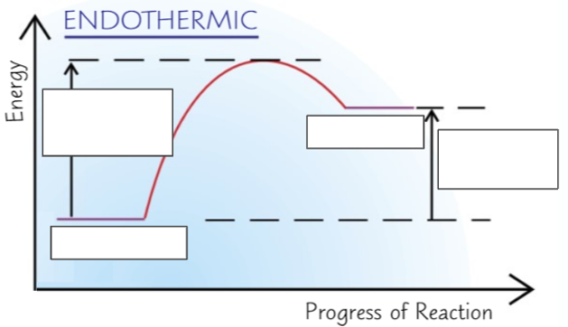

In an endothermic reaction, the energy level of the products is __________________ than the energy level of the reactants.
This is because energy has been ________________ ________ during the reaction.
The ______________________ in the height of the reactants and products shows the overall ___________________ __________________ in the reaction.
The rise in energy at the start shows the ____________________________ energy.

